Tuesday Upper Body

30 Seconds exercise, 30 seconds rest - repeat x 4 times
1. Star Jumps/Jumping Jacks
https://www.youtube.com/watch?v=c4DAnQ6DtF8
- Stand straight with your feet together and hands by your sides
- Jump up, spread your feet and bring both hands together above your head.
- Jump again and return to the starting position
- Repeat for 30 seconds
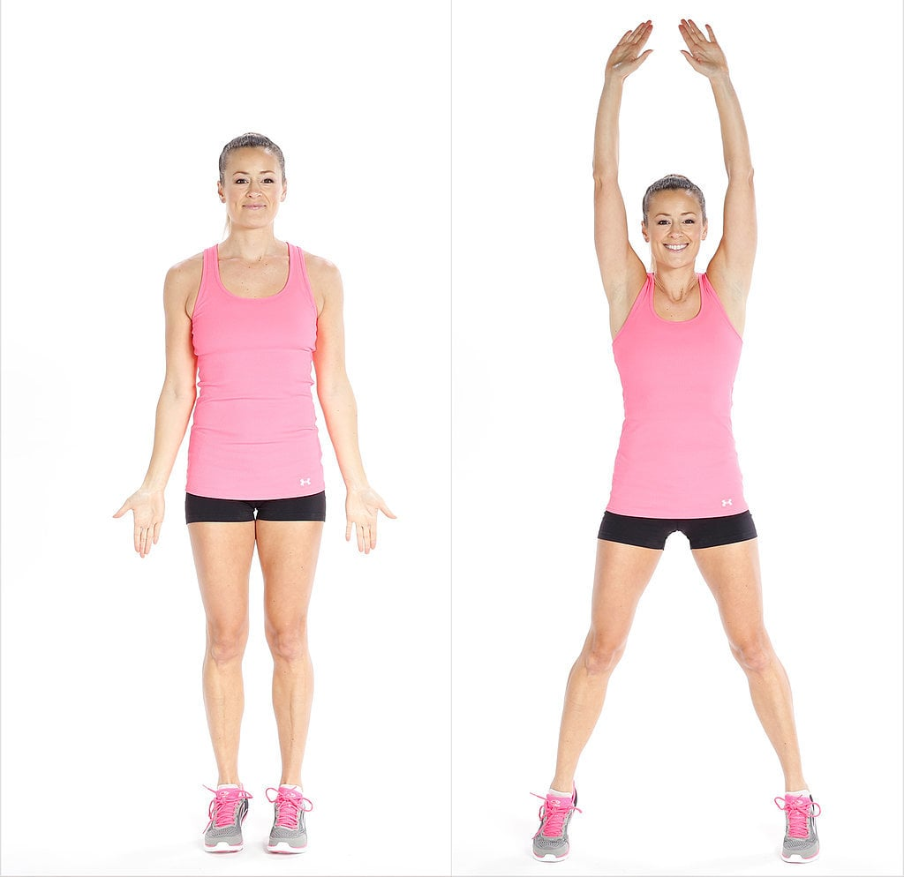

- Arm Circles
https://www.youtube.com/watch?v=140RTNMciH8
- Stand straight with your feet shoulder width apart
- Raise and extend your arms to the sides without bending the elbows
- Slowly rotate your arms forward making small circles
- Engage your core muscles, keep your back and arms straight.
- Keep your head up and your body in a T formation
- 15 seconds rotating arms forward and 15 seconds rotating arms backwards
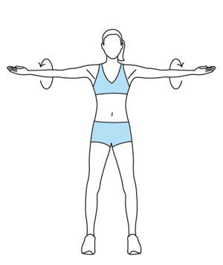

3. Burpess
https://www.youtube.com/watch?v=dZgVxmf6jkA
- Stand straight with your feet shoulder width apart
- Squat and place your hands in front of your feet
- Jump back until your legs are fully extended and your body is in a plank position
- Do a push up, jump forward and then push through the heels to return to the starting position
- Keep your core engaged at all times,
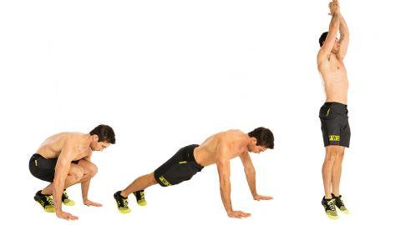

4. Tricep Dips
https://www.youtube.com/watch?v=0326dy_-CzM
- Place your hands behind you onto a chair so that your fingers face forward
- Extend your legs and start bending your elbows
- Lower your body until your arms are at a 90 degree angle
- Lift your body back up until your arms are straight.
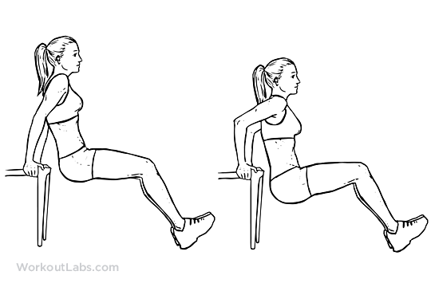
5. Push Up
https://www.youtube.com/watch?v=rjc0O7OXS3g
- With your legs extended back, place the hands below the shoulders, slightly wider that shoulder width apart.
- Start bending your elbows and lower your chest until it’s just above the floor
- Push back to the starting position
- Keep your head in line with your torso and your torso in line with your hips.
- Engage your core muscles and maintain your body in a straight line.

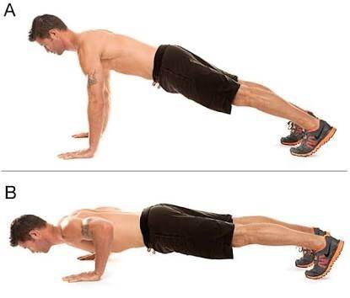

6.Plank with Arm Raise
https://www.youtube.com/watch?v=a1_fRyavWdA
- Begin in a plank position with your weight resting on your forearms.
- Keep your body in a completely straight line from your shoulders to your ankles
- Tighten your abs and without letting your hips move, raise one are straight out in front of you.
- Pause then lower your arm back to the starting position
- Alternate arms for 30 seconds
