Wednesday - Energy system day
Repeat all exercises five times. 2 mins rest between each round

1. Star Jumps/Jumping Jacks
https://www.youtube.com/watch?v=c4DAnQ6DtF8
- Stand straight with your feet together and hands by your sides
- Jump up, spread your feet and bring both hands together above your head.
- Jump again and return to the starting position
- Repeat for 30 seconds

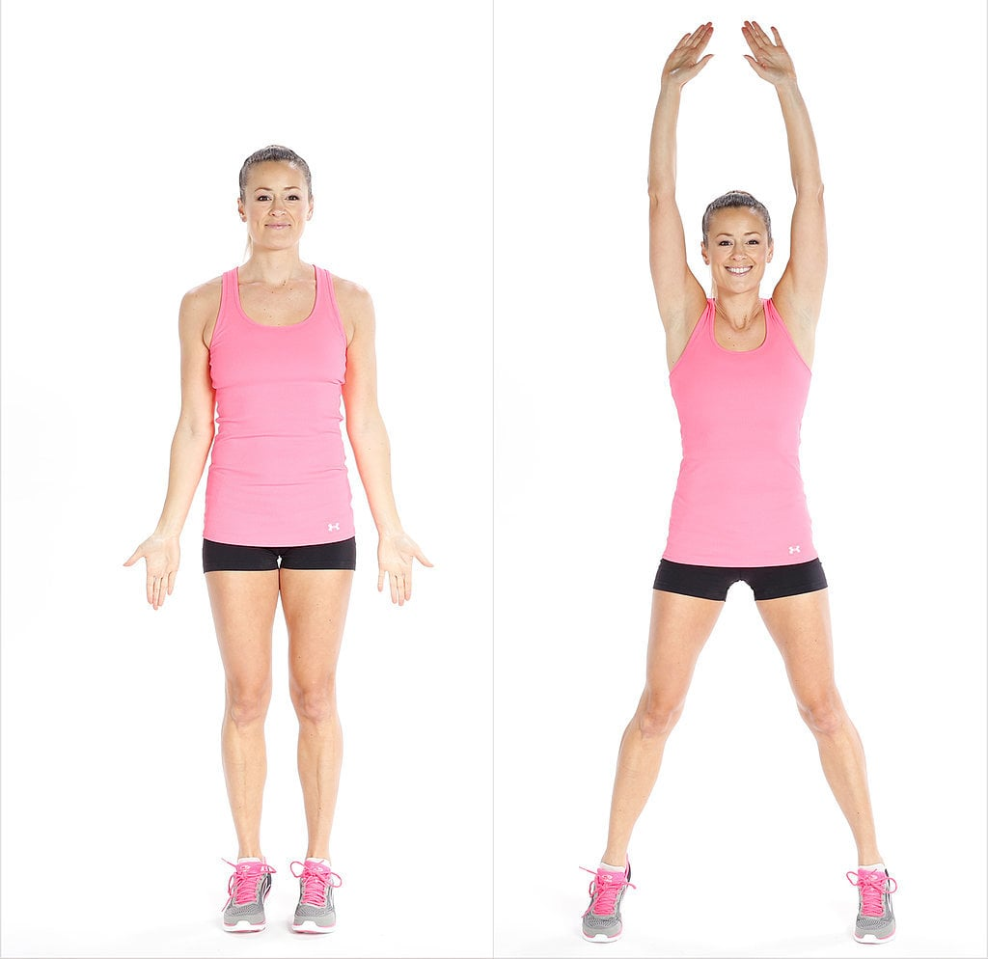

2. Sprinting on the spot
https://www.youtube.com/watch?v=O7Kyyws7gEI
Complete for 45 seconds

3. Reverse Lunge and Hop
https://www.youtube.com/watch?v=k8qPGcnlwSM
- Take a step backward and lower your hips so that your back knee is just above the floor and your front thigh is parallel to the floor
- Bring your back leg forward, lift your knee as high as you can and hop in the air
- Repeat on the same leg 20 times then change legs
20 times on each leg

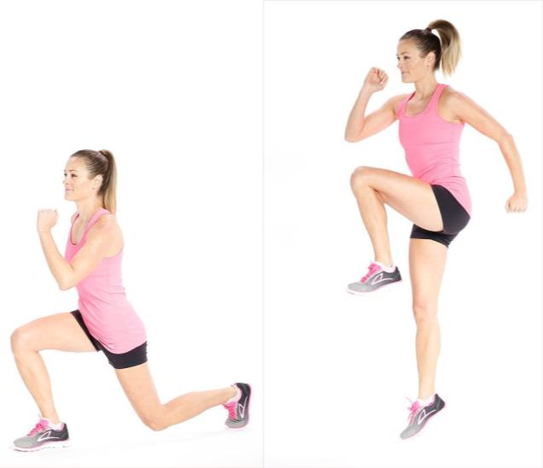

4. Burpess
https://www.youtube.com/watch?v=dZgVxmf6jkA
- Stand straight with your feet shoulder width apart
- Squat and place your hands in front of your feet
- Jump back until your legs are fully extended and your body is in a plank position
- Do a push up, jump forward and then push through the heels to return to the starting position
- Keep your core engaged at all times,
Complete for 30 seconds
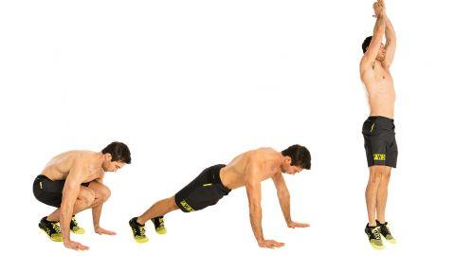

5. Skipping with a rope
- Hold the rope while keeping your hands at hip level
- Rotate your wrists to swing the rope and jump
- Jump with both feet at the same time
- Engage your abs, keep the upper body straight, knees slightly bent and jump on the balls of your feet
Complete for 30 seconds

