Travelling to Pavilions in the Park, Horsham
Location
Pavilions in the Park, Hurst Road, Horsham, RH12 2DF for Google Maps & Sat Navs. To reduce pressure on car parking, save the environment & reduce your costs, please consider car sharing.
Pavilions is a 3 minute walk from Horsham Railway Station – so why not come by train? Horsham is on the mainline from London via East Croydon and Crawley to Portsmouth and Southampton, and also on the Leatherhead – Dorking line (no Sunday service on this one though).
Car Parking on Saturday
Car parking at Pavilions on Saturday is limited to 5 hours maximum for a charge of £4.40, so is really only useful if you are just swimming 1 session. Other nearby car parks also have time limits.
Atlantis have rented the Collyers School car park for use on Saturday only for an all day charge of £4. It is located 400m along Hurst Road from the Pavilions and has a capacity of 150 cars. The car park is one way - the entrance is nearest to the main school buildings, and we will take payment on entry – please try to have the right change ready. Parking as always is at your own risk.
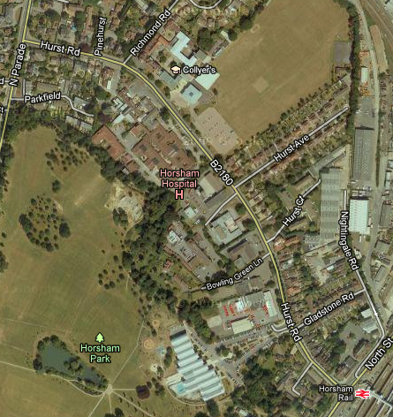

Collyers car park
entrance

Pavilions in the Park

See the Horsham Council website for details of alternative car parks in the local area: https://www.horsham.gov.uk/parking/town-centre-parking

Car Parking on Sunday
The car park at the Pavilions takes 200 cars and is £1.50 for the day on Sunday as are most other car parks in Horsham. Other nearby car parks are at Horsham Council Offices (120 cars) and BT Exchange (80 cars).
See the Horsham Council website for details: https://www.horsham.gov.uk/parking/town-centre-parking

