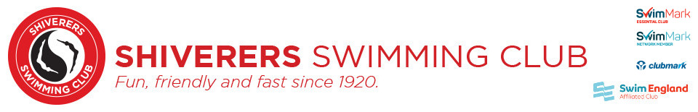
In loving Memory of Ian Newell 31/03/1947- 20/03/2021
by Allison and Mark Cannon on behalf of Shiverers Swimming Club

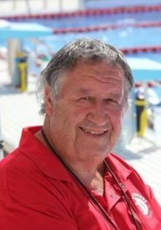

It is with great sadness that we have to write about the death of Ian Newell former Head Coach of Shiverers Swimming Club for over 30 years and all-round swimming legend.

Ian has played a big part in our life along with countless other families who have been members of Shiverers Swimming Club over the last three decades and more.

Ian was a larger-than-life character and was an amazing coach to so many who he helped by teaching them about the benefits of hard work, discipline, friendship and supporting each other.

He loved to tell jokes, not all of them were particularly funny it has to be said, but when you are 9 years old and starting your swimming journey who cares!

He was so encouraging of his swimmers, never getting down on them when in their eyes, they had a bad swim. He always believed in them and admired every single one of them for keeping going.

He loved Swimming, and Shiverers. He never had to say how passionate he was about it. It was obvious to everyone how much it meant to him. He lived and breathed it. It was his life and the swimmers were an extension of his family.

His success in the pool was unquestionable he had countless, county, regional, national and international champions. This is a testament to his coaching skills and ability. He had the unique ability to remember all the times his swimmers swam, and their year of birth, and played a mean game of bingo.

Despite all his success in the pool, starting the careers of so many incredibly successful swimmers, the sense of family and fun are what so many will remember.

Ian’s death at 73 came after the sad death of his loving and much-loved sister Sue who was another Shiverers legend. Our thoughts are with Dave and Amy and all who knew loved and cared about them.

So today the world and poolside are a little bit quieter but the night sky will shine a bit brighter.

I will leave the final words to Ian.....Mooove-It

