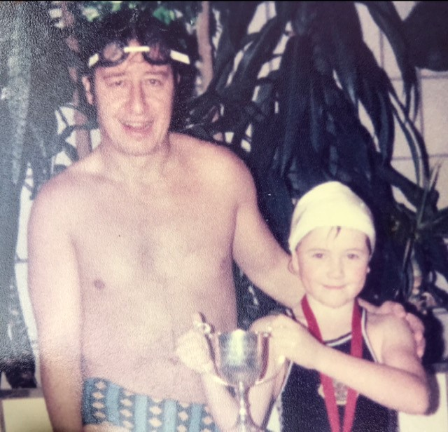

I am writing in relation to the sad passing of Ian Newell. As soon as I heard I went on a trip down memory lane to the time when I swam at Shiverers for the entirety of the 1980s.

My Dad (Phil Chapman) and I met Ian at the old and freezing cold King Alfred Swimming pool when I was around age 2, and he spotted some talent in me as I jumped off the high board. From that point I swam regularly at the pool and when I joined Shiverers Ian took me under his wing and trained me in the art of competitive swimming. Pretty much my entire childhood was spent at the pool. Soon I was taking part in competitions, and I remember Ian at the side of the pool encouraging us with our 16-length warm up. It was all so much fun. I remember Karen Pickering swimming in the 5-star lane, and it was so exciting watching such an amazing swimmer. Ian was devoted to all the swimmers and the club. I probably spent as much time with Ian as my own family in the 1980s. My Dad Phil was so great at taking me to the pool 5-7 days a week and with his own competitive sporting background Ian eventually made him one of his swimming coaches at the club.

I was so excited to see that Ian had kept all the old records. I too have kept many of the race sheets and also my medals. I am very proud of these and what I was able to achieve in the water as a result of Ian’s guidance.

My years in the 1980s at the club formed my personality in so many ways. I learned about patience, competition, determination, courage, and the importance of watching and learning from others. Ian was such an important part of my childhood; I only wish I had seen him again to let him know this. The photo I include gives an insight into how he supported, encouraged and looked out for me. Sadly, I suffered from Mastoiditus (Inner ear disease) and had to give up competitive swimming as a result, but I never forgot those days.

My Dad is also very sad to hear of Ian’s passing, and we discussed this morning that they had seen each other and caught up not so long ago. I was delighted to hear that my Dad had the opportunity to tell Ian in person what a fantastic and well-regarded swimming coach he had been, and how much he had admired his commitment to the club and swimmers.

I am sure so many other swimmers will come forward and share stories. I notice I am on the 1985 competition sheet and I remember it as if it was yesterday. So amazing Ian kept all of the documents. It again demonstrates his total commitment and passion for the sport.

Much love and thoughts to his family.

Best wishes
Emma Snowdon (nee Chapman)

