**Chantal’s W&DSC Head Coach Highlights January Report2020**

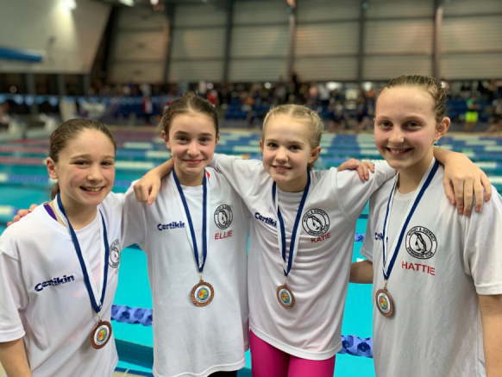[](https://www.pinterest.com/laurachristine8/swimming/)

**New club records:**

Jess and Hattie and girls age group relays!

Well done all

**Good luck at ONB County champs in Feb:**

Ellie Browne

Ellie Blake

James Bunyard

Sammy Cartwright

Georgia Duff

Camille Duff

Alice Dyson

Ella Edwards

Annaliese Elford

Katie Franklin

Iris Fraser

Maddie Good

Lucy Howarth

Hugo Jinks

Sophie Jarvis

Cameron Jarvis

Rory Jones

Ben Kinahan

Ethan Lefort

Beth Lefort

Hattie Lever

Bertie Lever

Lauren Mellings

Jessica Miller

Rosie Mullins

Harriet Mullins

Jonathan Opalczewski

Eleanor Perks

Isaac Perks

William Phair

Henry Purcell

Cameron Richards

Sienna Saunders

Erin Stewart

Maya T.Saldana

Ava White

Freya Warriner

[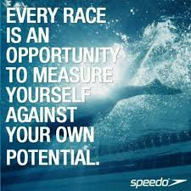](https://www.google.co.uk/imgres?imgurl=https://www.quotemaster.org/images/53/534d65be2e66d0a0ce27caf2c08bbf8f.jpeg&imgrefurl=https://www.quotemaster.org/swimming%2Bcompetition&docid=jkqEaCeNKoIGLM&tbnid=us4ll7cAvvuXoM:&vet=10ahUKEwj62tCG14DZAhVmLMAKHS3CBQEQMwhvKD4wPg..i&w=720&h=720&hl=en&bih=619&biw=1301&q=competitive%20swimming%20quotes&ved=0ahUKEwj62tCG14DZAhVmLMAKHS3CBQEQMwhvKD4wPg&iact=mrc&uact=8)

Good luck to all swimmers in Diddy heats on 28th Feb and 1st March!

[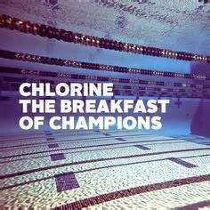](http://www.google.co.uk/url?sa=i&rct=j&q=&esrc=s&source=images&cd=&cad=rja&uact=8&ved=2ahUKEwj8mP_B1oDZAhWhCcAKHYSFCgEQjRx6BAgAEAY&url=http://linkuplink.info/competitive-swimming-quotes/2a6bbcee3423a19104153ccdd44709a5-b009d2734e5cfe85584ed795fcfb7a1d/&psig=AOvVaw0HG3mJyDRLGkVdFglwyNMm&ust=1517435302243525)[](https://www.google.co.uk/imgres?imgurl=http://www.crystalmountainsunspots.com/wp-content/uploads/2016/09/Penguin-cartoon-clip-art-free-clipart-kid.png&imgrefurl=http://www.crystalmountainsunspots.com/cartoon-clip-art-image-30695/&docid=T-aLf0Dv8Sx0WM&tbnid=GAf0U9ofJDETeM:&vet=10ahUKEwj3_63f1IDZAhVsD8AKHeAxCBEQMwiCASg6MDo..i&w=898&h=900&hl=en&bih=619&biw=1301&q=cartoon%20swimming%20penguin&ved=0ahUKEwj3_63f1IDZAhVsD8AKHeAxCBEQMwiCASg6MDo&iact=mrc&uact=8)

**Congratulations County top 8 positions in 400’s:**

Eleanor, Jess, Sienna, Erin, Ethan, Annaliese, Hattie, Katie, Maya, Ellie, Lauren, Rosie, Isaac, William, Jonathan, Hugo, Henry

No evening training Sunday 9th Feb due to Academy time trials

**ONB County age group 10-12 + 13/14yrs relay teams:**

