**Chantal’s W&DSC Head Coach Highlights July/Aug Report 19**

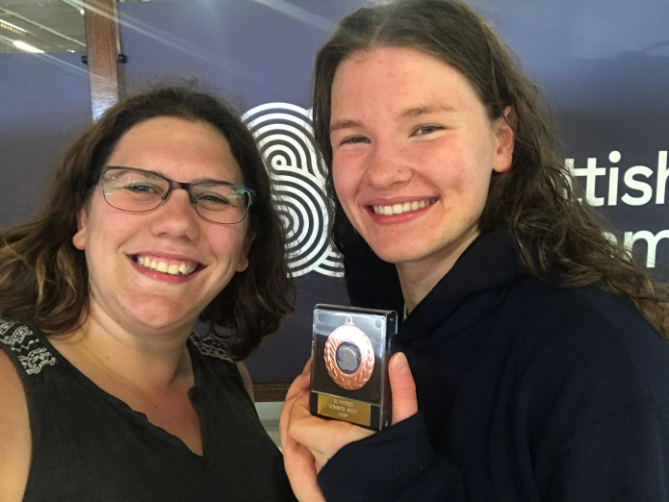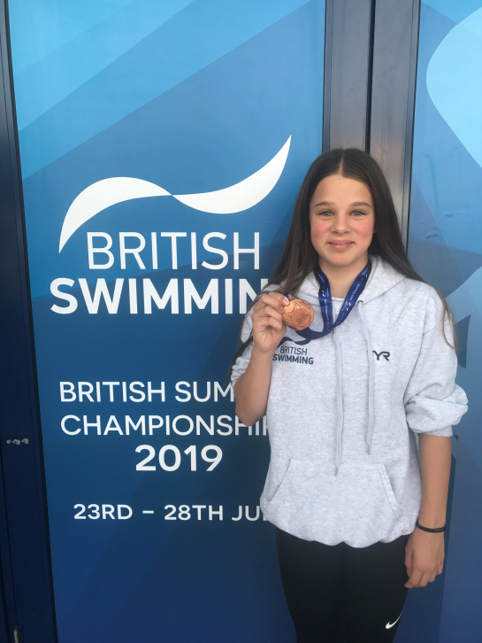

**Well done at Summer Nationals!!**

**Georgia Duff** – Scottish Nationals (bronze)

**Eleanor Perks** – British Nationals (bronze)

**Ella Edwards & Lauren Mellings** – Welsh Nationals (finals for both)

**Hugo Jinks**

-Open Water Nationals

[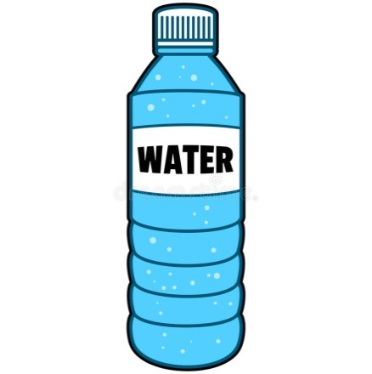](https://www.google.co.uk/url?sa=i&rct=j&q=&esrc=s&source=images&cd=&cad=rja&uact=8&ved=2ahUKEwjRztKVs5jdAhUOxIUKHcDjAJYQjRx6BAgBEAU&url=https://www.dreamstime.com/stock-illustration-bottle-water-cartoon-illustration-image53675001&psig=AOvVaw0dHEo967Lp_YXSi4CD4q8y&ust=1535842973946143)

**W**

**E**

**L**

**C**

**O**

**M**

**E**

**B**

**A**

**C**

**K**

**Make sure you have planned and handed in your 2019-20 goal form!**

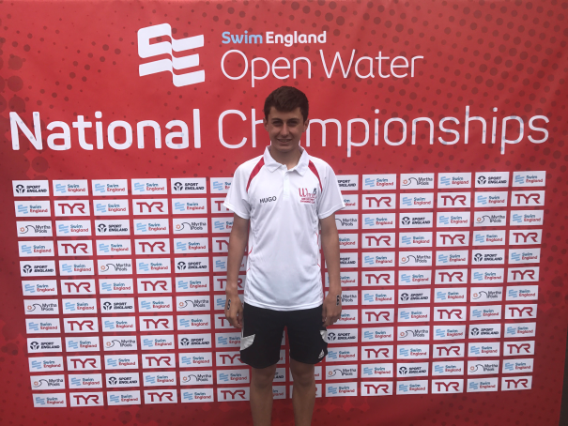

[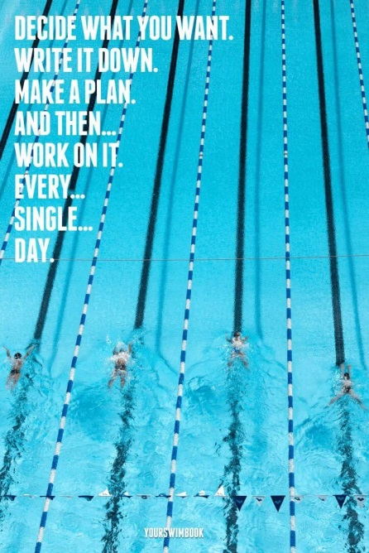](http://www.google.co.uk/url?sa=i&rct=j&q=&esrc=s&source=images&cd=&cad=rja&uact=8&ved=2ahUKEwjo9YXYspjdAhVOhxoKHREZA1UQjRx6BAgBEAU&url=http://vintageposterdesigns.com/swimming-posters-motivational/swimming-posters-motivational-d7bf43bbf1fc13997b30c80cab165012-triathlon-quotes-triathlon-motivation/&psig=AOvVaw1GQ5YHd_GWfXfairIQpZtH&ust=1535842805740947)

Pre pool is 10mins before pool training!!!!!

**Make sure you have all your correct training kit for the new season!!**

Fins, kick board, pull buoy, snorkel, finger paddles, hand paddles, thera-band,spare hats+goggles, skipping rope, roller

**Club Championships**

**Entries close 1st September**

Friday 20th September – 200 bk/100 fc

Saturday 20th September – 200 fc/100 brs

Sunday 22nd September – IM/400 fc/100 bk

Monday 23rd September – 200 fly

Friday 27th September – 200 brs/100 fly

Saturday 28th September – 50’s

Sunday 29th September – IM/400 fc/100bk

Monday 30th September – 200 IM

**Gala’s coming up…..**

7th Sept – home relay gala

14th Sept – Braunstone gala

14th Sept – MKJL RD 3

12th Oct – NAL RD 1

9th Nov – NAL RD 2

14th Dec – NAL RD 3

Club champ finals – 23/24th Nov

**Good luck everyone!!**