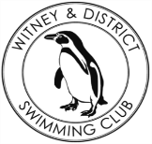**Chantal’s W&DSC Head Coach Highlights June Report2019**

**Well done to the following swimmers who attended the West Oxfordshire Sports Awards and were awarded GLL Sports Foundation awards:**

**County Awards:**

Erin Stewart, Sammy Cartwright,

**Regional Awards:**

Lauren Mellings, Ella Edwards, Georgia Duff, Jess Miller, Eleanor Perks, Ellie Browne, Maddie Good, Camille Duff, Lucy Howarth

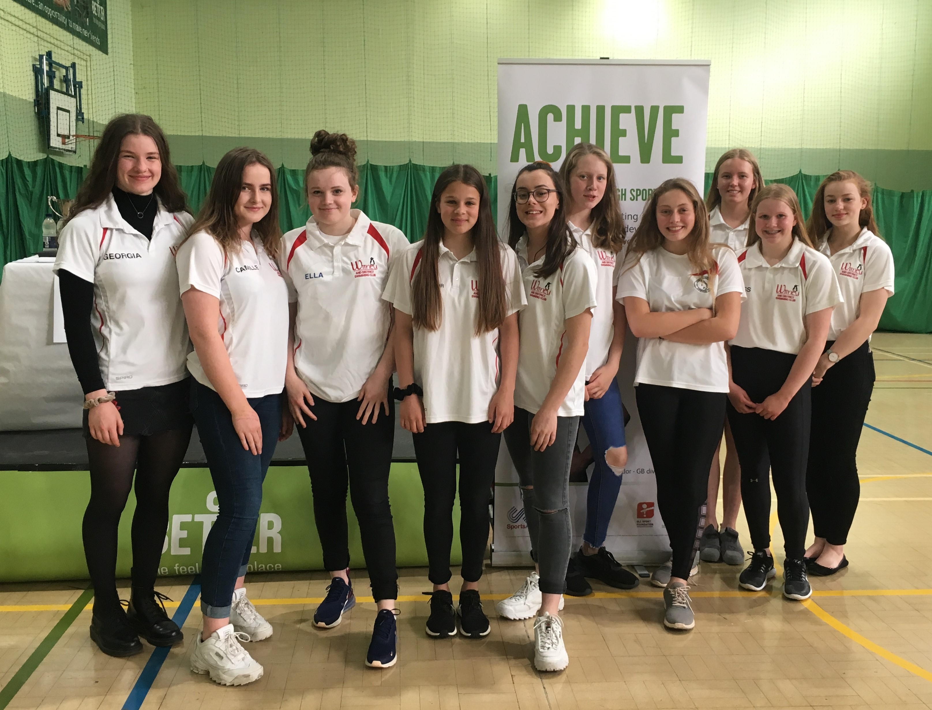

**Good luck at Nationals!!**

**Georgia Duff** – Scottish Nationals (12-14th July)

**Eleanor Perks** – British Nationals (23rd – 28th July)

**Ella Edwards & Lauren Mellings** – Welsh Nationals (29th July – 2nd August

**Wellingborough Gala 11/u age group winners!**

Ellie Blake, Beth Lefort, Ella Purcell, Katie Franklin

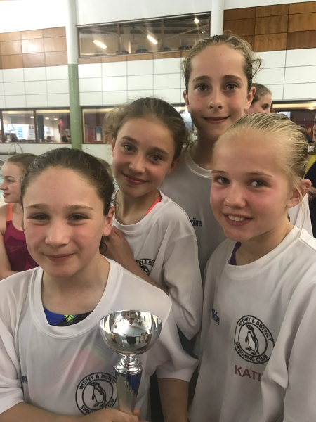

Great racing at all gala’s and open meets in June – been a busy month!!

**Masters Success:**

**Congratulations** to Janka and Darren for their GLL Sports Foundation Training awards.

Photo in their GB kit as they received this to support their training for the World Transplant Championships 17-24 August in Newcastle where they will be swimming  for Team GB.

**Congratulations** to Lynne for winning a bronze medal at the recent British Masters Championships in the 70-74yrs age group 100m Backstroke.

Don’t forget to check summer training hours – end on Wednesday 31st July and restart Thursday 29th August.

**Good luck to swimmers at regional open water champs:**

Hugo Jinks, Steffi Jinks, Megan Howe

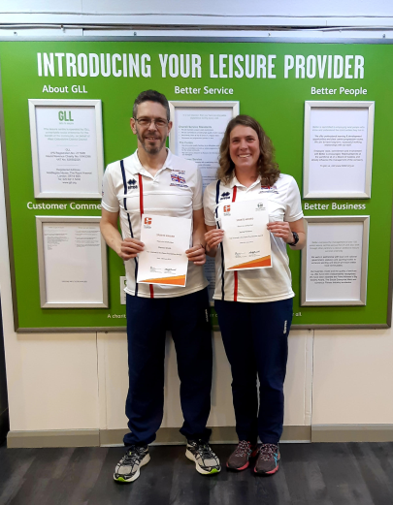

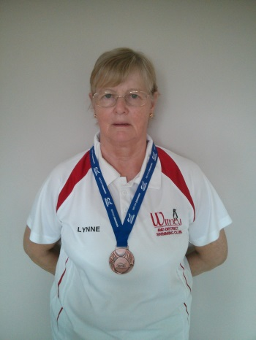

**New records broken in June:**

**Eleanor Perks** - 15/u and Open 200m IM SC - Maxwell meet

**James Bunyard** - Open 50m BRS SC - Hatfield