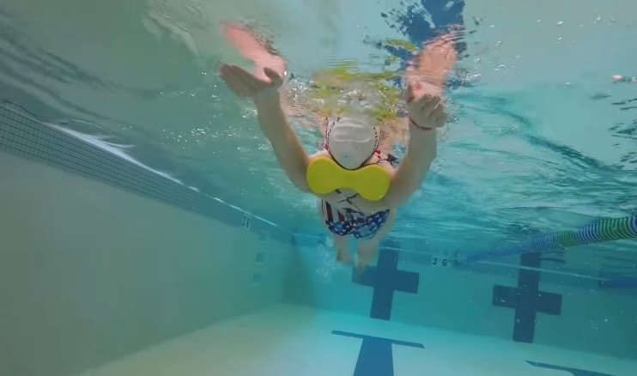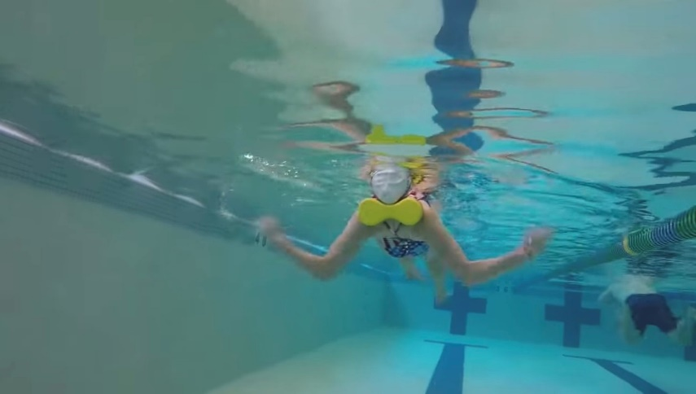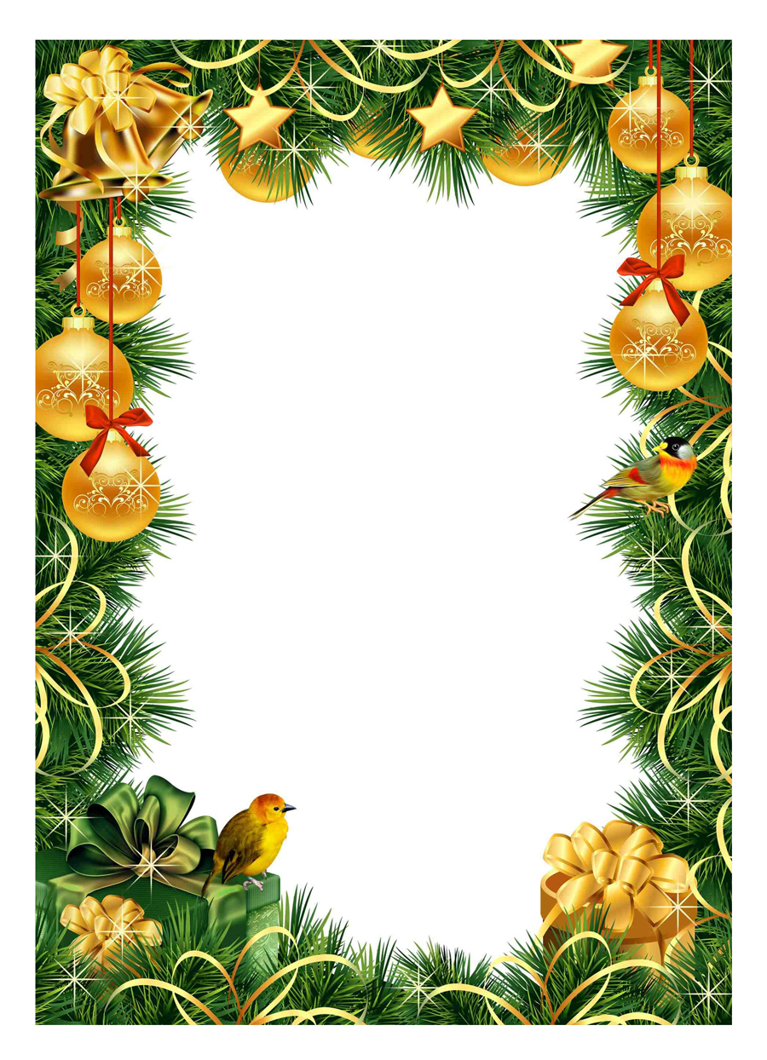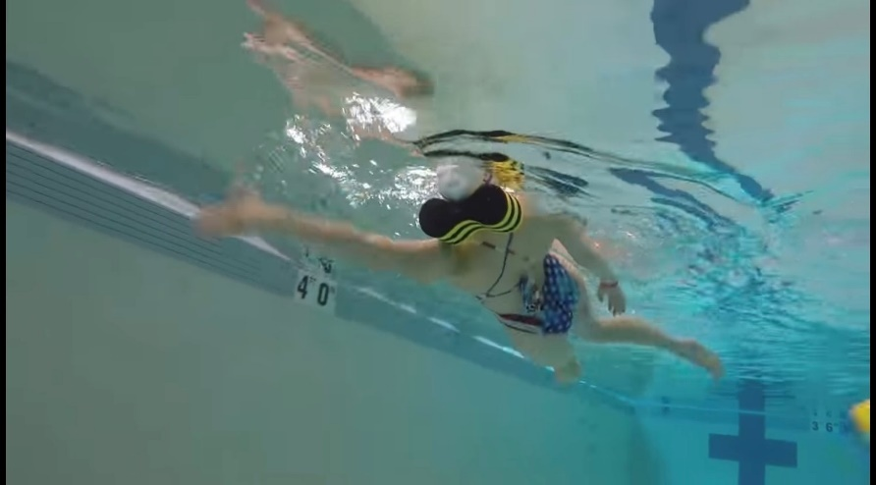

**HOW and WHY?**

* Pullbouy behind neck/head on backstroke
* Keeps head still
* Rotation through shoulders/hips
* Correct head position
* Can do kick, scull, drill, full

**Pillow backstroke**

**W&DSC**

**Advent Calendar Drills**

**10th December**