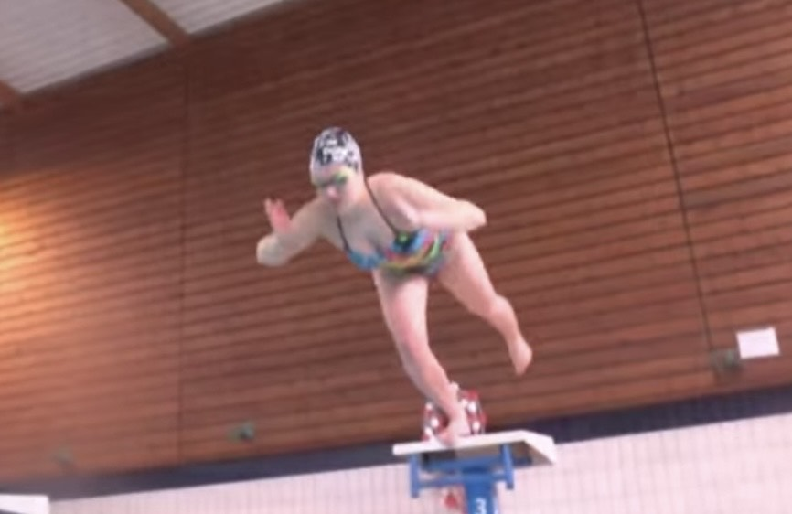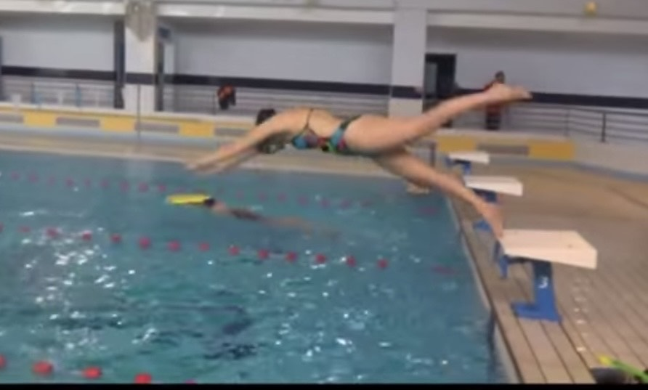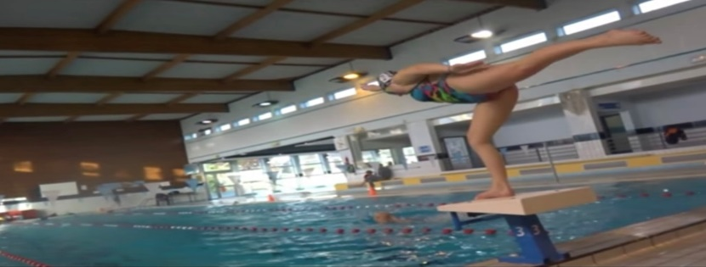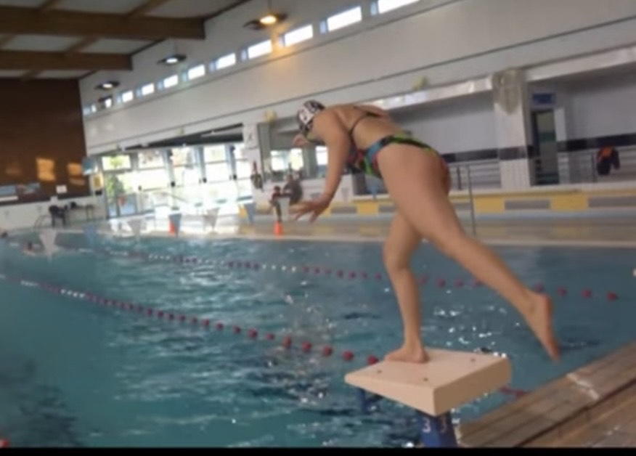

**HOW and WHY?**

* Balance work
* Power for pushing off one leg
* Control of core
* Driving start with arms
* Getting into streamline body position
* Bend front leg for push

**One legged Dives**

**W&DSC**

**Advent Calendar Drills**

**12th December**