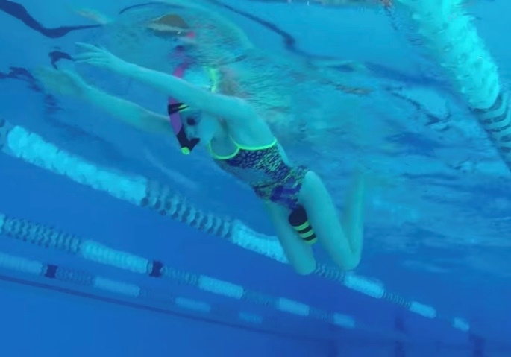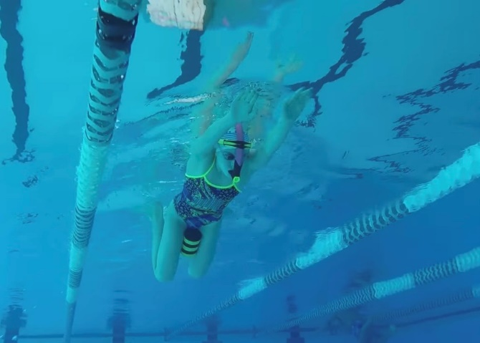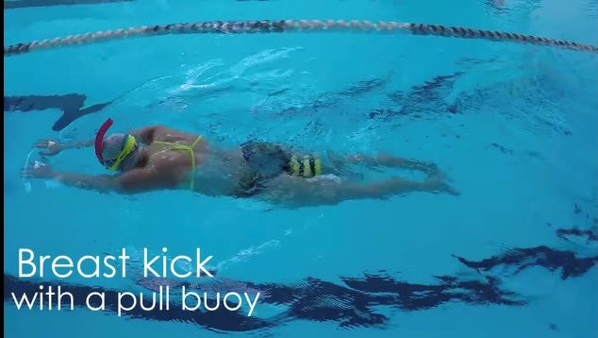

**HOW and WHY?**

You can do this drill as a BRS kick only drill or as full stroke.

* Can use snorkels
* Pull buoy put between thighs
* Perform BRS kick keeping pull buoy between legs
* If it pops out then knees are opening too far apart on kick
* Aim to keep knees narrow on kick
* Knees slightly wider than hips and feet slightly wider than knees
* Kick back and not out
* Keeps a balanced kick

**Breaststroke kick with pull buoy**

**W&DSC**

**Advent Calendar Drills**

**3rd December**