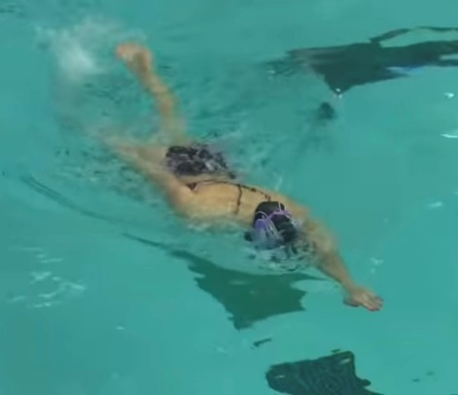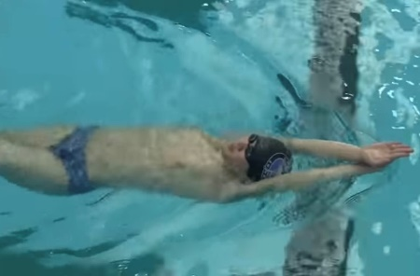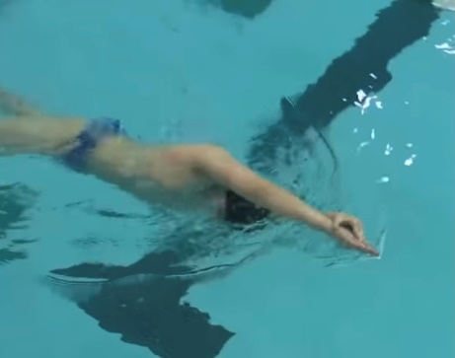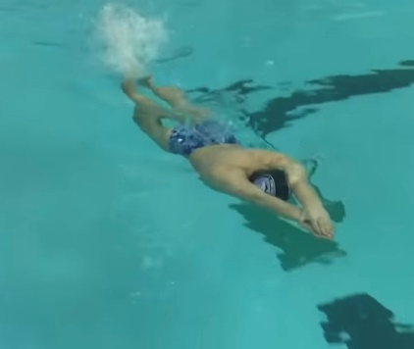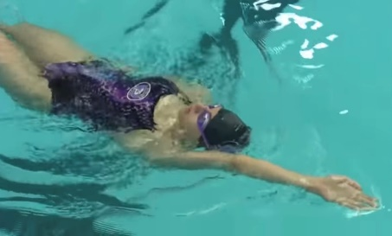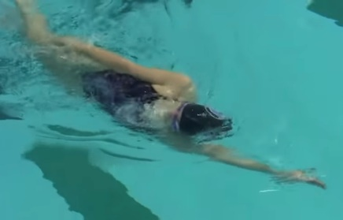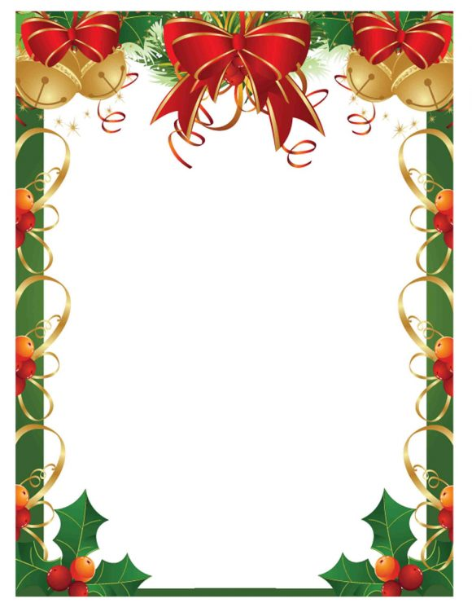

**HOW and WHY?**

Firstly do in streamline body position (above), progress to lateral position (below)

* Start on front and roll onto back then roll back onto front in same direction (don’t go round in circle!)
* 12 kicks on front, roll, 12 kicks on back, roll
* Roll onto lateral arm
* Initiate roll from hips
* Head and arms still
* Engage core to keep body straight
* Continual kick, no pause on roll
* Head positions on front (down + little forward) and back (chin up)
* Keep hips up on both positions

**FC + BK kick body positions + rotations**

**W&DSC**

**Advent Calendar Drills**

**4th December**