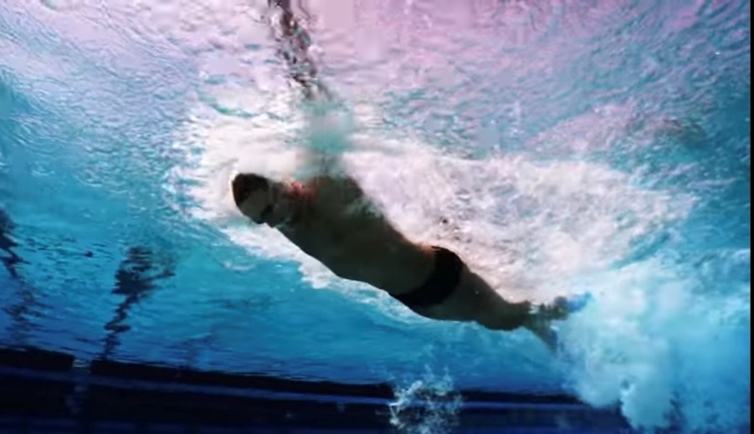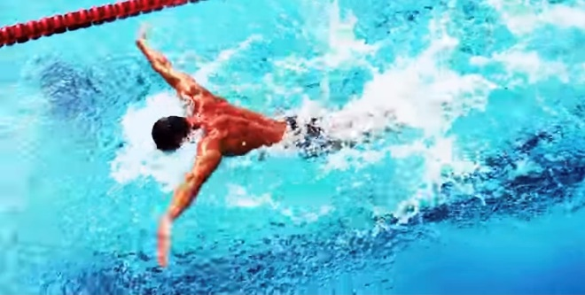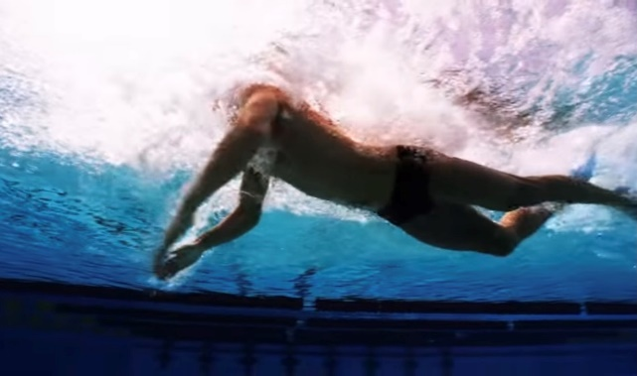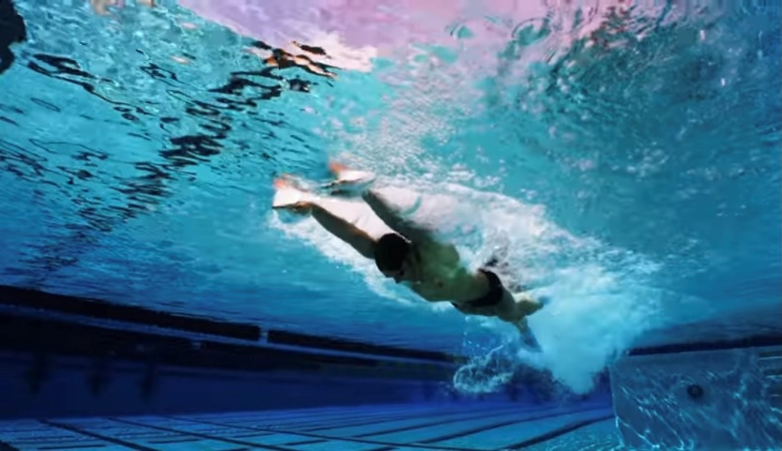

**HOW and WHY?**

**Can wear fins, then progress to no fins**

* Focusses on breathing low to the water
* Continual and fast FC kick
* Continual and fast arm rate
* Breath every stroke
* Chin on water, pull head up through top of head
* Push head down quickly after breath
* Don’t lift chest up to breath
* Positive impact on speed especially of arms and head action after the breath
* Surge forward after breath from FC kick and speed of putting head down
* Strong leg kick

**Butterfly with FC kick**

**W&DSC**

**Advent Calendar Drills**

**5th December**