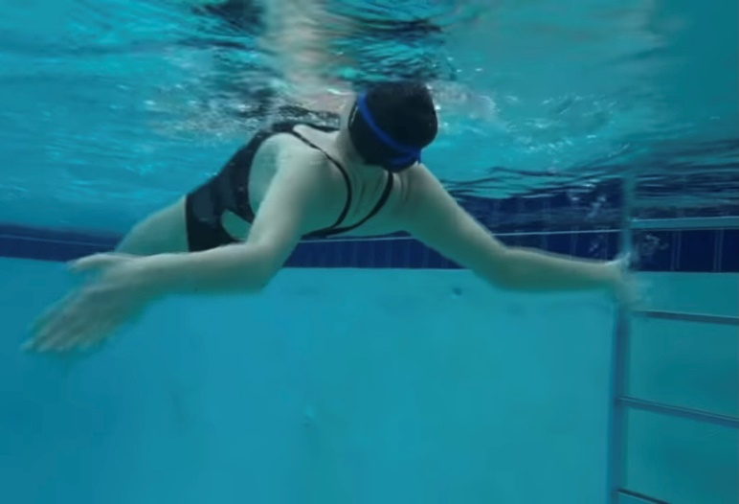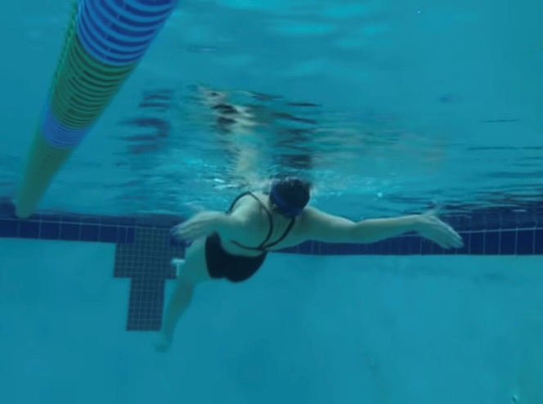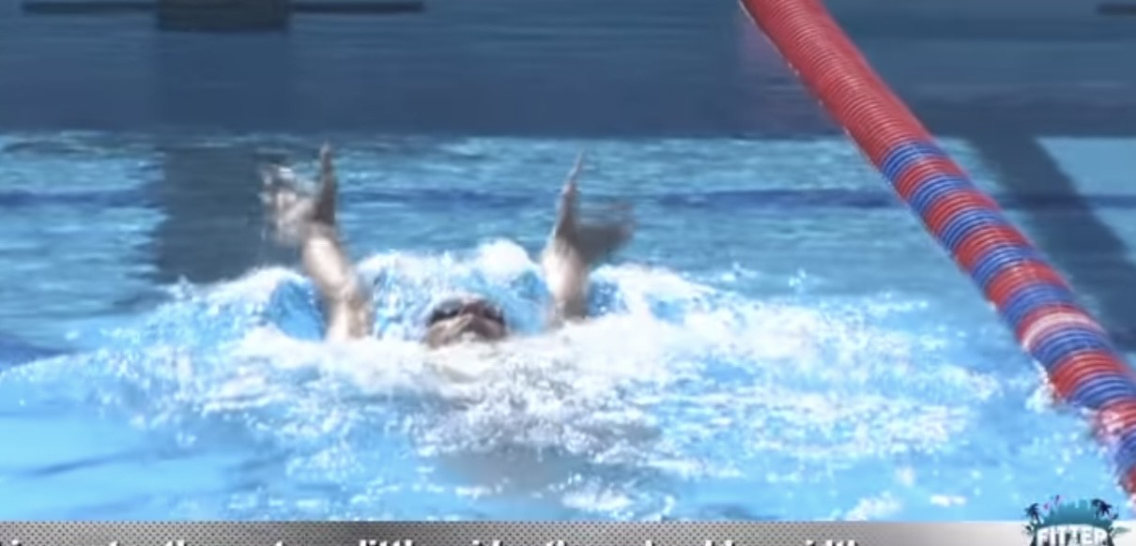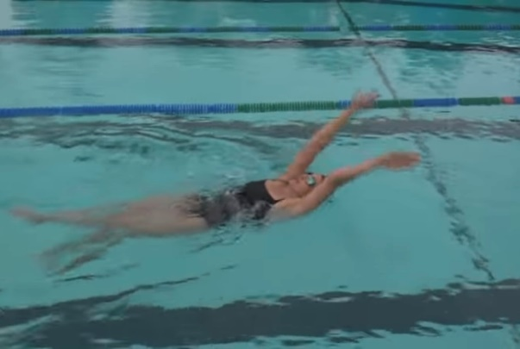

**HOW and WHY?**

* Both arms at the same time and enter water just a little wider than shoulder distance
* Normal BK kick to stay stable
* Works on hand positioning, placement and pull all the way through the stroke
* Shallow pull and parallel to body
* Deep bend in elbows for stronger push
* Palms facing towards feet, finger tips point outwards to side
* There will be no rotation so focus on catch into pull
* Thumbs exit, little finger entry into catch

**Double arm backstroke**

**W&DSC**

**Advent Calendar Drills**

**6th December**