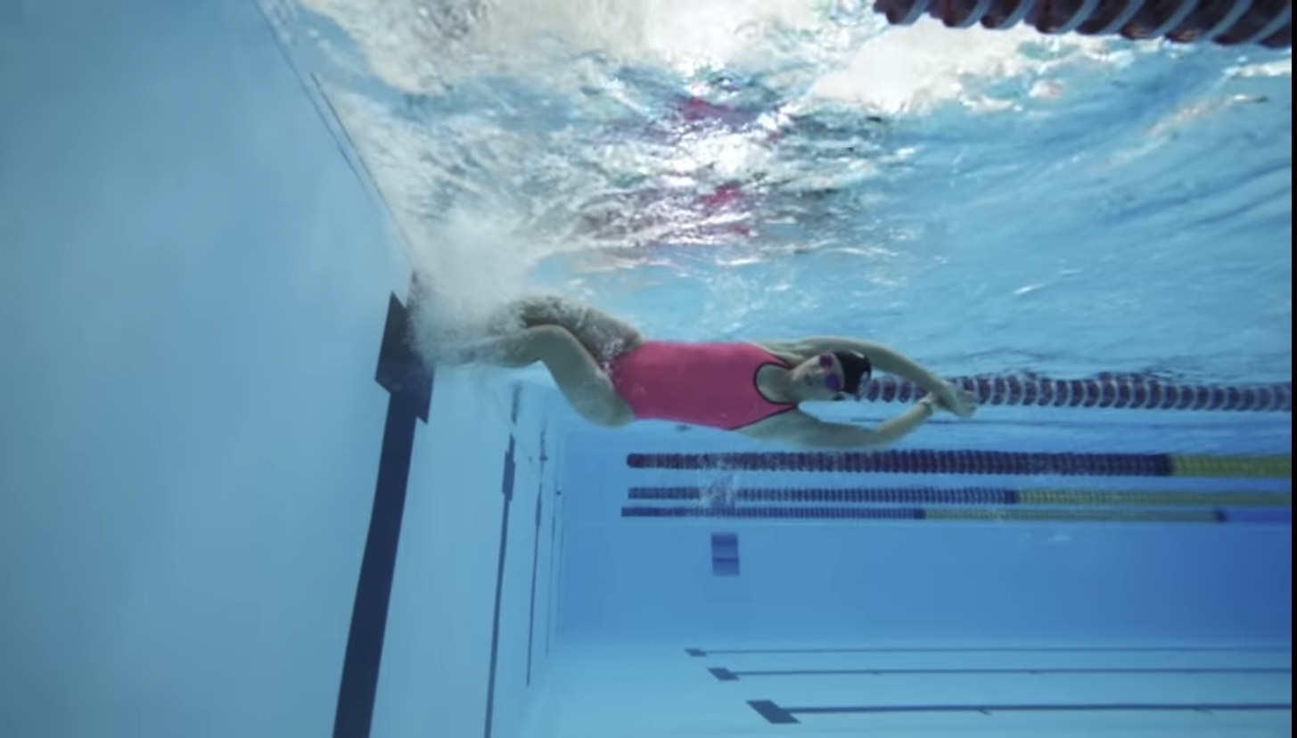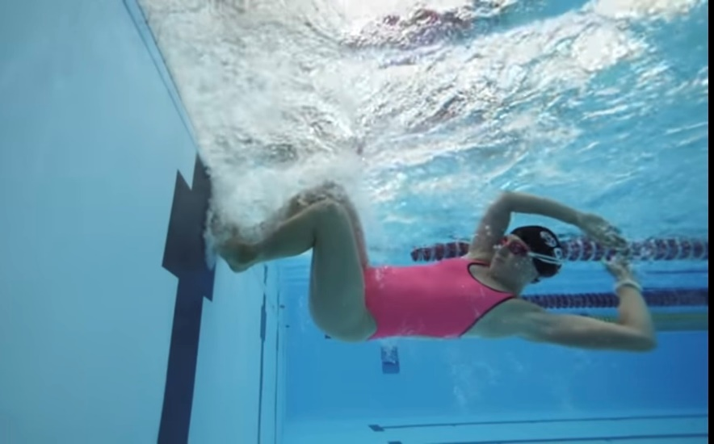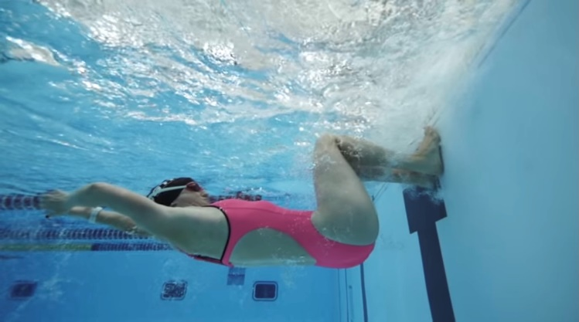

**W&DSC**

**Advent Calendar Drills**

**7th December**

**HOW and WHY?**

* FC and BK turns
* Land feet on wall and hold position on wall (feet stick to wall) for 3 secs before pushing off
* Time to check feet placement and body position
* Gives a stronger push off wall
* Can correct arm position to get into tight streamline
* Knees at 90 degrees

**Sticky Turns**