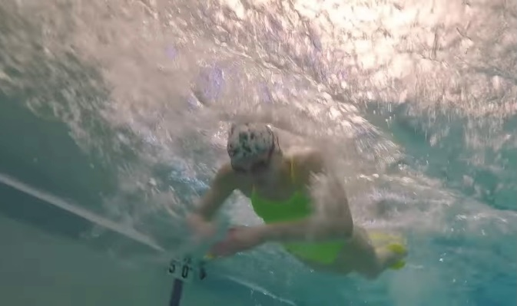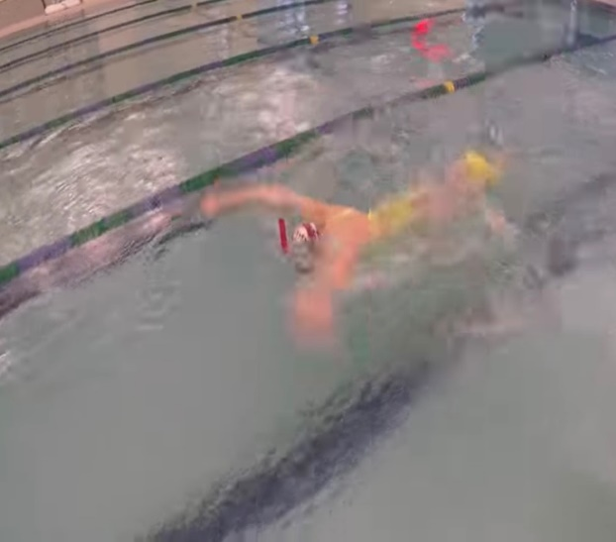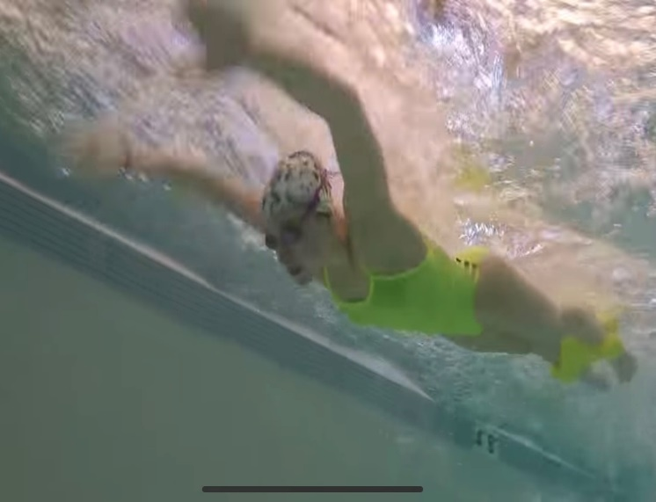

**Power Fly Pull – strength**

**HOW and WHY?**

* Focus on good catch and strong pull
* Keeping head low (can do with snorkel) to keep level
* Accelerate pull through and push back
* Complete whole pull or arms will drag on top of water
* No undulation – keep hips and legs still to focus on pull
* Fine ankle pull buoy the best

**W&DSC**

**Advent Calendar Drills**

**8th December**