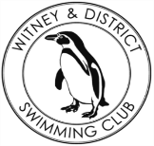**Chantal’s W&DSC Head Coach Highlights April Report 2018**

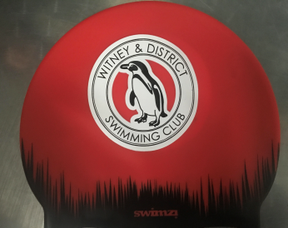

New Witney training hats!

Well done to the Chilterns League rd 3 team!

Came 5th overall in the league

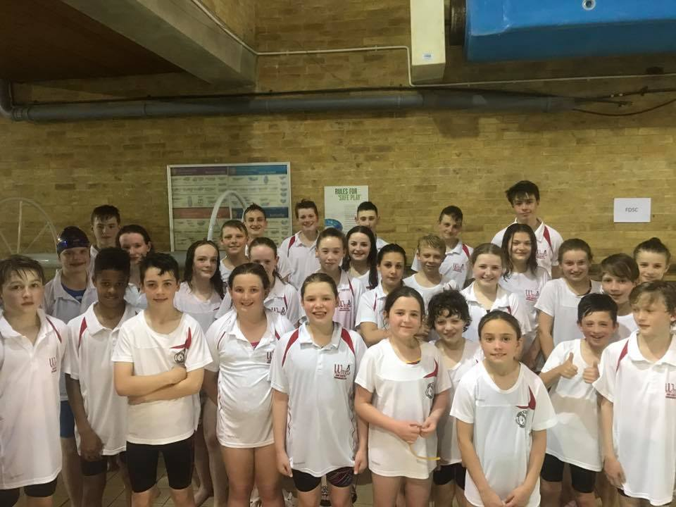

Good luck to the swimmers sitting exams!

**New April Club records:**

**Ella Edwards** – 15/u SC 200mIM

**Jonathan Opalczewski** – 13/u SC 100 IM

**Maya T-S** – 11/u LC 50 BK, FLY, 200 BRS

**Eleanor Perks** – 13/u LC 200m Brs

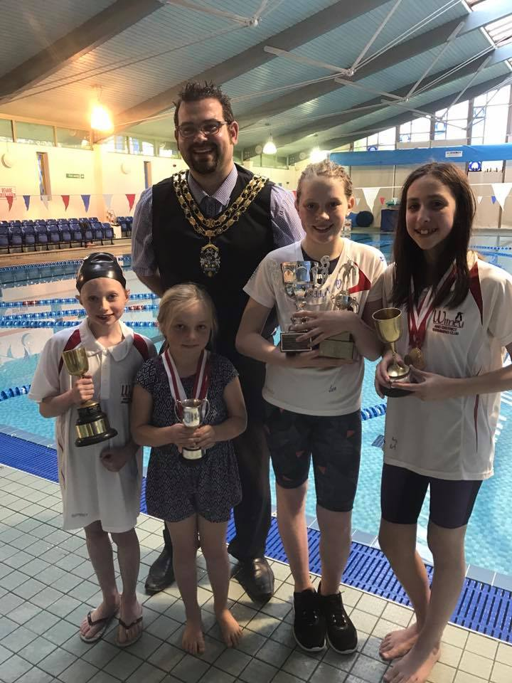

**Diddy Championship finals:**

8 Club champ records, 2 club records, over 140 PB’s!

Well done everyone!

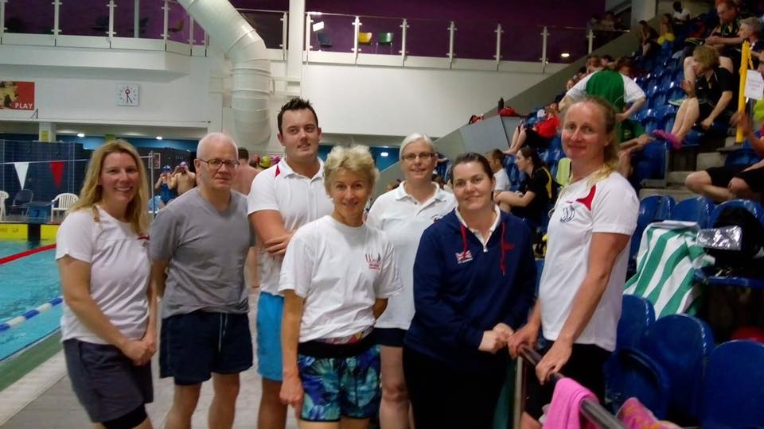

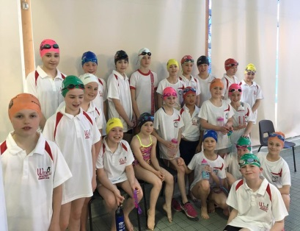

**Swimathon 2018!**

88 swimmers aimed to do 221,000m – but did way more!!

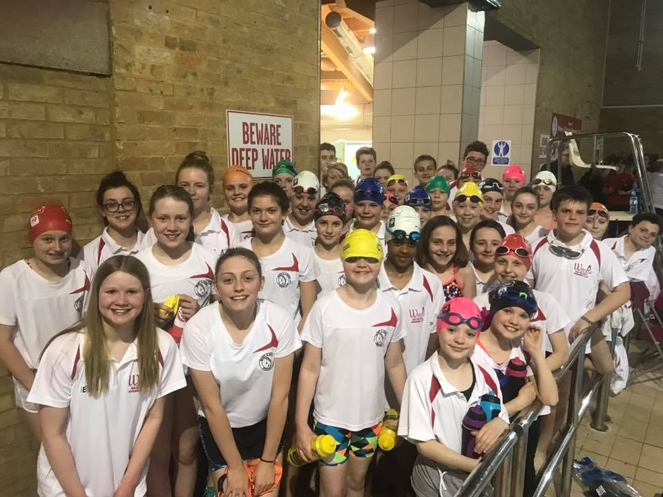

Masters success at Gloucester Open meet!

**Good luck to the following swimmers competing at Swim South East Regionals in May:**

Ella Edwards Eleanor Perks

Lauren Mellings Jessica Miller

Ellie Browne Reuben Coppuck

Maddie Good Erin Stewart

Georgia Duff Jonathan Opalczewski

Ben Kinahan Lucy Howarth

Maya T-S

