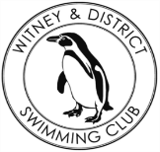**Chantal’s W&DSC Head Coach Highlights**

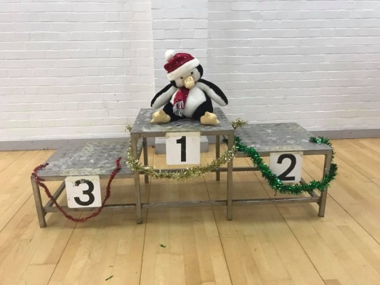 **December Report 2017**

Goodbye and good luck in America to the Khazir family – Malik, Grace, Michelle and Zac

**Success at NAL!**

**6th** Place in Division 2 West Midlands. Best since 2004!

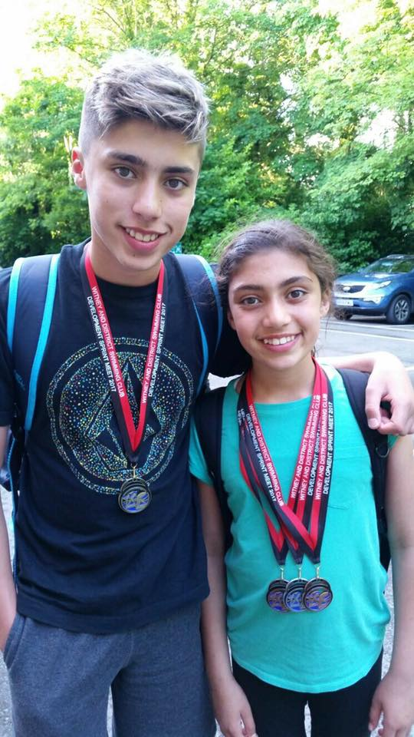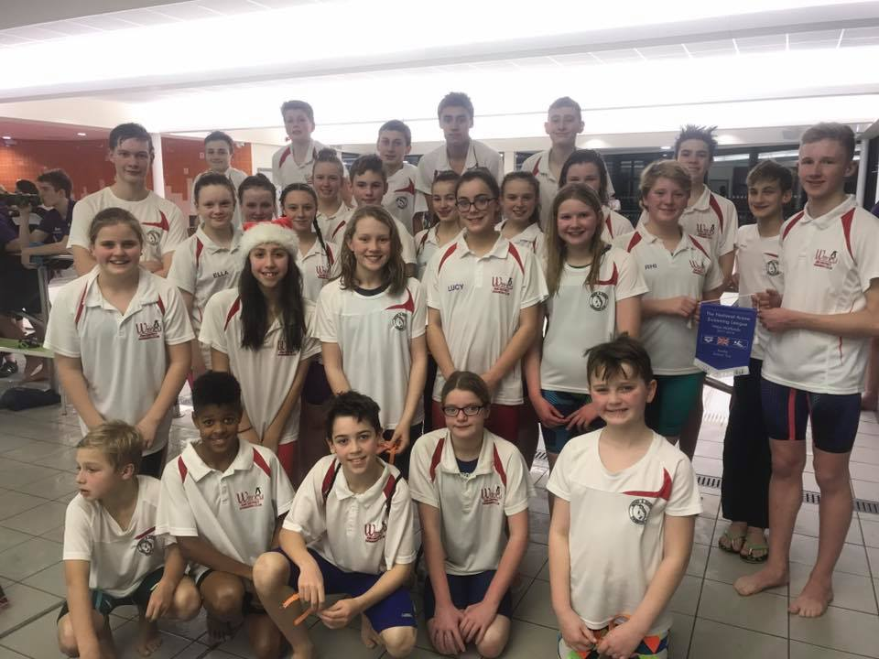

**New Club Relay records:**

**11U 4x50m Medley –** Sienna, Maya, Erin, Sophie

**15U 4x50m FC –** Maddie, Georgia, Ellie, Ella

**15U 4x50m Medley –** Lauren, Ellie, Georgia, Maddie

**Open 6x50m FC –** Maddie, Georgia, Lauren, Ella, Rhi, Ellie

Development day, presentations and Christmas social fun!

Captains Ben and Rhiannon collecting the finalists award

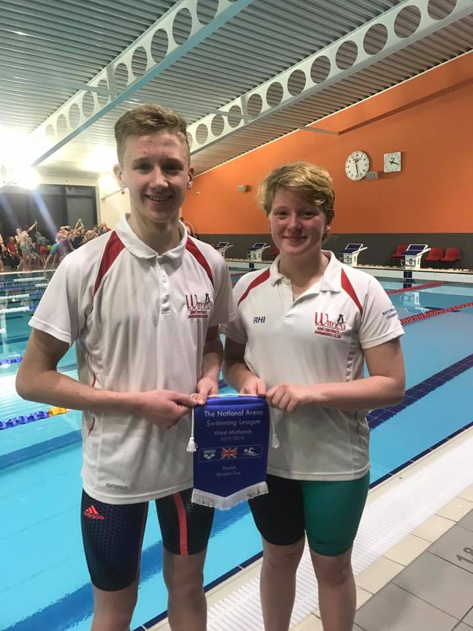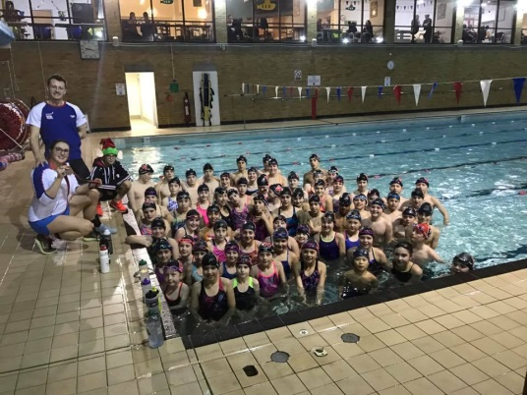

**Good luck at ONB County Distance Events in Jan:**

**1500m FC –** Hugo

**800m FC –** Steffi, Lauren, Camille, Jess, Ella

**400m FC** – Hugo, Dexter, Ellie, Sammy, Camille, Ella, Steffi, Lauren, Jess, Rosie, Eleanor, Sienna, Erin, Maya

**400m IM** – Hugo, Reuben, Ellie, Sammy, Camille, Lauren, Jess, Rosie, Eleanor, Sienna, Erin

