**Chantal’s W&DSC Head Coach Highlights**

**February Report2018**

Medal winners at Wycombe Duel long course meet:

Well done to the swimmers who escaped the snow and made it to Oxford Development meet 4!

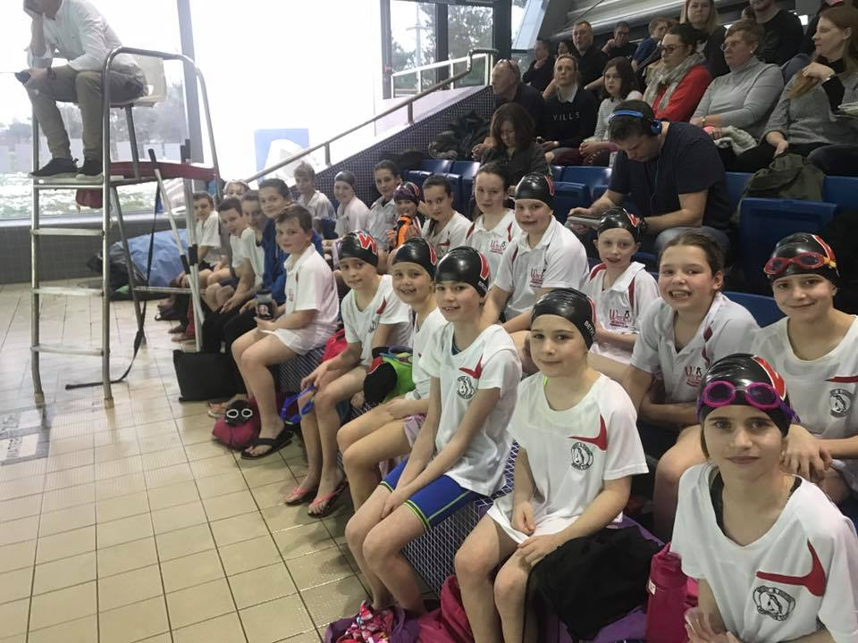

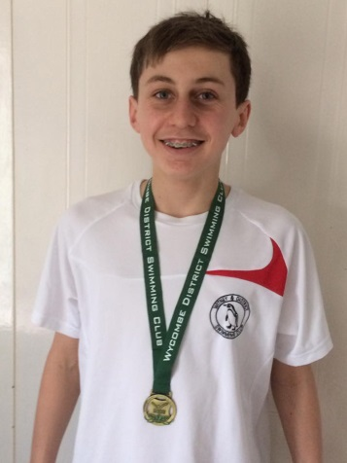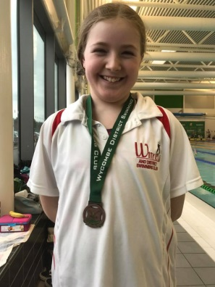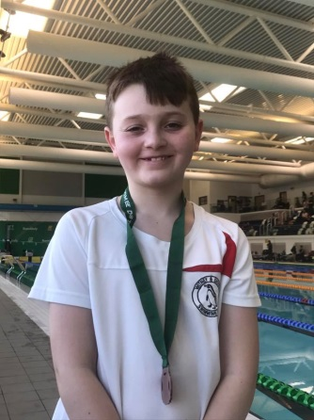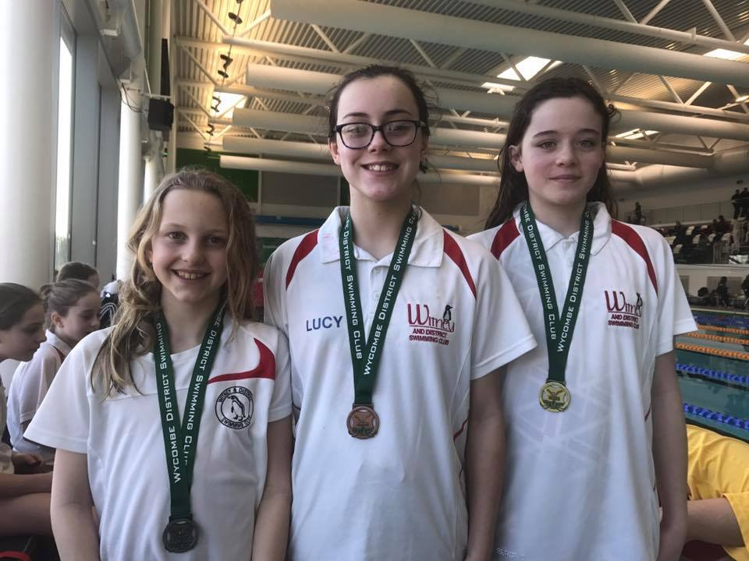

**New Feb Club records:**

**Dexter Townsend** – 9yrs 200m FC and BK

**Hattie Lever** – 9yrs 50m, 100m, 200m FC

**Maya T-S** – 11/u 200m BK

**Lauren Mellings** – 15/u 200m BK

**Georgia Duff** – open 50m BK

**Ben Kinahan** – open 200m IM

**Girls 16/u 4x50m Med relay** – Lauren, Ellie, Ella, Maddie

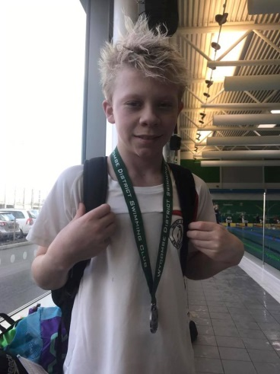

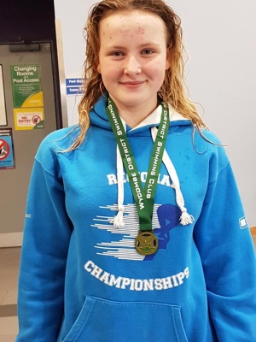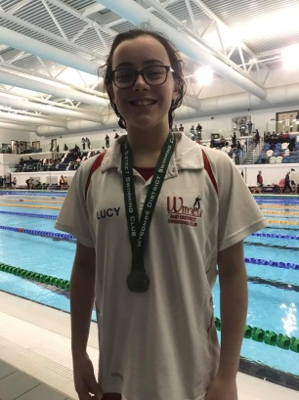

Georgia 2nd Junior ONB Champion in 50m BK

**Club Points at ONB County Championships:**

Every time a swimmer/relay places in the top 8 the club gets team points. The team points is split into 2 sections – Junior which is 10-13yrs and total team from all age groups

**You can see a big increase in points in the last years.**

**Year            Junior 13/u            Total club**

2016               9th  61.5pts            7th 151pts

2017               7th  68pts               9th  150pts

2018               7th  172pts             8th  323.5pts

