**Chantal’s W&DSC Head Coach Highlights FebruaryReport2019**

**Good luck to swimmers in lots of open meet coming up!**

Maxwell 9/10th March

Wycombe 22/24th March

Luton 30/31st March

Oxford Development meet

31st March

Well done to the Chilterns league team at Tiddenfoot LC who won the first round of the league by over 58 points! Second round is 16th March and 3rd round is 6th April. Team photo:



[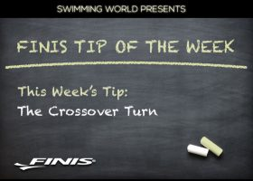](https://www.google.co.uk/url?sa=i&rct=j&q=&esrc=s&source=images&cd=&cad=rja&uact=8&ved=2ahUKEwjizeSL3ofhAhUKA2MBHR2oCuQQjRx6BAgBEAU&url=https://www.swimmingworldmagazine.com/news/finis-tip-of-the-week-the-crossover-turn/&psig=AOvVaw1yzvpxFYGh-0c6m9F7kDH6&ust=1552862532098294)

**Save the date** – Summer social Sunday 20th July

**Well done** to all the academy swimmers in their time trials – gaining more race experience

**Diddy Heats**

Friday 15th March

Sunday 15th March

Windursh Leisure Centre

Plan your swims/warm ups, pack your bag!





**New squads** will start from Monday 1st April

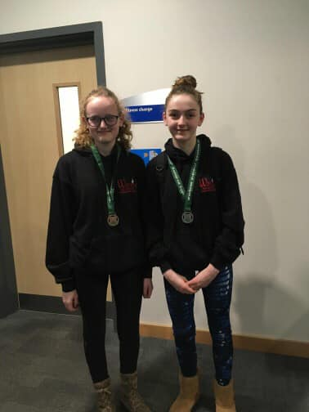

Well done to the swimmers who raced at Wycombe long course meet. Great experience racing in the 50m pool.