**Chantal’s W&DSC Head Coach Highlights January Report2018**

[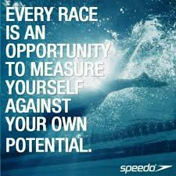](https://www.google.co.uk/imgres?imgurl=https://www.quotemaster.org/images/53/534d65be2e66d0a0ce27caf2c08bbf8f.jpeg&imgrefurl=https://www.quotemaster.org/swimming%2Bcompetition&docid=jkqEaCeNKoIGLM&tbnid=us4ll7cAvvuXoM:&vet=10ahUKEwj62tCG14DZAhVmLMAKHS3CBQEQMwhvKD4wPg..i&w=720&h=720&hl=en&bih=619&biw=1301&q=competitive%20swimming%20quotes&ved=0ahUKEwj62tCG14DZAhVmLMAKHS3CBQEQMwhvKD4wPg&iact=mrc&uact=8)[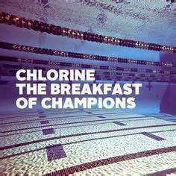](http://www.google.co.uk/url?sa=i&rct=j&q=&esrc=s&source=images&cd=&cad=rja&uact=8&ved=2ahUKEwj8mP_B1oDZAhWhCcAKHYSFCgEQjRx6BAgAEAY&url=http://linkuplink.info/competitive-swimming-quotes/2a6bbcee3423a19104153ccdd44709a5-b009d2734e5cfe85584ed795fcfb7a1d/&psig=AOvVaw0HG3mJyDRLGkVdFglwyNMm&ust=1517435302243525)

Busy month of junior galas and the start on ONB County Championships!

[](https://www.pinterest.com/laurachristine8/swimming/)

**New Club records:**

Dexter Townsend – 9yrs 400m FC

Camille Duff – 13/u 400m FC

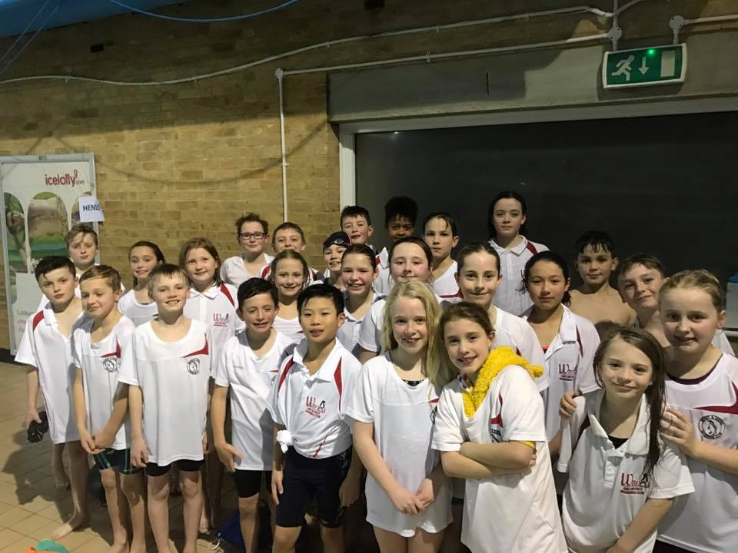

**Good luck at ONB County champs in Feb:**

Irene Aguado

Ellie Browne

Sammy Cartwright

Tia Collett

Reuben Coppuck

Camille Duff

Georgia Duff

Ella Edwards

Katie Franklin

Maddie Good

Lucy Howarth

Hugo Jinks

Rory Jones

Ben Kinahan

Ethan Lefort

Bertie Lever

Hattie Lever

Lauren Mellings

Jessica Miller

Rosie Mullins

Jonathan Opalczewski

Eleanor Perks

Rhiannon Saunders

Sienna Saunders

Erin Stewart

Maya Thorsdottir-Saldana

Dexter Townsend

[](https://www.google.co.uk/imgres?imgurl=http://www.crystalmountainsunspots.com/wp-content/uploads/2016/09/Penguin-cartoon-clip-art-free-clipart-kid.png&imgrefurl=http://www.crystalmountainsunspots.com/cartoon-clip-art-image-30695/&docid=T-aLf0Dv8Sx0WM&tbnid=GAf0U9ofJDETeM:&vet=10ahUKEwj3_63f1IDZAhVsD8AKHeAxCBEQMwiCASg6MDo..i&w=898&h=900&hl=en&bih=619&biw=1301&q=cartoon%20swimming%20penguin&ved=0ahUKEwj3_63f1IDZAhVsD8AKHeAxCBEQMwiCASg6MDo&iact=mrc&uact=8)

Coaches are pleased with training attendance in Jan and strong focus on skills and stroke work.

No evening training Sunday 11th Feb due to Academy time trials

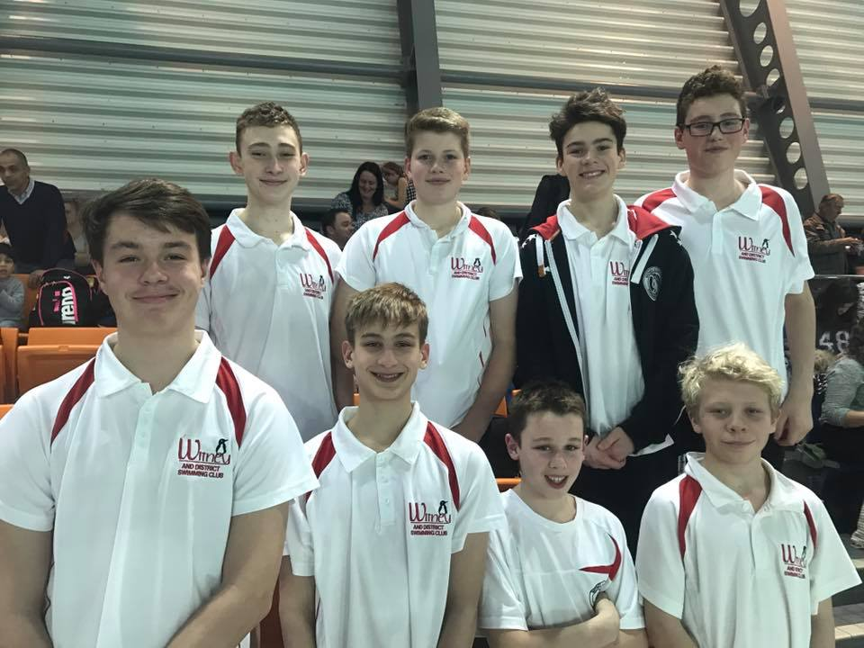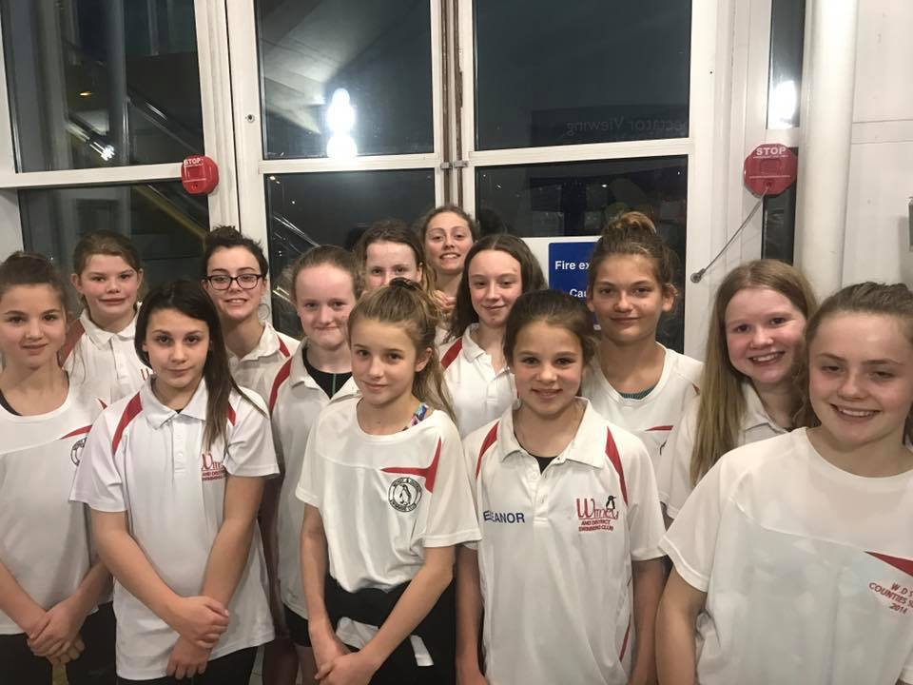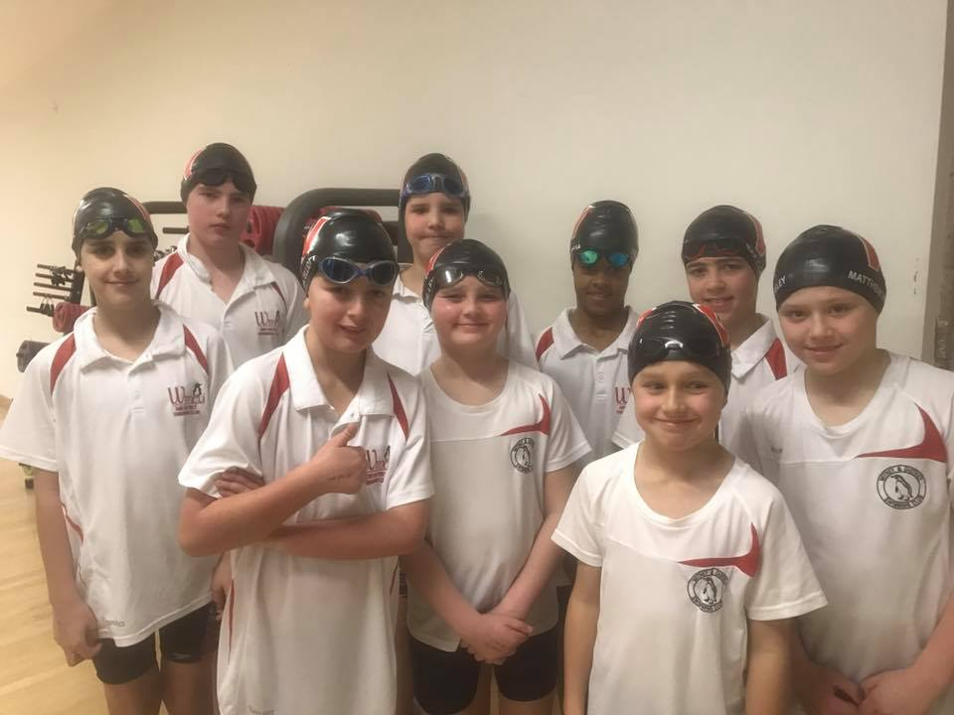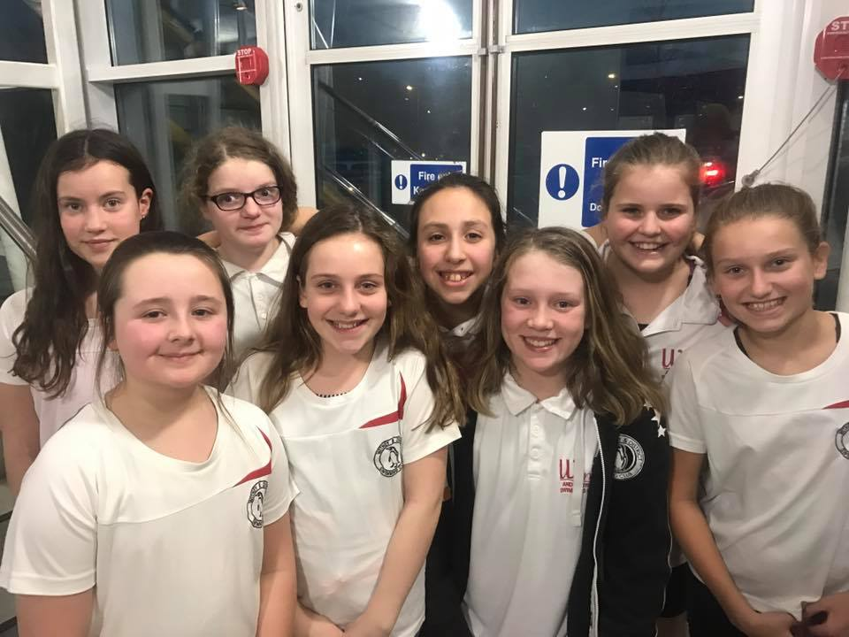

**ONB County age group 11/12 + 13/14yrs relay teams:**