**Chantal’s W&DSC Head Coach Highlights January Report2019**

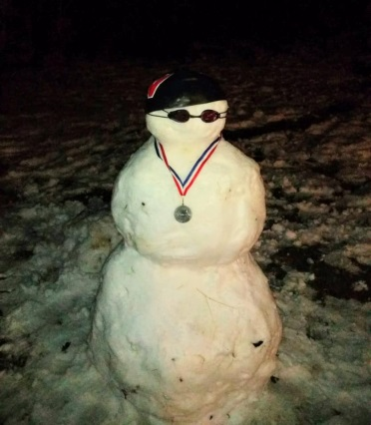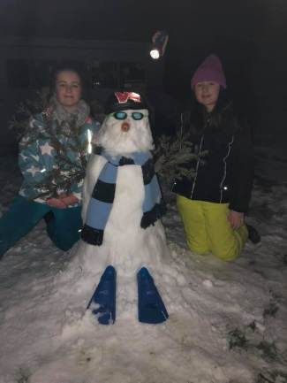[](https://www.pinterest.com/laurachristine8/swimming/)

Busy month of junior gala, Cov OM, and the start on ONB County Champs!

[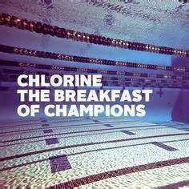](http://www.google.co.uk/url?sa=i&rct=j&q=&esrc=s&source=images&cd=&cad=rja&uact=8&ved=2ahUKEwj8mP_B1oDZAhWhCcAKHYSFCgEQjRx6BAgAEAY&url=http://linkuplink.info/competitive-swimming-quotes/2a6bbcee3423a19104153ccdd44709a5-b009d2734e5cfe85584ed795fcfb7a1d/&psig=AOvVaw0HG3mJyDRLGkVdFglwyNMm&ust=1517435302243525)

[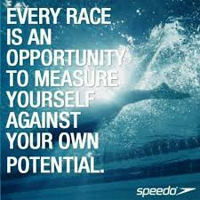](https://www.google.co.uk/imgres?imgurl=https://www.quotemaster.org/images/53/534d65be2e66d0a0ce27caf2c08bbf8f.jpeg&imgrefurl=https://www.quotemaster.org/swimming%2Bcompetition&docid=jkqEaCeNKoIGLM&tbnid=us4ll7cAvvuXoM:&vet=10ahUKEwj62tCG14DZAhVmLMAKHS3CBQEQMwhvKD4wPg..i&w=720&h=720&hl=en&bih=619&biw=1301&q=competitive%20swimming%20quotes&ved=0ahUKEwj62tCG14DZAhVmLMAKHS3CBQEQMwhvKD4wPg&iact=mrc&uact=8)

**Good luck at ONB County champs in Feb:**

Ellie Browne

Ellie Blake

James Bunyard

Sammy Cartwright

Tia Collett

Reuben Coppuck

Georgia Duff

Alice Dyson

Ella Edwards

Katie Franklin

Maddie Good

Lucy Howarth

Hugo Jinks

Sophie Jarvis

Rory Jones

Ben Kinahan

Ethan Lefort

Beth Lefort

Hattie Lever

Lauren Mellings

Jessica Miller

Rosie Mullins

Harriet Mullins

Jonathan Opalczewski

Eleanor Perks

William Phair

Henry Purcell

Cameron Richards

Rhiannon Saunders

Sienna Saunders

Erin Stewart

Maya Thorsdottir-Saldana

Ava White

**Save the date** – Sunday 3rd March – W&DSC Skills development day

[](https://www.google.co.uk/imgres?imgurl=http://www.crystalmountainsunspots.com/wp-content/uploads/2016/09/Penguin-cartoon-clip-art-free-clipart-kid.png&imgrefurl=http://www.crystalmountainsunspots.com/cartoon-clip-art-image-30695/&docid=T-aLf0Dv8Sx0WM&tbnid=GAf0U9ofJDETeM:&vet=10ahUKEwj3_63f1IDZAhVsD8AKHeAxCBEQMwiCASg6MDo..i&w=898&h=900&hl=en&bih=619&biw=1301&q=cartoon%20swimming%20penguin&ved=0ahUKEwj3_63f1IDZAhVsD8AKHeAxCBEQMwiCASg6MDo&iact=mrc&uact=8)

**Congratulations County top 8 positions in 400’s:**

Eleanor, Jess, Ellie, Erin, Sienna, James, Hattie, Katie, Maya, Ellie, Lauren, Reuben

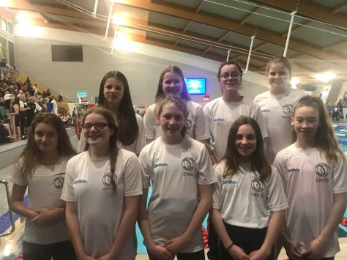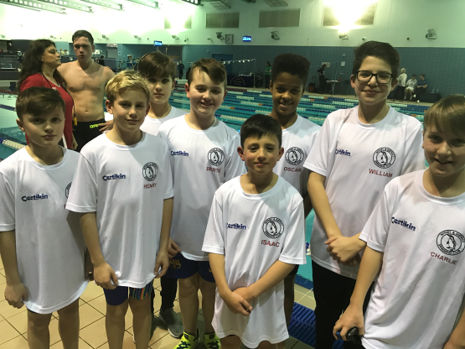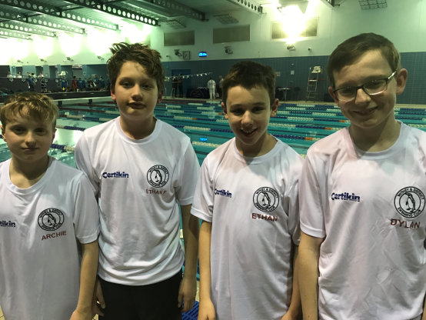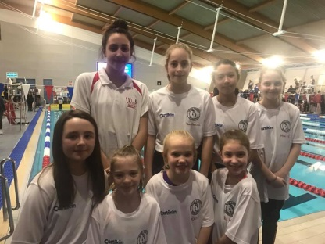

No evening training Sunday 17th Feb due to Academy time trials

**ONB County age group 10-12 + 13/14yrs relay teams:**