**Chantal’s W&DSC Head Coach Highlights July/Aug Report 18**



**W**

**E**

**L**

**C**

**O**

**M**

**E**

**B**

**A**

**C**

**K**

**New July/Aug Club records:**

Ella Edwards – 15/u LC 100 Fly

Jess Miller – 13/u LC 400 FC

Well done to swimmers who got their exam results!

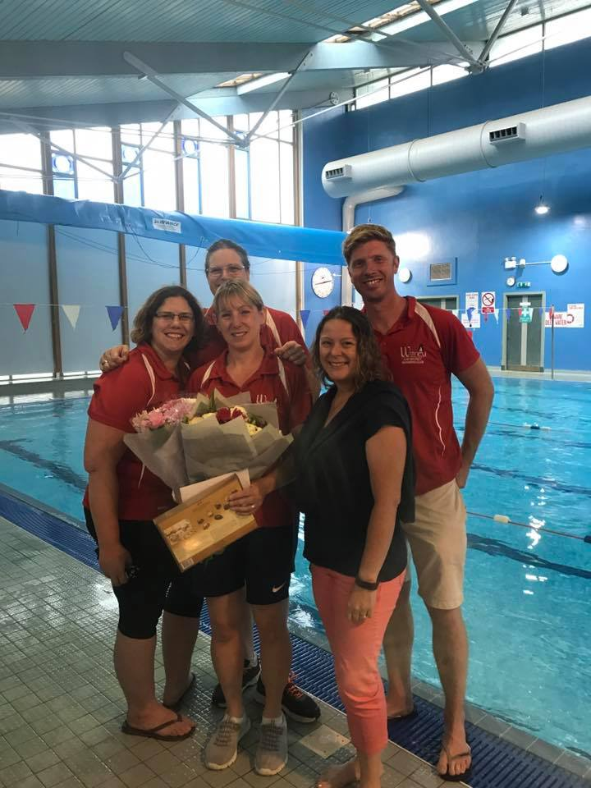

Thank you Michelle! We will miss you lots!

**Good luck back at school!** Remember to plan your homework and food ready for training

Make sure all swimmers have all correct equipment and spares (hats googles, swim kit) ready for the new season! Plus land training kit for pre pool which is 10mins before pool training!

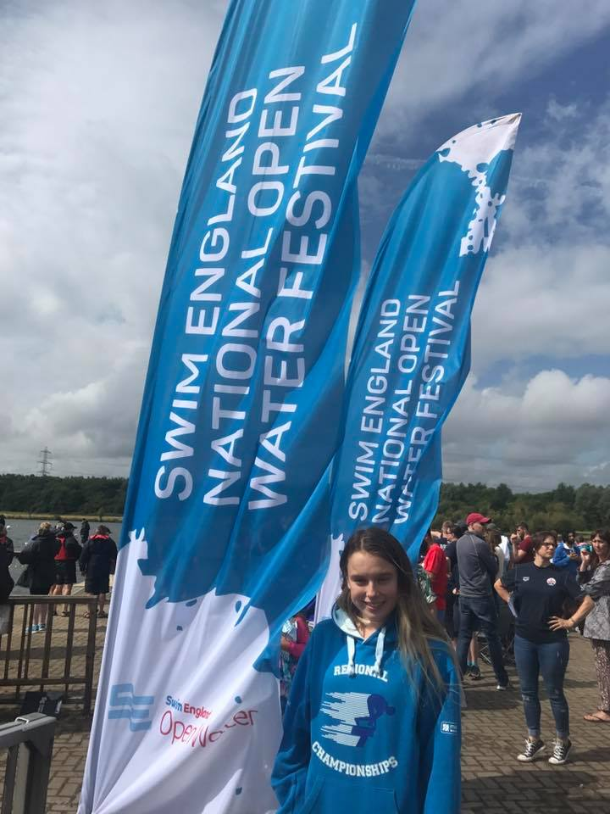

**Well done** to Maddie at English Open water Nationals – 23rd in the 16yrs 5k

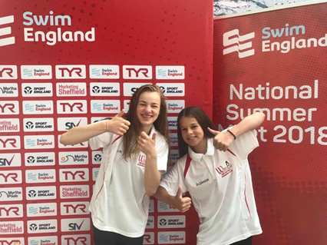

[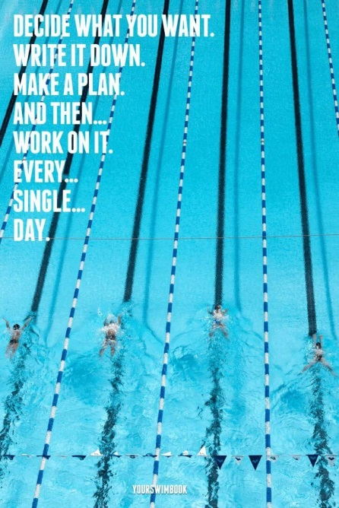](http://www.google.co.uk/url?sa=i&rct=j&q=&esrc=s&source=images&cd=&cad=rja&uact=8&ved=2ahUKEwjo9YXYspjdAhVOhxoKHREZA1UQjRx6BAgBEAU&url=http://vintageposterdesigns.com/swimming-posters-motivational/swimming-posters-motivational-d7bf43bbf1fc13997b30c80cab165012-triathlon-quotes-triathlon-motivation/&psig=AOvVaw1GQ5YHd_GWfXfairIQpZtH&ust=1535842805740947)

**Well done** to Jess and Ella at Welsh summer nationals!

**Ella** 50m BRS – 12th

100m FLY – **FINAL** 5th

200m FLY – **FINAL** 6th

200m IM – 11th

50m FLY – 12th

**Jessica**  400m FC –12th

200m FC –12th

100m FC –11th

100m BK – 11th

200m IM –25th

**Well done** to Ellie and Eleanor at English Summer nationals!

**Eleanor** 100m BRS – 18th

200m BRS – **FINAL** 7th

**Ellie** 200m BRS – 15th

[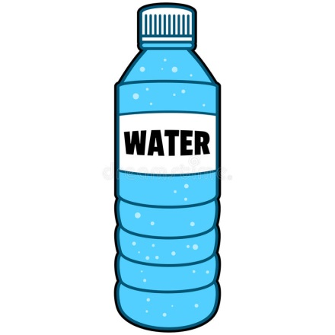](https://www.google.co.uk/url?sa=i&rct=j&q=&esrc=s&source=images&cd=&cad=rja&uact=8&ved=2ahUKEwjRztKVs5jdAhUOxIUKHcDjAJYQjRx6BAgBEAU&url=https://www.dreamstime.com/stock-illustration-bottle-water-cartoon-illustration-image53675001&psig=AOvVaw0dHEo967Lp_YXSi4CD4q8y&ust=1535842973946143)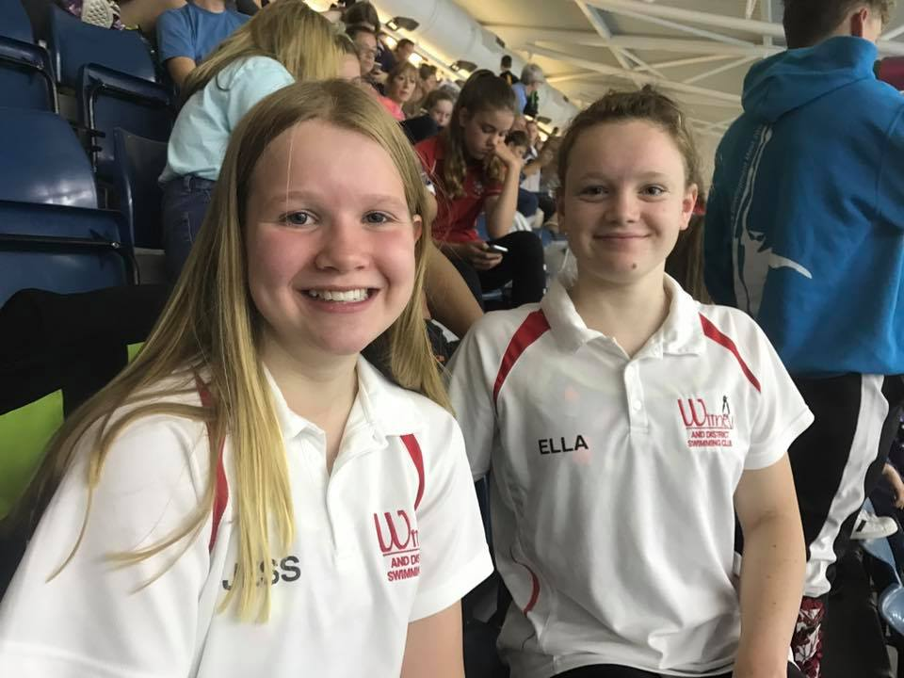

**Don’t forget NAL dates:**

**Sat 14th Oct**

**Sat 10th Nov**

**Sat 8th Dec**

**Let’s go A team!!**

**Club champs are 21 -24th Sept and 28 – 1st Oct. Good luck!**