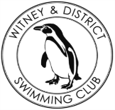**Chantal’s W&DSC Head Coach Highlights March Report 2018**

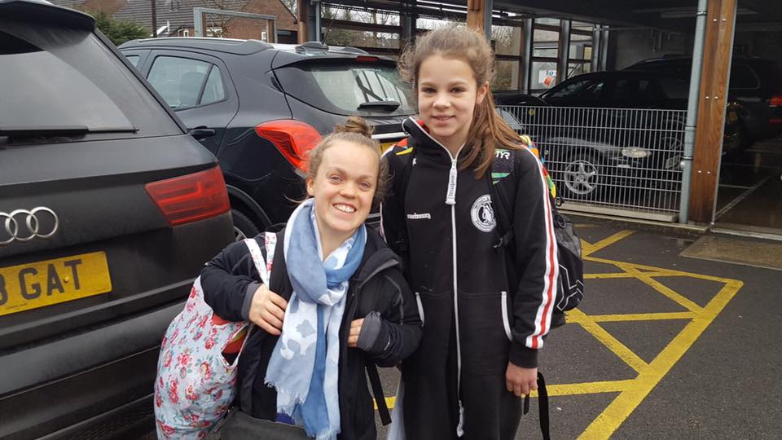

Well done to Georgia, Camille, Jess, Lauren and Ella who competed at Scottish and Welsh National championships at Easter

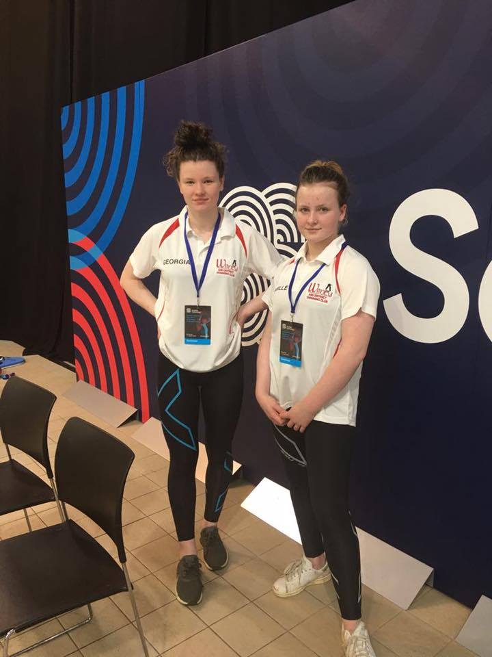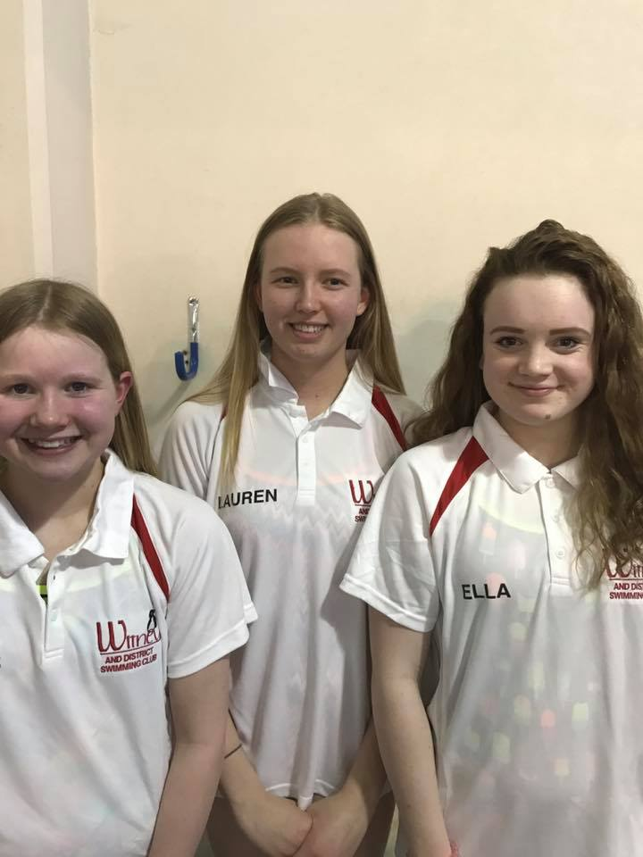

Well done William for his medals and PB’s at GB Deaf Gala

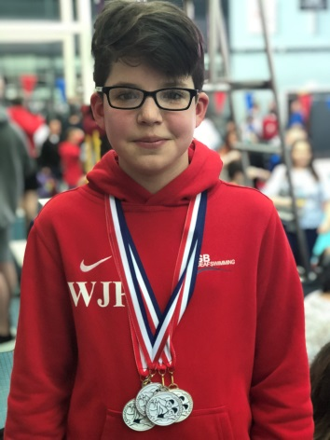

Eleanor meets Ellie Simmonds at Wycombe meet!

**New March Club records:**

**Eleanor Perks** – 13/u LC 200m BRS

**Jonathan Opalczewski** – 13/u SC and LC 50m Fly

**Hattie Lever** – 9yrs LC 200m IM, 100 BK, 100 FC

**Camille Duff** – 13/u LC 200m FLY

**Hugo Jinks** – 15/u LC 1500m FC

**Lucy Howarth** – 13/u LC 100m FLY

**Jessica Miller** – 13/u LC 400m FC



**Swimming starts 5th April!**

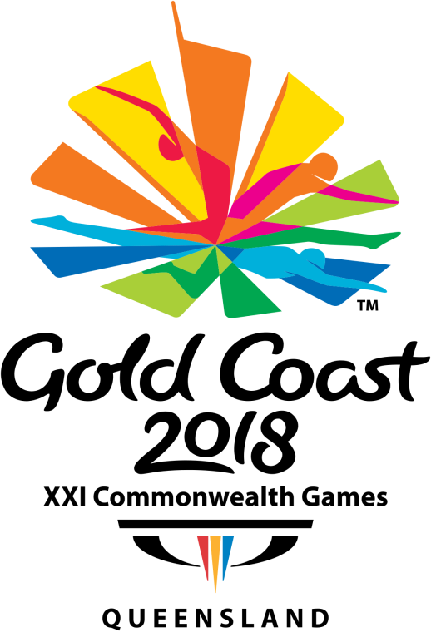

**Coaches are happy with…….**

**Swimmers mind set to work hard and push themselves to be better and stronger.**

**Keep working on…..**

**Strong SL fly kick!**

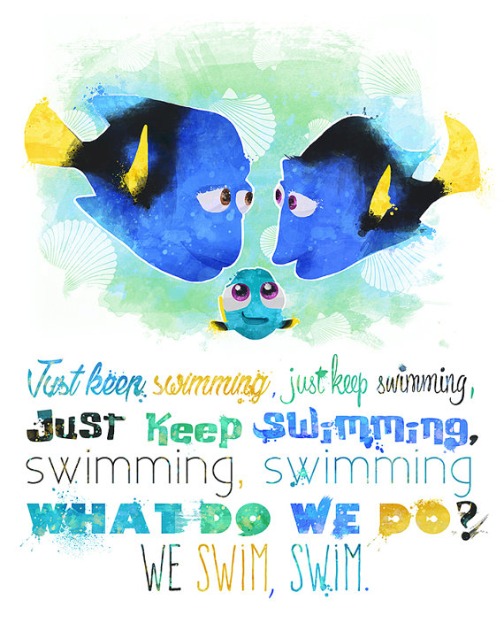

**Diddy Championship records:**

**Dexter Townsend –** 100 IM, 50 FC, 50 BK

**Katie Frankin –** 100 IM, 50 FLY, 50 FC, 50 BK

**Bertie Lever –** 100 IM

**Maya T-S –** 100 IM, 50 FLY, 50 BK

**Swimming starts 5th April!**