**Chantal’s W&DSC Head Coach Highlights March Report2019**

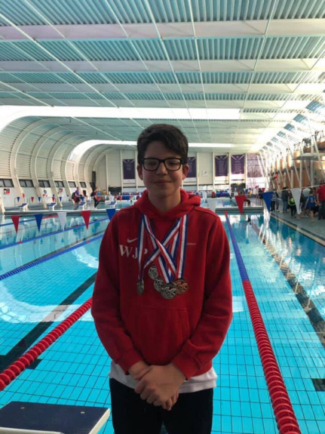

Well done William for his 4 medals at GB Deaf Gala in Loughborough

**Time Trials 2019** **Schedule**

**Friday 10th May *7 - 9pm WLC***

400m FC or 400m IM

**Friday 17th May *7 – 9pm WLC***

200m Breaststroke

**Sunday 19th May *9 – 10.30am CLC***

200m Backstroke

**Sunday 19th May *5.30 – 7.30pm WLC***

200m Frontcrawl

**Monday 20th May** *7.30pm WLC onwards*

200m Butterfly

All swimmers from AGE 1,2,3, YOUTH 1,2,3 must attend.

Performance swimmers are to also attend but will do a race pace on their form 200m.

**Sunday 7th July**

***4.30 – 6pm WLC***

Academy 1,2,3 – All strokes & 100m IM

Development 1,2,3,club – 100m IM (if wish to do 200m IM then arrive at for 6pm session)

***6 – 7.30pm WLC***

Age Group/Youth – 200m or 400m IM



Good luck to all sitting GCSE’s

Great fun was had by all at the development day with Amy Smith and Joe Roebuck

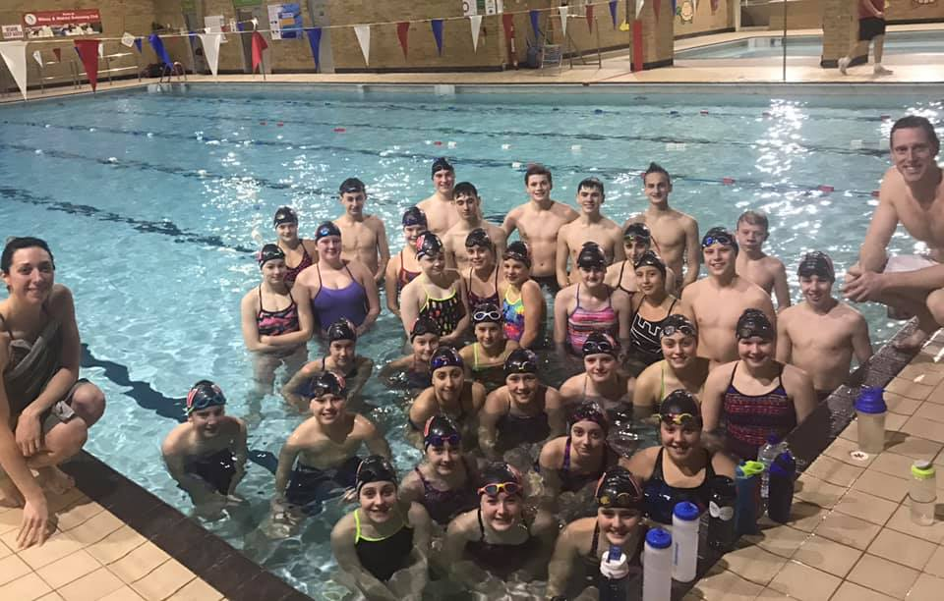

Well done to William winning 3 medals at the BD deaf gala at Loughborough

**New records broken in March:**

**Diddy Championship records from heats:**

Henry Purcell 10yrs - 50 BK and 100IM

William Phair 12yrs- 100IM, 100BK and 100FLY

Maya Thorsdottir-Saldana  12 yrs - 100FLY

**New Short Course club records:**

Henry Purcell - 9yrs 100m IM at Diddy Heats

**New Long Course club records:**

**Wycombe L1:**

James Bunyard  50BRS and 100FS - Open

Jessica Miller     800FS - 13U, 15U, Open

                           200FS - 13U

Eleanor Perks     50BRS - 13U, 15U, Open

                           100BRS - 13U, 15U, Open

                           200BRS - 13U, 15U, Open

                           200IM - 13U, 15U

                           400IM - 13U, 15U, Open

**Luton L1:**

James Bunyard   200FS Open

Lucy Howarth      100FLY 13U

Jessica Miller      1500FS 13U, 15U, Open

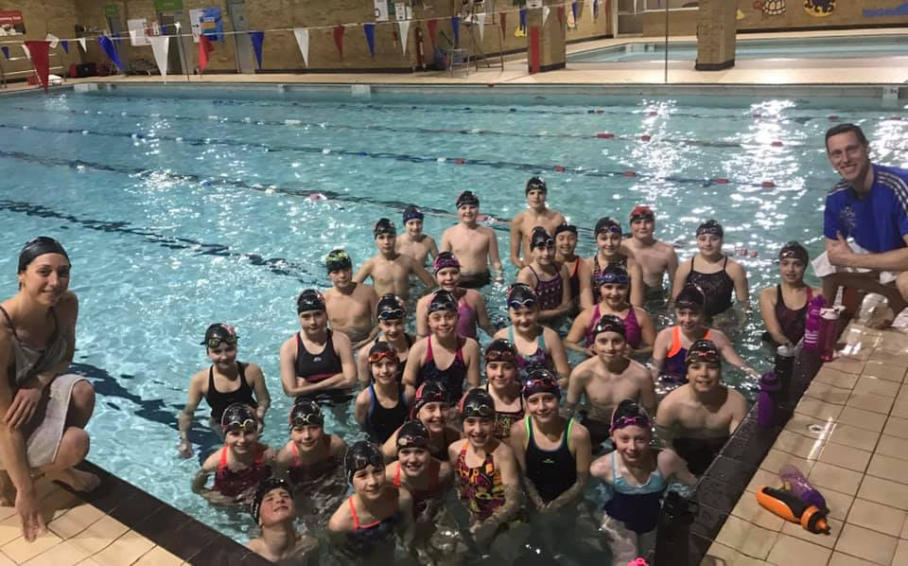

Level 1 meet medal winners in March

