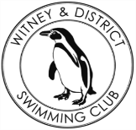**Chantal’s W&DSC Head Coach Highlights**

**November Report 2017**

**3rd place at NAL rd 2 means finals for RD3!!**

Ranked 6th Div 2 West Midlands

**Blan’s success at Irish Masters Nationals:**

**Club championship finals fun!**

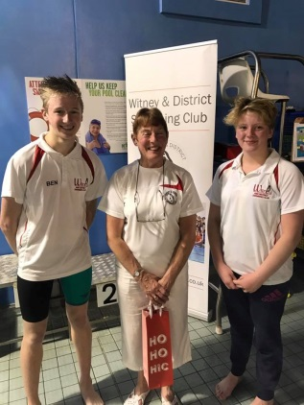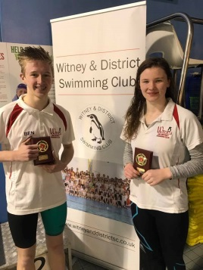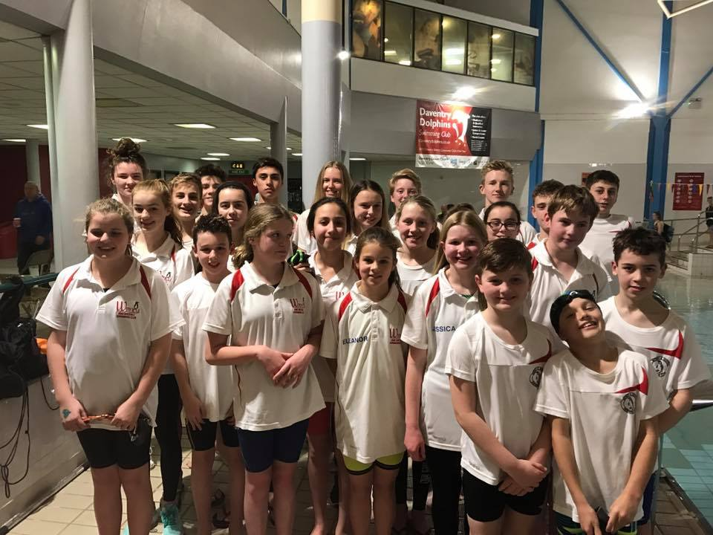

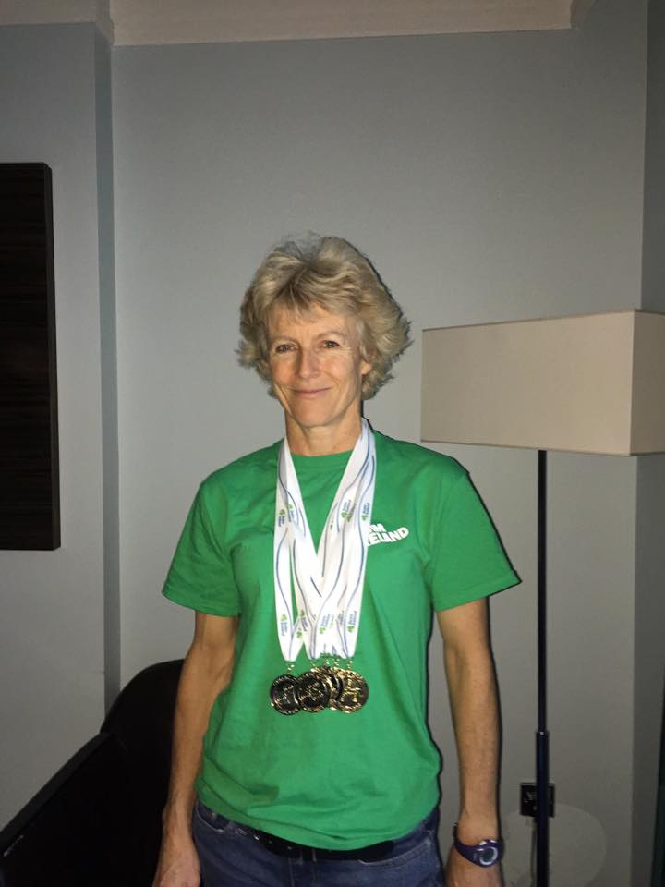

Skins winners – Georgia + Ben

Captains Ben + Rhiannon with Mayor Chris and Club president Chris James

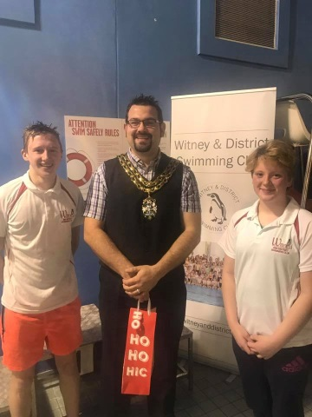

**New Club Championship records:**

Jonathan – 100 BK Malik – 100 FLY + FC

Georgia – 200 IM + 100 BK Reuben – 100 BRS

Jessica – 100 FC Camille – 100 FLY

Erin – 100 BK Ella – 100 FLY

**New club record:** Hugo – 1500m FC

**New Club relay record:**

Lauren, Ellie, Georgia and Maddie – 15/u 4x50m Medley

OVER 110 PB’S at Club Championship finals!!!

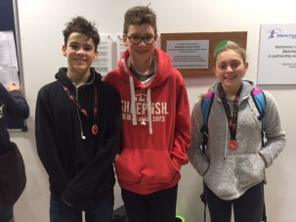

[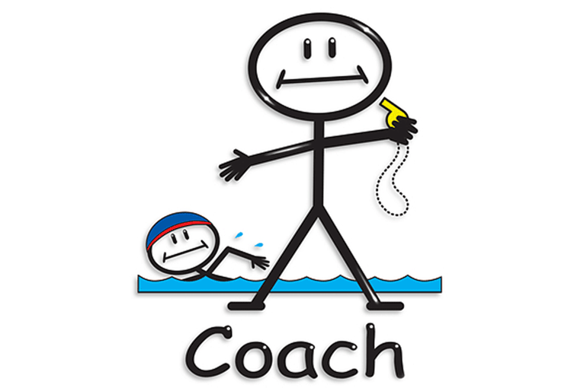](http://www.google.co.uk/url?sa=i&rct=j&q=&esrc=s&source=images&cd=&cad=rja&uact=8&ved=0ahUKEwj94uTz8-TXAhUKD8AKHeWHALoQjRwIBw&url=http://www.londonswimming.org/coaches/coaches-forum&psig=AOvVaw1kZgeKHnvmWabHWTc528IK&ust=1512083414757959)

**Winter Regionals Success!**

Georgia, Ben, Ellie, Maddie and Lauren

**Coaches are really happy to see great progress this month on those important processes – strokes, turns, starts, finishes, streamlining……..**

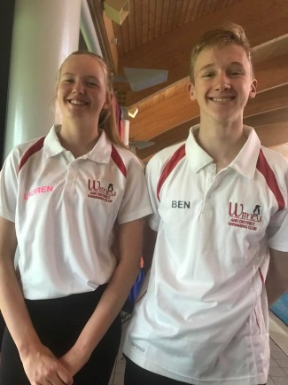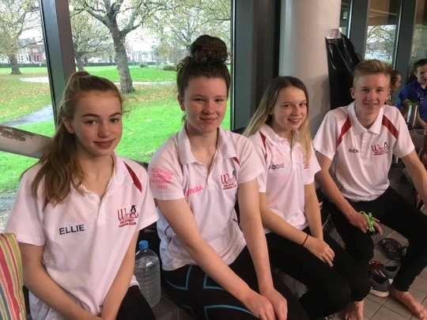

[](https://www.google.co.uk/url?sa=i&rct=j&q=&esrc=s&source=images&cd=&cad=rja&uact=8&ved=0ahUKEwjo_sH58eTXAhXLCsAKHclWANYQjRwIBw&url=https://avante.biz/christmas-cartoon-wallpapers-67-wallpapers/&psig=AOvVaw19_sadnRAyMJxh59kQ4T8n&ust=1512082880681223)

Don’t forget to ask Santa nicely for your swimming Christmas presents!

**Sunday 17th December**

* Development Day
* Christmas social
* Penguin Draw
* Club Championship presentations
* Food and Fun!!!