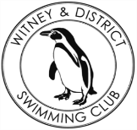**Chantal’s W&DSC Head Coach Highlights Nov+Dec Report 18**

**Good luck ONB Distance events!**

**1500m FC** – Hugo, Sammy, Jess

**400m FC** – Ethan, Reuben, Jonathan, Hugo, James, Katie, Hattie, Ellie, Maya, Erin, Sienna, Harriet, Jess, Eleanor, Sammy, Rosie, Ellie, Lauren, Steffi

**400m IM** – Erin, Sienna, Harriet, Eleanor, Jess, Sammy, Rosie, Ellie, Ethan, Reuben, Hugo, Cameron

**New Club records:**

Jess Miller 13/u 800 + 1500m FC , Maya T-S - 11/u 50m Brs / Eleanor Perks - 13/u 100m Brs , 13/u 4 x 50m Medley relay - Jess, Lucy, Erin and Eleanor, Hugo Jinks 15/u 1500m FC, Sienna Saunders (11/u 100m Bk), Maya T-S (11/u 100 + 200 Brs), Eleanor Perks (13/u 100m Brs) , Henry Purcell (9/u 200m Bk)

New club championship records from finals – James Bunyard, Ben Kinahan, Maya T-S, Jess Miller, Lucy Howarth, Eleanor Perks, Georgia Duff

New club records from club champ finals – Henry Purcell, Ben Kinahan, Maya T-S, Jess Miller, Eleanor Perks



**Club championship finals**

Skins winners – Georgia, Ben + James

13 CCR’s and 6 CR’s

**ONB County Champs**

34 swimmers

28 relays

231 individual swims

**Happy**

**New**

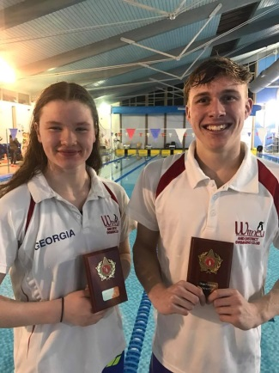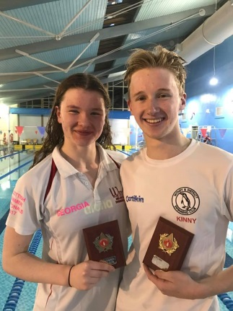 **Year! Year!**

**Club championship finals**

Ella and Jess both competed in a range events with Ella achieving a final in the 200m Fly and Jess silver medal (and welsh champion) in 1500m FC

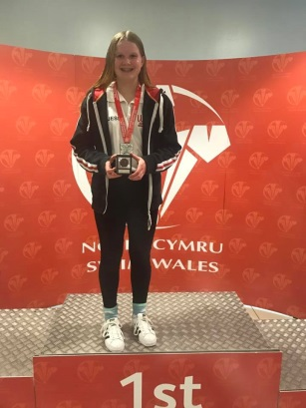

**Winter regionals results**

Ella, Ben, Georgia and Maddie all competed in the

open Swim

South East

Winter regionals.

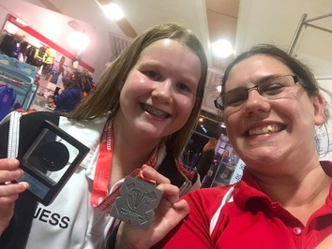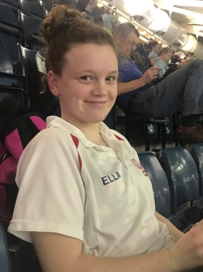

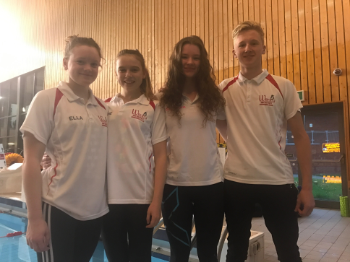

**Georgia at Scottish SC Nationals in Edinburgh**

Moving up rankings and 2 PB’s in 100 BK and 50 Fly

**National Arena League success!!**

**Coming 4th in final round we are now in**

**Division 1 for 2019!**

