******Chantal’s W&DSC Head Coach Highlights**

**October Report 2017**

Masters with Kerri-Anne Payne

**8th in DIV 2 after round 1 of NAL!!**

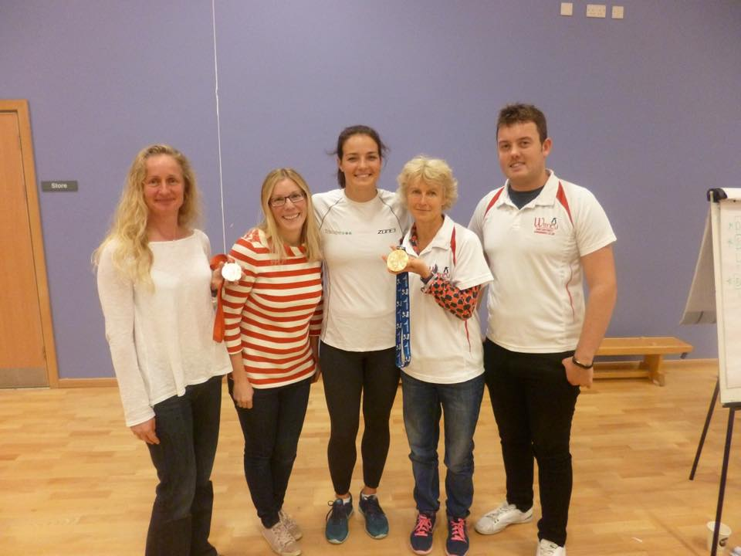

**Congratulations to Record Breakers:**

**Dexter Townsend – 9/u 400m FC**

**Open 6x50m FC girls relay team – Maddie, Georgia, Lauren, Ella, Rhiannon, Ellie**

**Swim Camp fun!**

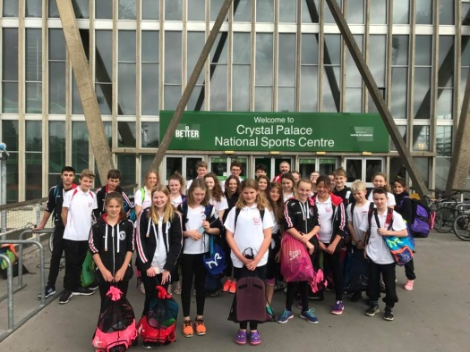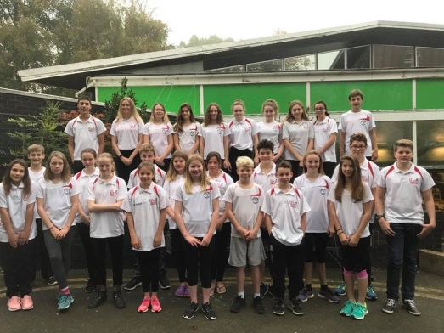

Happy Halloween!!!!



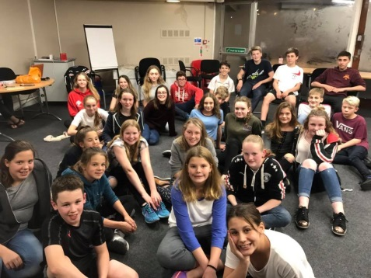

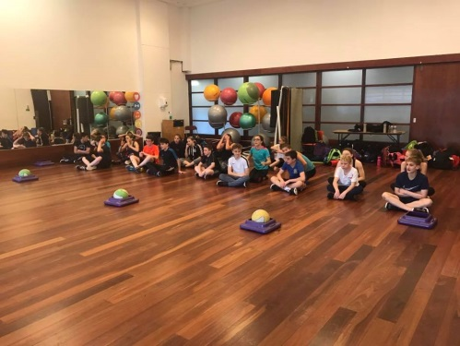

ONB County development day!

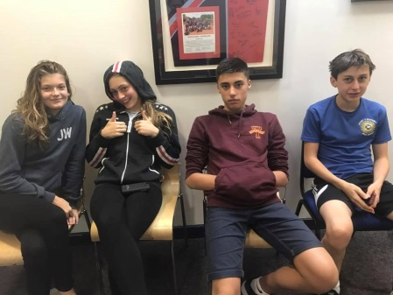

**Oxford Development meet 1**

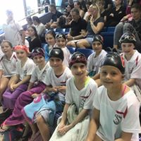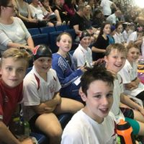

[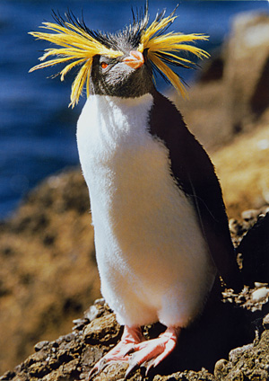](https://www.google.co.uk/url?sa=i&rct=j&q=&esrc=s&source=images&cd=&cad=rja&uact=8&ved=0ahUKEwjnj4yimrXXAhXPFsAKHeB8AW0QjRwIBw&url=https://www.pinterest.com/pin/307792955756653187/&psig=AOvVaw3Yo2IxJfvdkJKUHUk21ei0&ust=1510444392415357)

**Chantal’s favourite penguin of the month………**

**ROCKHOPPER! GOOD LUCK at Club championships finals in Nov!**

**Did you know…..**

The fastest penguin is the Gentoo up to 22mph