**Chantal’s W&DSC Head Coach Highlights Oct Report 18**

**New October/Nov Club records:**

Distance meet - Jess Miller 13/u 1500m FC

NAL RD 1 - Maya T-S - 11/u 50m Brs / Eleanor Perks - 13/u 100m Brs

                 13/u 4 x 50m Medley relay - Jess, Lucy, Erin and Eleanor

**NAL RD 2 Gala** - Girls 13/u 4 x 50m Medley Relay – again!

**W&DSC distance meet** - Jess Miller (13/u 800m FC) and Hugo Jinks (15/u 1500m FC)

**Cardiff open meet** - Sienna Saunders (11/u 100m Bk), Maya T-S (11/u 100 + 200 Brs), Eleanor Perks (13/u 100m Brs)

**Oxford Development meet** - Henry Purcell (9/u 200m Bk)

**ONB County closing date is Monday 3rd December!**

**Club championship finals 24/25th November at Carterton LC**

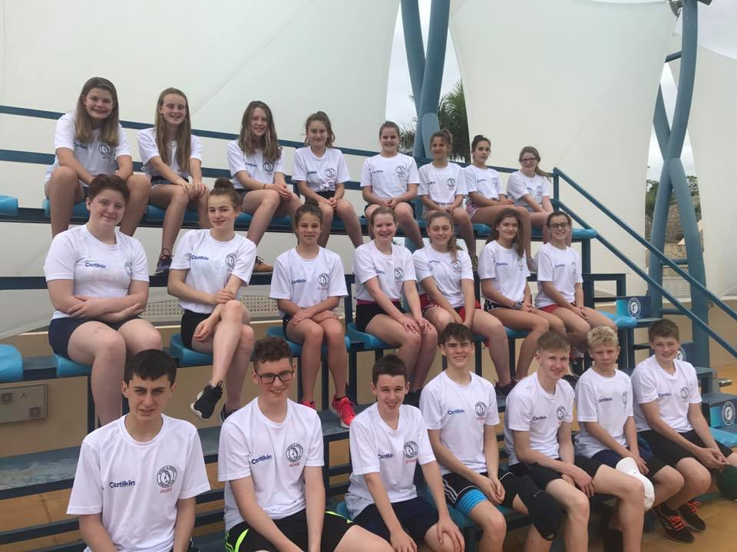

**Swim camp 2018**

22 Witney swimmers travelled to Tenerife with 4 coaches to do a 7 day training camp – 2 x 2hr pool sessions per day, 2 x 1hr land training sessions per day. Lot of food, games, giggles and a fun day at Siam water park.

Well done to all for their hard work and great behaviour representing W&DSC

[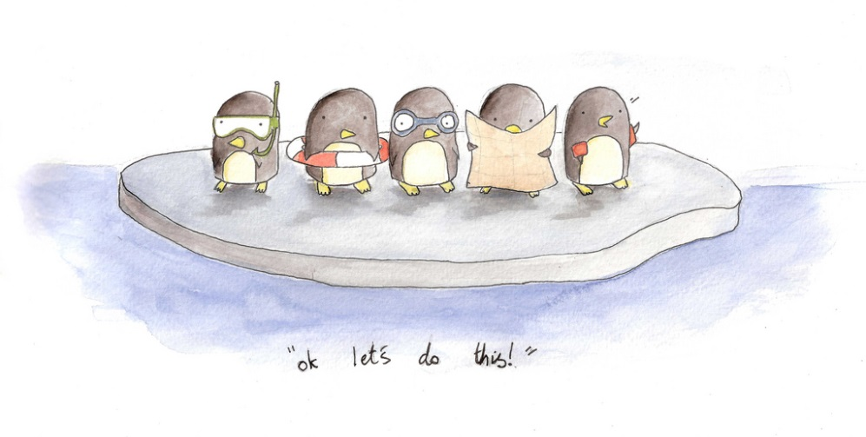](https://www.google.co.uk/url?sa=i&rct=j&q=&esrc=s&source=images&cd=&cad=rja&uact=8&ved=2ahUKEwjeptKp8-XeAhXMFsAKHc1MA0AQjRx6BAgBEAU&url=https://www.flickr.com/photos/osm_art/5126319131&psig=AOvVaw1XZ9PWj_FEvTPZzVqE5CRD&ust=1542903956474757)

Good luck to Georgia Duff at Scottish Nationals and Ella + Jess at Welsh Nationals.

[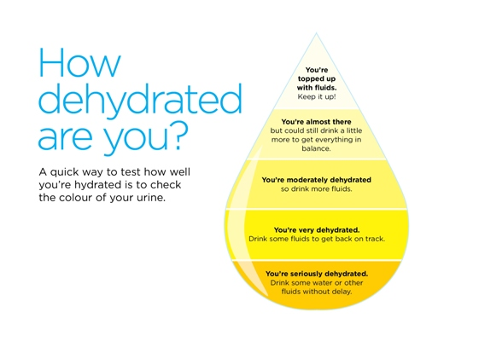](https://www.google.co.uk/url?sa=i&rct=j&q=&esrc=s&source=images&cd=&cad=rja&uact=8&ved=2ahUKEwiZloXf8-XeAhVIB8AKHaeJCIQQjRx6BAgBEAU&url=https://www.bupa.co.uk/health-information/exercise-fitness/hydration-exercise&psig=AOvVaw1Yf3G9cIP1xBPLTT_zFPSB&ust=1542904032136548)

**National Arena League success!!**

Rd 1 – 3rd = 9th in league

RD 2 – 1st= 5th in league

**We are in the final of the National Arena League Div 2 West Midlands League!**

**Saturday 8th December – Worcester!**