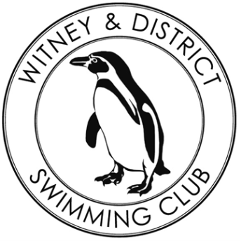
W&DSC Crowdfunding Campaign
Prize Draw winners
Tuesday 16th February 2021
 | Prize | Winner(s)
1 | Apple Airpods Pro | Jill Franklin
2 | Win your height in Hobgoblin – Wychwood Brewery | Joanna Burson
3 | RAF Brize Norton Tour | Ian Fifield
4 | The Edge Eatery £50 voucher | Pauline Clark
5 | Amazon £20 gift voucher | Christina Slater
6 | Martell cognac 70cl | Pauline Clark
7 | VAT 69 Scotch whiskey 70cl | Christine Naus
8 | Food hamper | Sarah Roche
9 | Beauty Forum – 20min Facial or B,N,S massage | Vivien Elford
10 | Hair Forum – Cut & Blow dry | Lucy Palmer
11 | 3 bottles of wine (2 W,1 R) | Pierre Lefort
12 | 2 bottles of wine (1 W, 1 R) | Andrea F
13 | Penguin Pack | Sarah Roche
14 | R&R Pack | Helena Stewart
15 | Oxford Bus Museum voucher for 1 family | Rick Johnson
16 | Pot Luck Bags x 3 | Graham Tanner  Felicity Tonkin  Gillian Reynolds

All winners will be contacted regarding the collection/delivery of their prizes
Many thanks for your support

