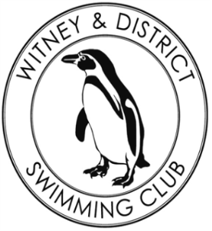**Chantal’s W&DSC Head Coach Highlights**

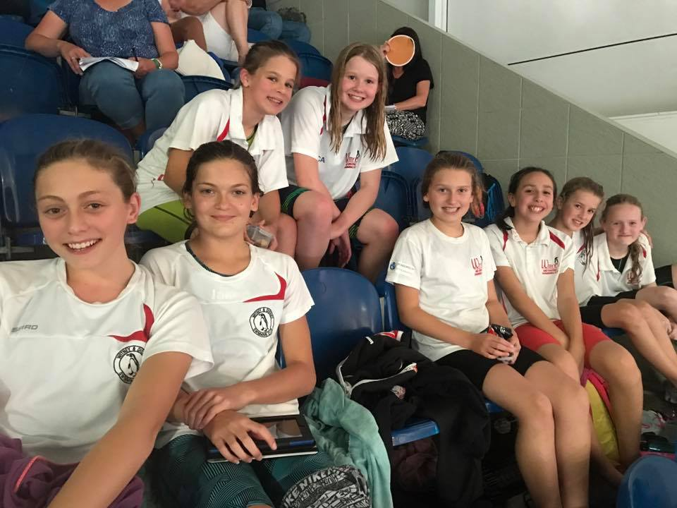**October 2017**

Open meet happiness:

Our 2017 – 18 Club Captains:

Rhiannon, Ben, Matthew and Sophie

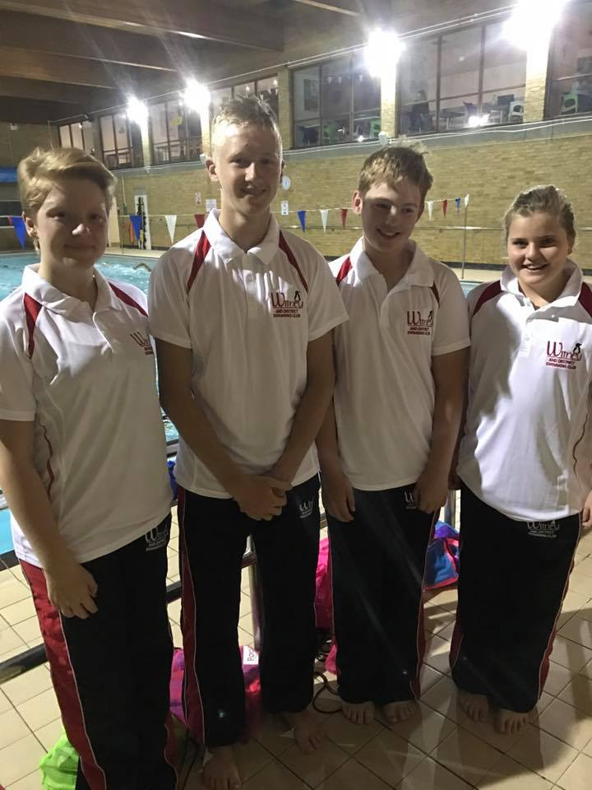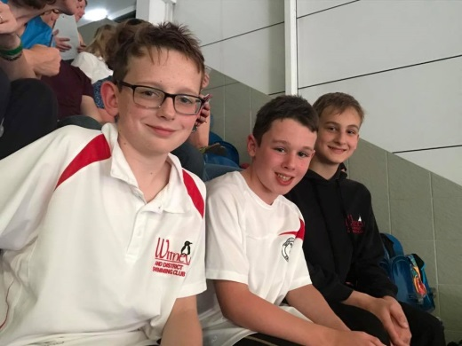

**Congratulations to Club Championship Record Breakers:**

**Georgia Duff – 50 FLY, 50 BK, 100 BK, 100 IM**

**Lauren Mellings – 200 FC, 200 BK, 400 IM**

**Ellie Browne – 200 BRS, 400 IM**

**Camille Duff – 50 FLY. 400 FC, 100 FLY, 200 FLY**

**Malik Khazir – 50 FC, 50 FLY**

**Tia Collett – 50 FC, 100 IM**

**Reuben Coppuck – 100 IM, 50 BRS**

**Erin Stewart – 50 FLY**

2017 MKJL Results:

2nd overall and promoted to div 1 2018!

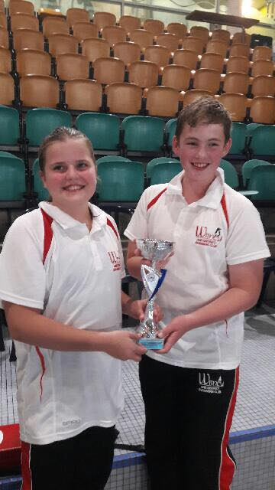

**Club Championship fun!**

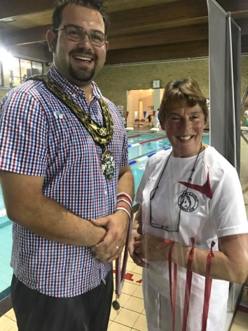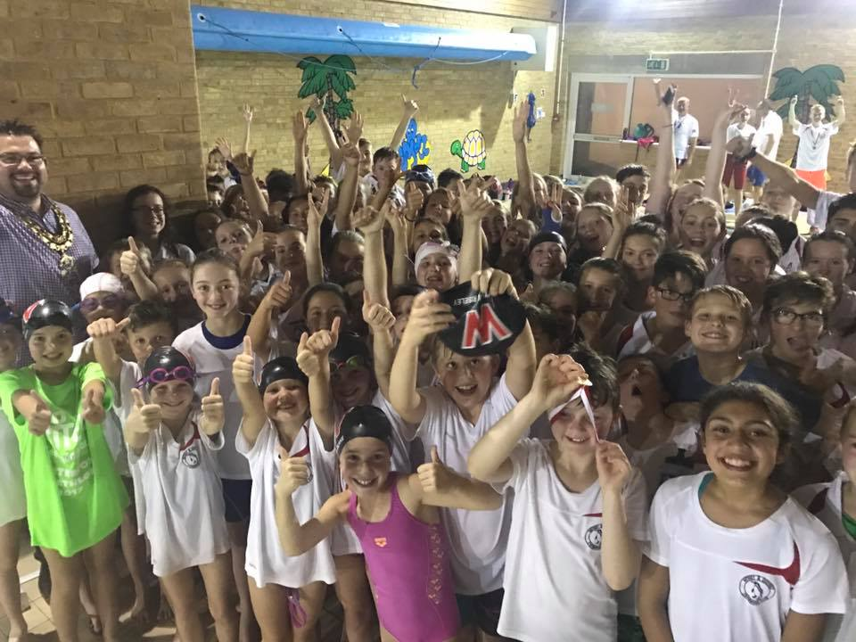

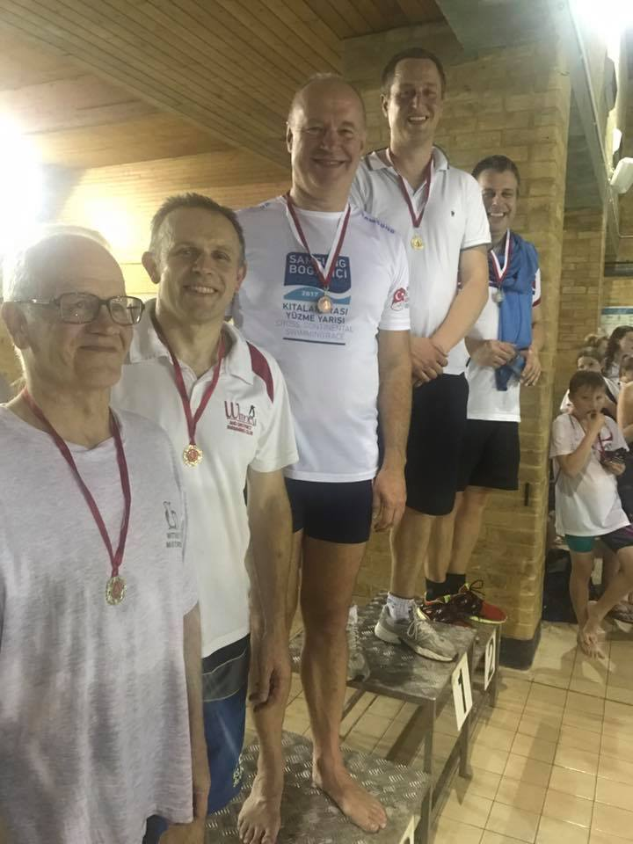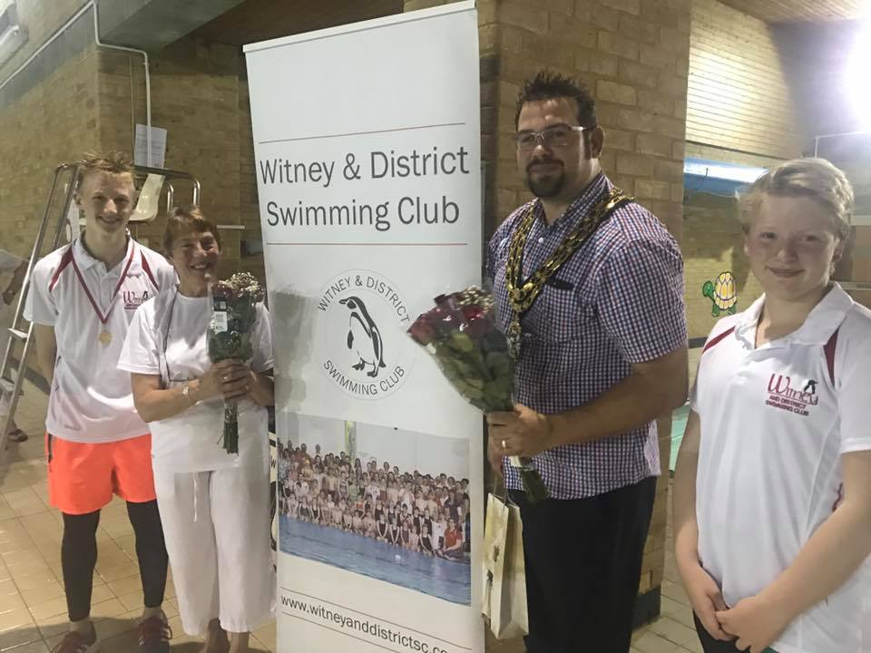

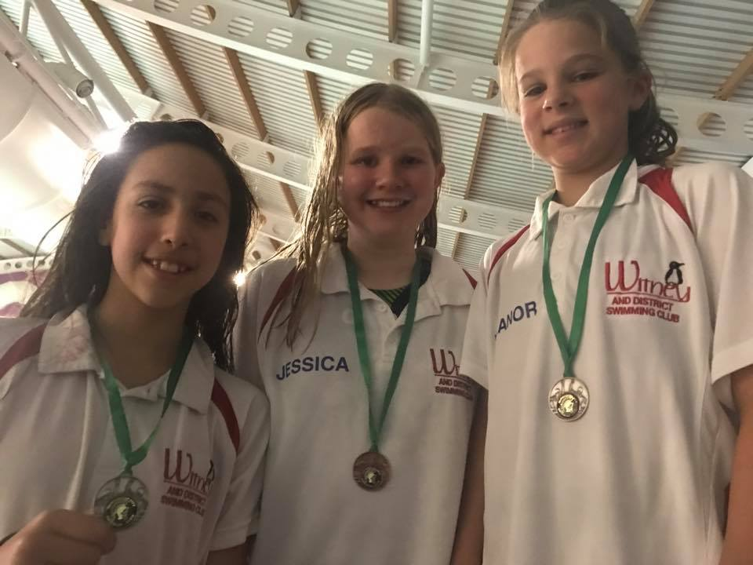

**Did you know…..**

Swimmers use nearly every muscle in their bodies - more than football!

Elephants can swim an average of 20 miles a day!

Benjamin Franklin invented the lightbulb and fins!