**Chantal’s W&DSC Head Coach Highlights Sept Report 18**

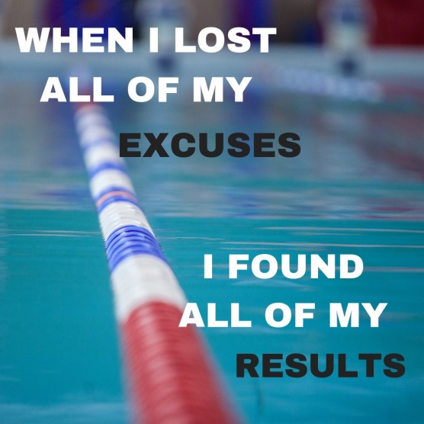

Club records are age on day and can be broken at any club meet. Club championship records are age at end of year and can only be broken at club and Diddy championships.

**New September Club records:**

Hattie Lever (9yrs), Henry Purcell (9yrs)

Maya Thorsdittor-Saldana (11/u),

Eleanor Perks (13/u)

**ONB 2019 County Championships**

Saturday 5th January - 1500m FC + Boys Age Group Relays (Oxford)

Saturday 12th January - 800m FC (Oxford)

Sunday 20th January - 400m’s + Girls Age Group Relays (Aylesbury)

Saturday 9th/ Sunday 10th February - Main Champs (inc. Junior/Senior relays) (Aylesbury)

Saturday 16th/ Sunday 17th February - Main Champs (inc. Junior/Senior relays) (Aylesbury)

All times achieved in level 1,2,3,4 meet since 9th April 2019

Club closing date 3rd December (will update times from 9th Dec CMK Meet)

**PLEASE KEEP ALL DATES FREE!!**

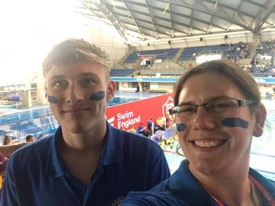

Congratulations to James who competed for ONB at National team gala in Sheffield

Club captains Ellie and Ben with Witney MP Robert Courts

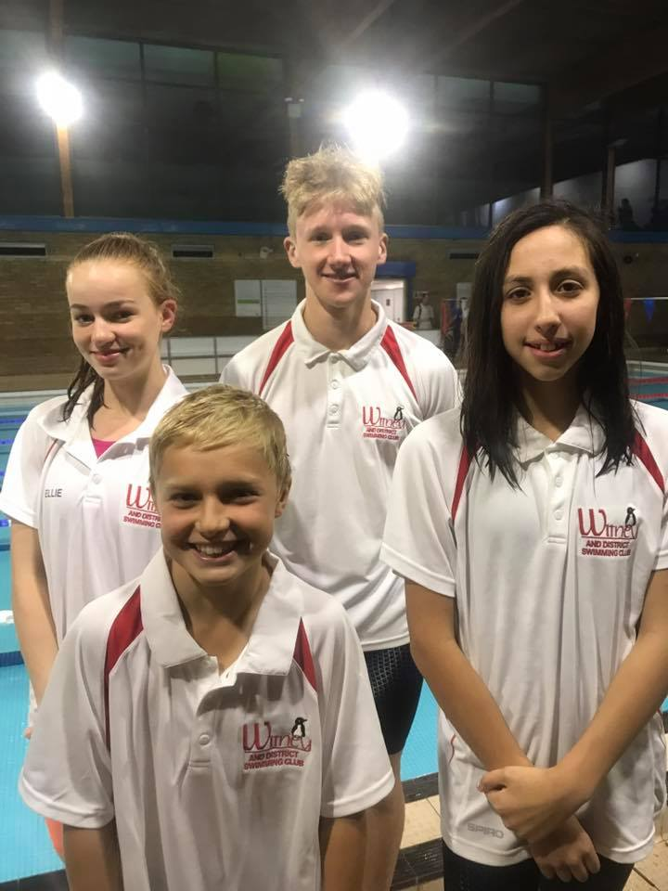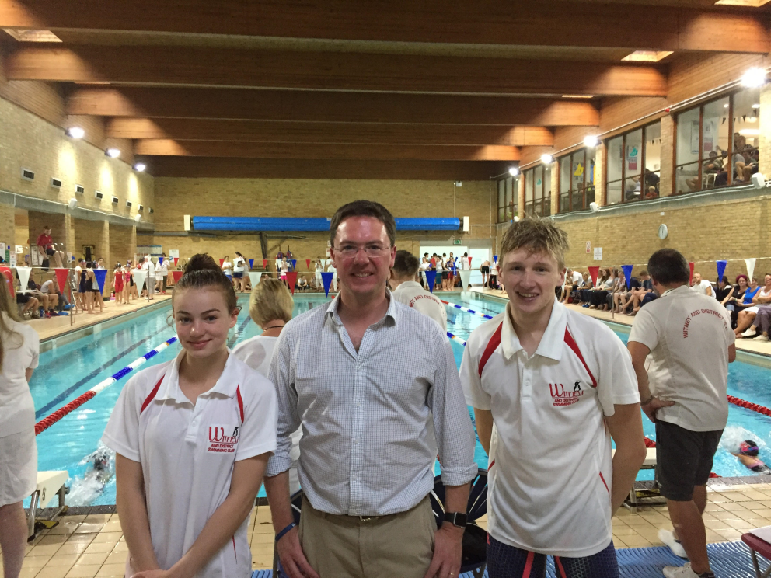

New 2018/19 Captains:

Ellie Browne

Ben Kinahan

Finn Spearman

Maya Thorsdottir-S

**Don’t forget NAL dates:**

**Sat 10th Nov and Sat 8th Dec**

**We are 8th in Div 2 after Rd 1**

**Let’s go A team!!**

Happy 18th birthday to captain Ben!!