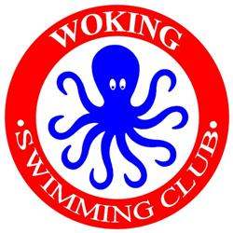**WOKING SWIMMING CLUB**

**10th B/C GRADE “OCTOPUS” OPEN MEET**

j0135087[1]

**Sunday 19 May 2019**

ASA LICENCE 3SE191160

Under ASA Laws and ASA Technical Rules

**ENTRY FORM - MALE / FEMALE**

**Closing Date: 19 April 2019**

|  |  |  |  |
| --- | --- | --- | --- |
| **CLUB:** |  | | |
| **FULL NAME:** |  | **Gender:** | **M or F** |
| **FULL ADDRESS :** |  | | |
| **CONTACT TEL. No:** |  | | |
| **EMAIL ADDRESS:** |  | | |
| **ASA REGISTRATION No:** |  | | |
| **FULL DATE OF BIRTH:** |  | | |
| **AGE ON DAY:** |  | | |

Please enter me for the following Events:-

Please enter short course times

|  |  |  |
| --- | --- | --- |
| **50m Free** | **100m Free** | **200m Free** |
|  |  |  |

|  |  |  |
| --- | --- | --- |
| **50m Back** | **100m Back** | **50m Fly** |
|  |  |  |

|  |  |  |
| --- | --- | --- |
| **50m Breast** | **100m Breast** | **100m IM** |
|  |  |  |

**Total Number of entries _____ at £6.50 per entry = £______**

**Signed___________________(Swimmer / Parent / Guardian)**