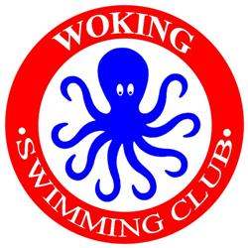
WOKING SWIMMING CLUB

11th B/C GRADE “OCTOPUS” OPEN MEET

Sunday 17 May 2020

CLUB ENTRY FORM

Please email this completed form to wokingsc.octopus@gmail.com and make payment electronically to Woking SC Open Meets Account, Lloyds TSB sort code 30 99 80, account number 51045968.
Alternatively return this completed form with your entries (if not on HyTek) and a SINGLE CHEQUE payable to Woking Swimming Club, to: Hilary Dickenson, 2 Pinehurst Gardens, West Byfleet, Surrey KT14 6HB

Closing Date for entries: 17 April 2020

DECLARATION
- All entrants are eligible competitors and are registered members of the below named club.
- All entrants accept the Promoter’s Conditions

Signed…………………………………………………………………………………………………..

Club Official……………………………………………………………………………………………

CLUB……………………………………………………………………………………………………..

CLUB CONTACT:
FULL NAME:
FULL ADDRESS:
E-mail ADDRESS:
CONTACT TEL. No: (mobile for emergency contact)

NUMBER OF ENTRIES | No.
INDIVIDUALS |  | @ £6.50 each | £
COACH PASS |  | @ £15 each | £
TOTAL CHEQUE ENCLOSED/BACS PAYMENT |  |  | £

