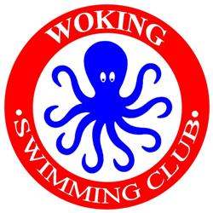

**WOKING SWIMMING CLUB**

**11th B/C GRADE “OCTOPUS” OPEN MEET**

**17 May 2020**

Swim England Licence 3SE200656

Under Swim England Laws and Swim England Technical Rules

**PROGRAMME OF EVENTS**

|  |  |  |  |  |  |  |  |  |
| --- | --- | --- | --- | --- | --- | --- | --- | --- |
| **Session 1**  **Warm up 07:30**  **Start 08:30**  **Est. finish 11:00** | | | **Session 2**  **Warm up 11:15**  **Start 12:15**  **Est. finish 14:45** | | | **Session 3**  **Warm up 15:00**  **Start 15:30**  **Est. finish 18:00** | | |
| **Event** | **Gender** | **Stroke** | **Event** | **Gender** | **Stroke** | **Event** | **Gender** | **Stroke** |
| 1 | Girls  9/over | 200 free | 7 | Girls  9/over | 50 back | 13 | Girls  9/over | 100 IM |
| 2 | Boys  9/over | 200 free | 8 | Boys  9/over | 50 back | 14 | Boys  9/over | 100 IM |
| 3 | Girls  9/over | 100 back | 9 | Girls  9/over | 100 breast | 15 | Girls  9/over | 50 fly |
| 4 | Boys  9/over | 100 back | 10 | Boys  9/over | 100 breast | 16 | Boys  9/over | 50 fly |
| 5 | Girls  9/over | 50 breast | 11 | Girls  9/over | 50 free | 17 | Girls  9/over | 100 free |
| 6 | Boys  9/over | 50 breast | 12 | Boys  9/over | 50 free | 18 | Boys  9/over | 100 free |

j0135087[1]