2nd Weekend – And what a weekend it was; 71 Swims and 90+% personal best times achieved!
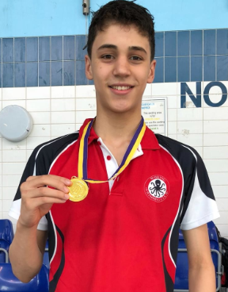
The 400m boy’s freestyle event saw a fantastic start to the second weekend of the Surrey Spring meet 2018. Victor de Oliveira stormed home to win Gold in time of 5:09.41 and 12 year old Aiden Elford setting a great PB of 5:50.71. Great swims for both boys.

Lauren Baker was then rewarded with Silver in the gruelling 200m fly in a time of 3:11.95.

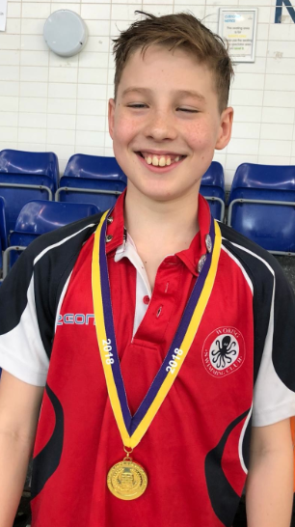
Next up was the 100m breast, Daniel Baldwin taking Gold and Sam Alford taking Silver in the 12 year old age group whilst Victor, back in the 100m Breaststroke secured a finalist position alongside fellow swim mate Alexej Baldwin also taking a finalist position

The Woking girls were out on force for the 200IM event, with Sophie King both crowned Champion in the 12 year old age group. Whilst Ellie Trojanovich (10) and Maddie Livingstone (14) taking a well fought for Silver medals. Finalist spots were secured by Anya Beeharry (10), Annabelle Simon (11), Sadie Warmington (11), Lizzie Chapman (12), Emma Gandy (13), Niamh Uttley (13) and further great swims by Gemma Robins (14) and Olivia Mills (12) were witnessed.
An early start for the second Sunday of the meet and it was great to see so many Woking Swimmers kicking off the girls 400m Freestyle. Emily Sanderson took Bronze in the 11 year age group and top 8 finalist slots were secured by Ellie Trojanovich (10), Emma Gandy (13), Niamh Uttley (13), Gemma Robbins (14) and Josephine Lee (14) with additional and significant PB’s in other swims by Olivia Mills (12), Gemma Allen (12), Alyshea Lee (12) and Freya Woolfenden (13).
The 100 individual medley didn’t disappoint with an array of medal positions with Mana Tanaka (11) and Kiera Doherty (15) taking championship Gold positions, closely followed by Ellie Trojanovich (10), Akane Hincapie (11) reaching out for Silver in their respective age groups with yet more Personal best times being secured by Isabelle Heney (11), Niamh Uttley (13), Gemma Robins (14) and Lily Johnson (14).
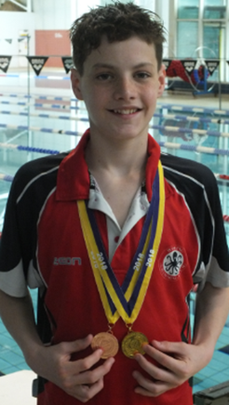
The final event of the morning was taken up by the Boys in the 200m Backstroke with Alexej Baldwin taking the top podium position in the Boys 14 year old age group, knocking 5.5 seconds off his personal best time and Nathaniel Reeve taking 14 seconds off his best time securing a 7th place position.
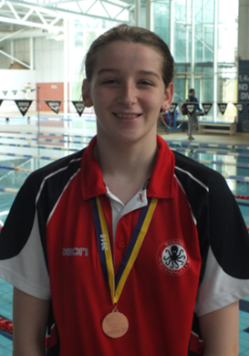
The afternoon session proved a very exciting time with the girls 200m breaststroke, boys 200m individual medley and the girls and boys 100m freestyle to close the meet out. The Gold medallist of the afternoon went to Victor de Oliveira in the boys 100m freestyle and Victor also took bronze in the 200 IM. Silver medals went to Mana Tanaka (200 Brs), Erin Pritchard (100m Free), Kiera Doherty (100m Free), Sam Alford (200IM & 100 Free), and Alexej Baldwin (200IM). Bronze Medals went to Isabelle Heney (200 Brs & 100m Freestyle), Maddie Livingston (200 Brs) and Niamh Uttley (200 Brs).

The afternoon finalists were: Abigail Elford, Anya Beeharry, Bella Hornzee, Akane Hincapie, Isabelle Wall-Budden, Annabelle Simon, Sofia Cockin, Joely Hartwell, Josephine Lee, Michael Gar, Matthew Alford, and Joseph Trundle. Additional personal best times were also achieved in the afternoon by Ellie Trajanovich, Evie Mackay, Tegan Gale, Beth Horne, Sadie Warmington, Gemma Robins, Aiden Alford and Nathaniel Reeve. Well done to all swimmers for their amazing results.

To close out the weekend, we took a few statistics – all of the above swimmers swam incredibly well, and the coaches were thrilled by their results. There were 71 individual swims this weekend with a total of 90% of swims were personal bests. Keep up the hard work swimmers, your hard work is certainly paying off!
