Old Palace Swimming Pool – Staff Car Park, Church Road, South Croydon

Please note that the swimming pool entrance is via the staff car park which you can use – keep travelling (one way) past the Surrey Q Street car park (on the right) and the entrance is a big metal gate on the LEFT HAND side. The entrance to the pool is just inside the entrance on the left hand side through a pedestrian gate.

N.B. The Postcode will take you to the front of the School not to the swimming pool.
CR0 1AX (front of school)

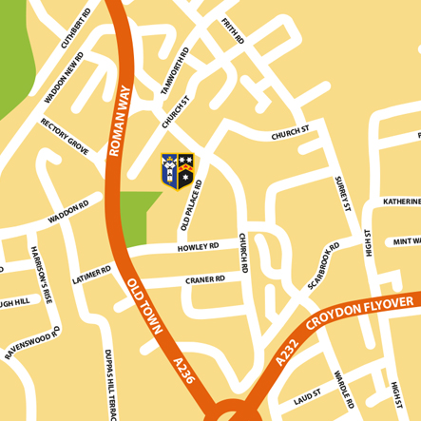Staff Car park Entrance

