Sit-ups
- Lie on the floor facing the ceiling with a slight bend in your knees and arms bent at the elbows and hands lightly touching your head by the ears.
- Engage your core and lift your upper body so your right elbow touches your left knee.
- Return to the start position then lift your upper body so your left elbow touches your right knee.
- Return to the start position.

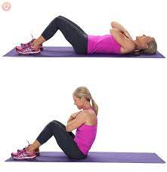

Squats

- Stand with your feet slightly wider than your hips.
- Your toes should be pointed slightly outward – about 5 to 20 degrees outward (the wider your stance, the more you’ll want to rotate your feet outward).
- Look straight ahead and pick a spot on the wall in front of you.
- Look at this spot the entire time you squat, not looking down at the floor or up at the ceiling.
- Your weight is on your feet – it should be on the heels and the balls of your feet, as if they were pasted to the ground. You should be able to wiggle your toes the entire movement (though that’s not a part of squatting!).
- It’s important to start with your hips back, and not by bending your knees.
- As you squat down, focus on keeping your knees in line with your feet.

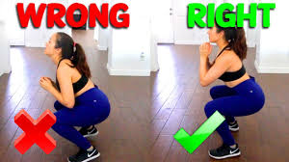

Push ups

- Get on the floor on all fours, positioning your hands slightly wider than your shoulders.
- Extend your legs back so that you are balanced on your hands and toes. Keep your body in a straight line from head to toe without sagging in the middle or arching your back. You can position your feet to be close together or a bit wider depending on what is most comfortable for you.
- Before you begin any movement, contract your abs and tighten your core by pulling your belly button toward your spine. Keep a tight core throughout the entire push up.﻿
- Inhale as you slowly bend your elbows and lower yourself until your elbows are at a 90-degree angle.
- Exhale as you begin contracting your chest muscles and pushing back up through your hands to the start position. Don't lock out the elbows; keep them slightly bent.

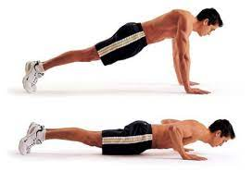

Plank

- Start in a press-up position.
- Bend your elbows until your forearms are on the floor beneath your shoulders so your body is in a straight line from your feet to your head.
- Keep your abs tight and look at the space between your hands to ensure a neutral spine position.
- Hold the position for as long as you can.

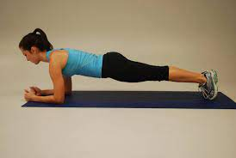

Leg rise

- Start by lying down on the floor or a mat. Unfortunately, it gets tougher from here.
- Lay flat with your arms at your sides and legs stretched out next to each other, then raise those legs.
- Even if you can’t hold them perfectly rigid, keep your legs as straight as possible, and lift them until they are pointing at the ceiling, or as near as you can get. Make sure your toes are pointed.
- Then lower them back down, being careful to keep your movements measured. The return journey should be at the same pace at which you raised your legs. Lower them until they’re hovering just above the ground, and then raise them again.

