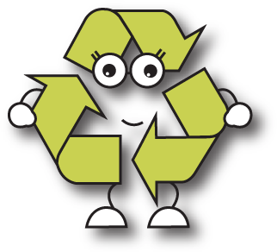




A guide for Parents and Guardians

Cash for Clobber from Cookstown Textile Recyclers is the easy way to generate valuable funds for your School, Club or Organisation.

How it works
Your School or Society has agreed to participate in our clothing recycling programme, known as Cash for Clobber.
We encourage Children, Parents and Guardians to contribute their used or unwanted clothes, using either bags or a Clothing Bank conveniently located on your premises.
The School or Organisation receives payment in full (value directly linked to weight collected), which is paid directly to you.

What happens to the clothing?
Provided they are of suitable quality, reusable items are exported to developing Countries, including sub-Saharan Africa, Pakistan, and in some instances Eastern Europe.
We also accept shoes (pairs only), handbags and belts, but please note that pillows and duvets cannot be re-used for hygiene reasons.

Why use Cash for Clobber?
Cookstown Textile Recyclers are Ireland’s premiere Clothing Recycling Organisation.
By using CTR, you are not only guaranteed premium rates for your clothing, but you can rely on our professional and helpful service to deliver (and collect!) to your requirements.
In addition, we are compliant with all legal and licensing requirements, and are certified to BSI standards.
We only ever make collections, or place Clothing Banks that have been granted full permission and agreed by you.
We work closely with a number of local authorities, charities and numerous Schools and other organisations.

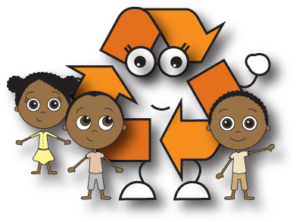

Our record and success speaks for itself.

Thank you for participating.

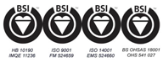www.cashforclobber.ie

