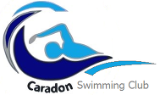

CARADON SWIMMING CLUB FEE TABLE 2016/17

SQUADS | FEE
National Performance x 6 swims or more | £85.00
Regional Performance x 5 swims | £77.25
Junior Performance x 4 swims | £66.95
F1 x 3 swims | £51.50
Masters | £61.80
Fast Track x 4 swims | £66.95
Fast Track x 3 swims | £51.50
Talent Development x 3 swims | £51.50
Development x 3 swims | £46.35
Development x 2 swims | £41.20
PAYG (10 SWIMS in ADVANCE) | £50.00

