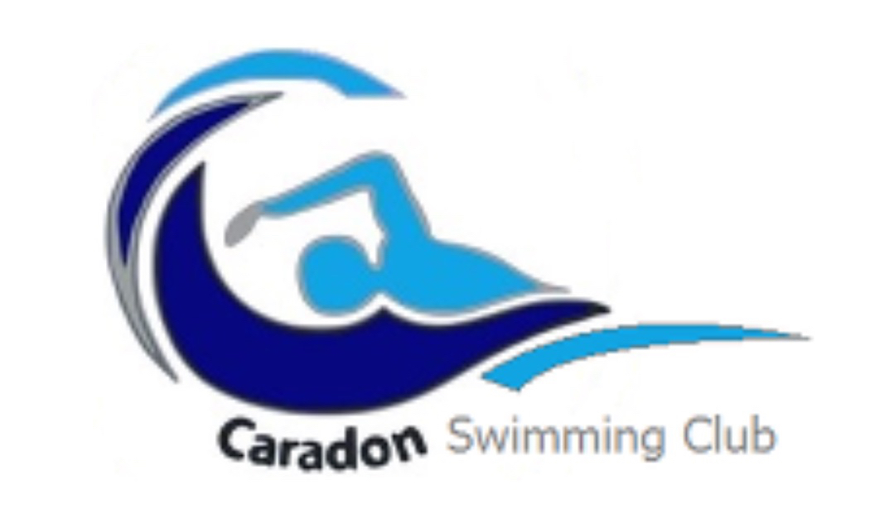

Caradon Swimming Club Privacy Notice

What personal information does Caradon Swimming Club collect about you?

Caradon collects and/or processes--through the TeamUnify platform--the following personal information about swimmers and their parents / guardians:
- Athlete / swimmer name, date of birth, gender, sportswear size and other measurements, physician name and contact details, medical information (if relevant and with parental consent), information about club membership and membership in sports bodies and associations, ability group, attendance history, competition results, medical insurance information, emergency contact, physician’s name and contact details, videos, photos, any additional comments, notes or information about an Athlete submitted by the web co-ordinator.
- Parent / legal guardian name, date of birth, and contact details, such as address, email and phone number.
- Billing information and payment details, such as credit card and purchase history (not in use at present)
- Videos and photos
- Athlete / swimmer meet results.
- Swim England registration data for athletes / swimmers and the club workforce.
- Background and criminal record checks results for club workforce, with consent.

How does Caradon Swimming Club use swimmer and parent/legal guardian personal information?

Caradon uses this information for the following purposes:
- To operate the club and allow swimmers and their parents / guardians with [to easily register for and attend swim meets, sign up for jobs, access swim time histories and swimming practice photos and videos, practice management, for event management, communication, billing and collection of fees, and other services they request.]
- For internal club record keeping.
- To comply with national and regional sports bodies’ (e.g., Swim England) registration and membership requirements.

Does Caradon Swimming Club share your personal information with third parties?

Caradon will not share personal information without consent, except:
- Where it is necessary to share with a service provider, such as TeamUnify or SportsEngine (TeamUnify’s parent company), in order to provide members, their parents, and coaches with services they have requested (e.g., to easily register for and attend swim meets, sign up for jobs, access swim time histories and swimming practice photos and videos); for practice management; event management; communication; billing and collection of fees; and other services they request.
- Where Caradon Swimming Club has a legal obligation to disclose the information (such as responding to a court order), to protect Swimming Club’s legal rights or to prevent fraud or illegal activity.

