Swimming Kit

The Caradon Swimming Club is produced by Kitworld, located in Plymouth

www.kitworld.uk/product-category/caradon-swimming-club

There are currently 10 items available to purchase. We do ask that every Caradon Swimmer has at least the Polo Shirt or T-Shirt to wear at Swim meets and galas.

Caradon Polo Shirt | £20.00
Caradon T-Shirt | £13.00
Caradon Hoodie | £25.00
Caradon Track Jacket | £25.00
Caradon Track Pants | £20.00
Caradon Shorts | £15.00
Caradon Rucksack | £15.00
Caradon Cap | £6.00
Caradon Onesie | £25-£30
Caradon Bobble Hat | £8

We advise for all items to be embroidered with first name and surname. This needs to go in the options at checkout.

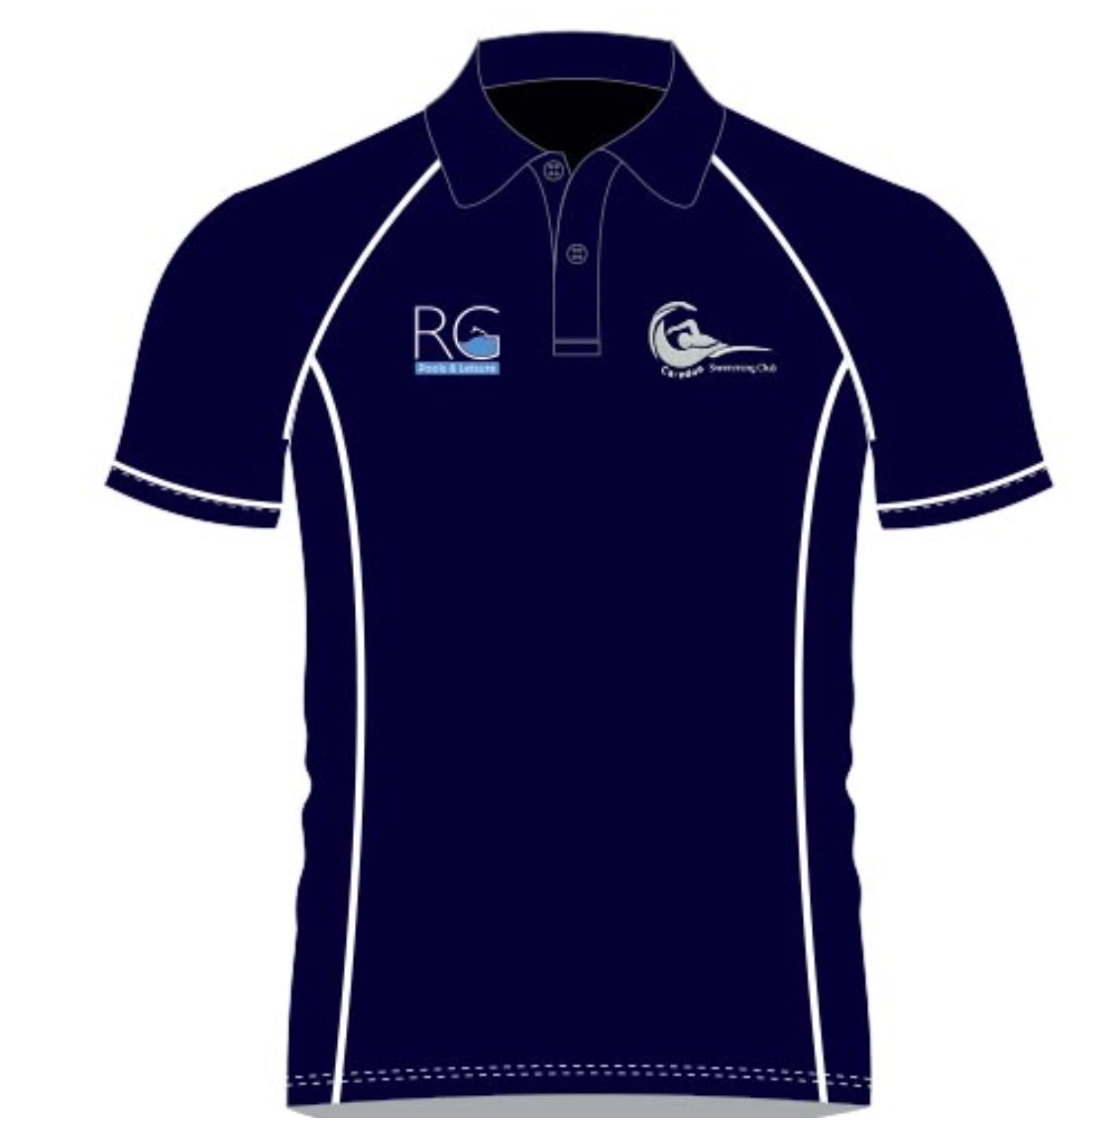

Caradon Swimming hats are available to pre-order and are available through our kit officer Alex. Please email alexschlussas@gmail.com

Option 1: Plain Hat £6.00
Option 2: Personalised Hat £10.00
Option 3: 2nd Personalised Hat (of the same name) £7.50

Personalisation can be of your choosing, surname, first name, nickname

Kit Bag Requirements

Upon joining the club all swimmers should acquire a kit bag along with a pull buoy and a 2 x kick board (1 x small and 1 x big). It is necessary to purchase a pair of fins and a Snorkel as well (optional for Development).

Pull buoys and kick boards should last a lifetime if properly looked after. As children grow it will be necessary to purchase larger sizes of fins as they outgrow a pair. If a newly purchased pair of fins are a little too large for swimmers, they can also wear a pair of socks to help them fit better.

Swimmers in Talent Development, Fast Track and Performance should also be in possession of a pair of finger paddles and a snorkel. Examples of acceptable finger paddles are shown in the following links.

Finger paddles cover only the finger area when worn. Please DO NOT purchase hand paddles – these cover the entire surface of the hand – as these create too much resistance against water for younger swimmers to manage and can result in injury to the shoulder joint.

https://www.simplyswim.com/products/Speedo/BioFUSEFingerPaddle-RedandGrey.aspx
http://www.swimshop.co.uk/win-finger-paddles-880671
https://www.proswimwear.co.uk/arena-elite-finger-paddle-pink.html
https://www.proswimwear.co.uk/mad-wave-finger-paddles.html

Upon receipt of your finger paddles it will be necessary to adjust the straps so that they stay firmly on the hand. Parents, please ensure that new equipment is adjusted accordingly so swimmers are able to use these items at training. It is not feasible for the coaching team to have to adjust every swimmer’s equipment during a set.

Snorkels should be the upright version as shown in the following link. They should come with a solid head bracket. The head bracket should sit across the forehead just above the goggles and not be worn over the top of the head. The strapping will need adjusting to ensure it fits tightly against the resistance of the water without coming off and ensure the snorkel itself is in the right position in the bracket.

https://www.proswimwear.co.uk/arena-swim-snorkel-small-pink.html
https://www.proswimwear.co.uk/finis-swimmers-snorkels.html

Whilst we appreciate that all these purchases add up, they are important items of kit that enable the coaching team to undertake work with the swimmers in order to develop and progress their strokes. Swimmers should have these items as they serve a purpose when used in training. As swimmer’s progress through the squad structure they will use their equipment with greater regularity.

All items can be purchased from online retailers at the above links and come in various colours by various manufacturers. Do feel free to shop around.

Items can be ordered from www.proswimwear.co.uk via the clubs website as each order made this way generates 5% commission to the club www.caradon-swimming.org.uk

Swimsuits

One of the most important articles any swimmer should have are swimsuits – for both boys and girls – and for both training and competition.

For training purposes, swimmers should have swimsuits that are comfortable and well fitting for them to undertake their sessions in. Most swimmers have multiple cheaper suits for training as they get used with greater frequency. Consequently, they will fade over time due to the chemical compounds in swimming pools and will lose their elasticity and comfort of fit. Swim suits for training must be comfortable for swimmers to be in for the duration of their training sessions.

Everyone gets a swimsuit from time to time that looks great, but actually isn’t so comfortable to train in and ends up being put aside.

For competition purposes, swimmers should have a number of racing swimsuits. These should be tight fitting in order to minimise drag. Sometimes, It is noticeable that a lot of swimmers are wearing the same swimsuits for training sessions and then to compete in. Some of these suits are far too big and the swathes of material flapping in the water create drag and slow swimmers down.

A racing suit should be tight fitting. If you are able to get your index finger between the swimmers body and any of the areas of opening of the suit, then it is too lose. Racing suits are intended to be worn for approximately thirty minutes at a time. This is the time required for the swimmer to be briefed by the coach, to go to marshaling and to undertake their race.

At a competition parents and younger swimmers may well notice the older and more experience swimmers undertaking their warm up in one of their regular training swim suits. They will then go and change into a racing suit for their first race. Following their race, they will change into a further training suit in order to swim down. Many of the girls put a training suit over their racing suit and roll the racing suit down off the shoulders and bust to allow for better comfort and blood flow. You may also notice swim suits being draped around on poolside in order for them to dry before being worn again.

If swimmers have multiple suits then they do not need to sit in a constantly wet or damp state on poolside, but will be able to change and stay warm and dry throughout competitions.

We do not advocate parents spending hundreds of pounds on racing swim suits that will be outgrown in a short space of time, however anyone serious about their swimming should have a number of reasonable quality, tight fitting racing suits that they can use over the course of each day of competition.

