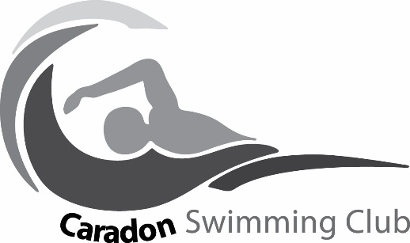

Caradon Swimming Club
Two Counties Spring Open Meet 2018
14th – 15th April 2018
Plymouth Life Centre, Mayflower Drive, PL2 3DG
Entry Form

Swimmers Name:
Date of Birth:
ASA Registration Number:
Club: CARADON
Age as of 15th April 2018:
Event | Submitted Time | Event |  | Submitted Time
50m Freestyle |  | 50m Breaststroke
100m Freestyle  10yr and Over only |  | 100m Breaststroke  10yr and over only
200m Freestyle |  | 200m Breaststroke
400m Freestyle |  | 50m Butterfly
50m Backstroke |  | 100m Butterfly  10yr and over only
100m Backstroke  10yr and over only |  | 200m Butterfly
200m Backstroke |  | 100m IM
 |  | 200m IM

Total Number of entries ________ @ £6.50 per event Total Entry Fee £______________

Coaching & Admin Fee £3.50

Total Fee Payable £______________

Cheques should be made payable to ‘Caradon Swimming Club’
Closing date for entries to be received by the club is Tuesday 6th Feb 2018

