Congratulations on successfully completing your online Time Keeping training.

As a member of Swim England or Swim Wales, you need to upload a copy of your certificate and/or competency to https://swimmingresults.org

- Register (You only ever need to do step 1 once) at https://swimmingresults.org/member_options/register.php, using the email address on your membership record
- Once registered, log in to Swim England Member Options at https://swimmingresults.org/member_options by adding your membership number and registered email address
- Once logged in, on that page select HERE within 2nd paragraph “To view or upload a copy of listed certificates to be added to your membership record select here”
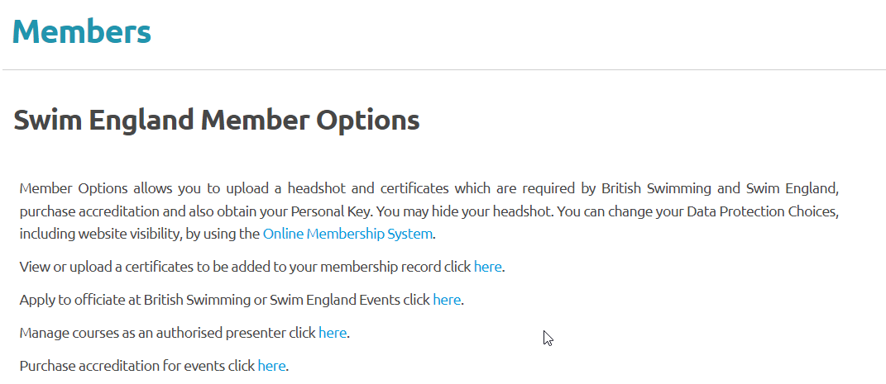
- This takes you to a new page Swim England Member Options Certificates. To upload a new certificate select HERE within “you can view and upload certificates here, click here to upload a new certificate. ”
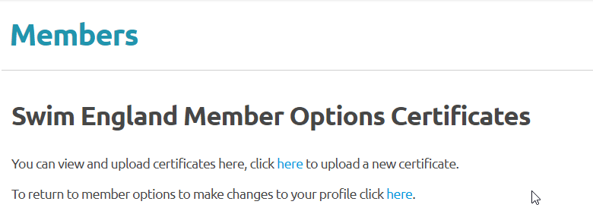
- Use the Certificate Type drop down menu to select Swimming Timekeeper Theory to add the certificate gained for the online part of the training you did
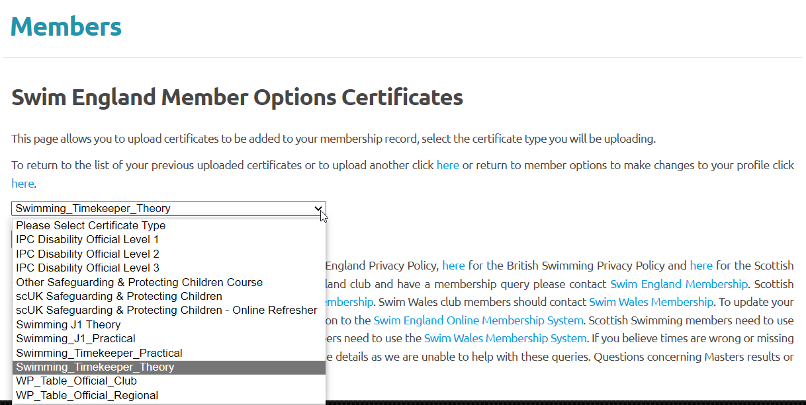

- Select Certificate, which takes you to
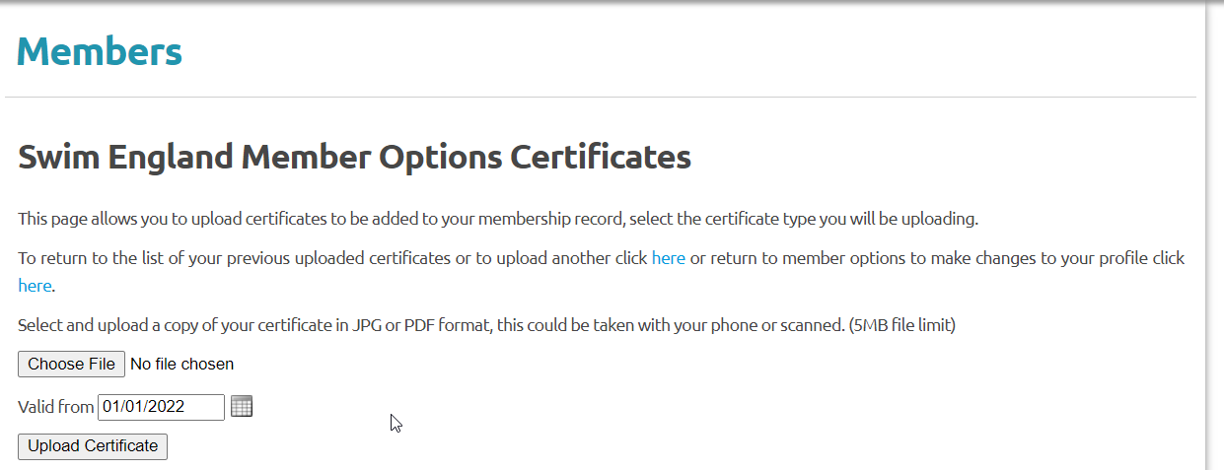
- Select Choose File which opens your files on PC/laptop. Select the certificate to add this.
- Add the date as shown on your certificate in the “Valid From” box
- Now select “Upload Certificate”
- Repeat this process to upload competency gained following your successful practical session.
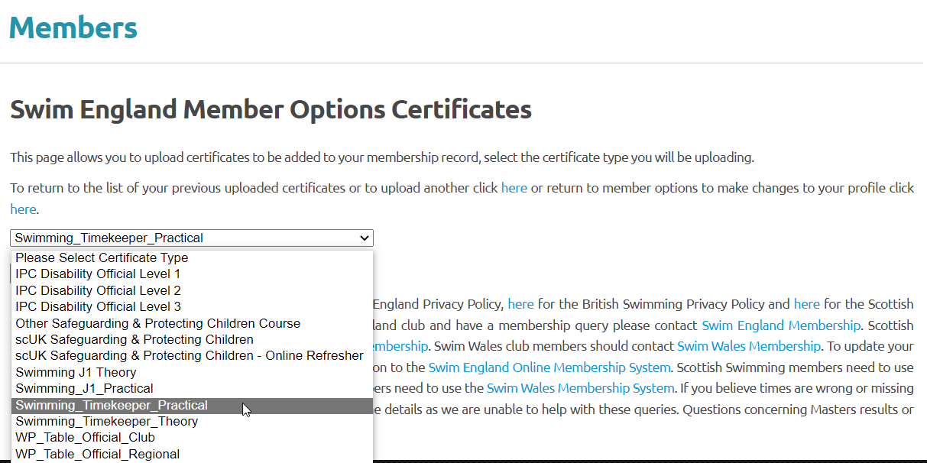

Well done and thank you for your support.

