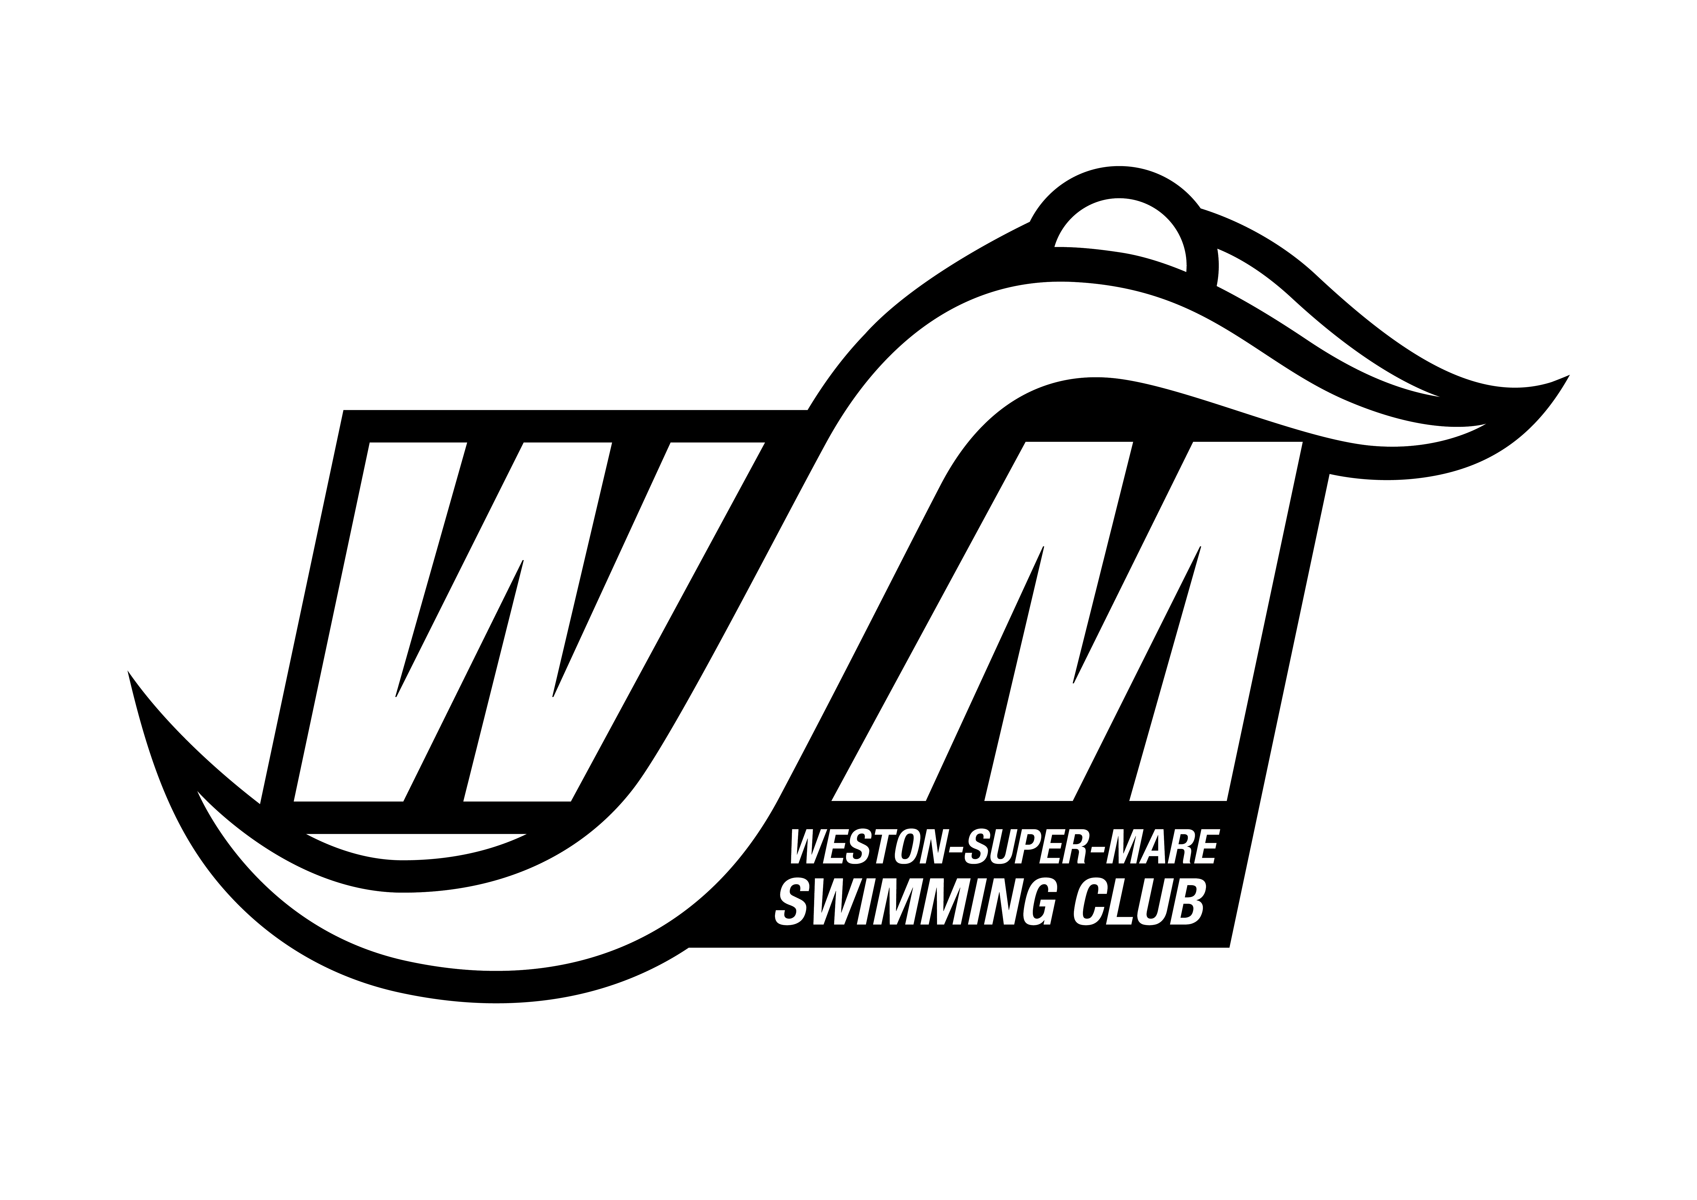
WESTON-SUPER-MARE S.C.
Saturday 16th & Sunday 17th APRIL 2022 EASTER OPEN MEET
OFFICIALS REPLY FORM
To ensure this Easter Open Meet can run effectively and efficiently and that times from all sessions can be submitted to British Swimming rankings WSM SC would be grateful and welcome help from your qualified officials. Please could you complete the full details of any qualified official who is willing to help and return it with your club entry. Thank you

CLUB NAME:
Official’s Name
Qualification (J1, J2 etc)
Licence | Number: Expiry Date:
Email
Session availability (please circle) | 1 | 2 |  | 3 |  |  | 4
Official’s Name
Qualification (J1, J2 etc)
Licence | Number: Expiry Date:
Email
Session availability (please circle) | 1 | 2 |  |  | 3 |  |  | 4
Official’s Name
Qualification (J1, J2 etc)
Licence | Number: Expiry Date:
Email
Session availability (please circle) | 1 |  | 2 |  |  | 3 |  |  | 4

