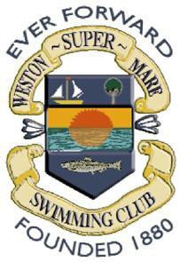 | WESTON-SUPER-MARE S.C.  Affiliated to ASA South West and Somerset ASA Under Swim England Laws and Swim England Technical Rules of Swimming

EASTER OPEN MEET - 11TH & 12TH APRIL 2020.

Individual Entry Form for NON WSM SWIMMERS ONLY.

CLUB NAME:

All times to be 25m (short course) times.

Name:
Gender: | Male/Female | Entry Check: (Official Use only)
Date of Birth: |  | Age as at 12TH April 2020
ASA Reg No:
Address:
Phone No: |  |  | E-mail:

EVENT | Age Group | ENTRY TIME | EVENT | Age Group | ENTRY TIME
50m Freestyle  [M:27 F:47] | All |  | 100m Freestyle  [M:44 F:24] | ALL
50m Backstroke  [M:14 F:34] | All |  | 100m Backstroke  [M:25 F:45] | ALL
50m Breaststroke  [M:33 F:13] | All |  | 100m Breaststroke  [M:37 F:17] | ALL
50m Butterfly  [M:46 F:26] | All |  | 100m Butterfly  [M:16 F:36] | ALL
200m Freestyle  [M:12 F:32] | 10/Over |  | 100m IM  [M:23 F:43] | ALL
200m Backstroke  [M:42 F:22] | 10/Over
200m Breaststroke  [M:21 F:41] | 10/Over
200m Butterfly  [M:35 F:15] | 10/Over
200m IM  [M:31 F:11] | 10/Over

TOTAL NO OF ENTRIES | Sat & Sun Sessions | @ £6.00 PER EVENT | £ :
I certify that the above details are correct, I will abide by the Promoter’s conditions and that I am an eligible competitor in accordance with the laws of the Amateur Swimming Association.

Swimmer’s Signature: Dated:

RETURN BY CLOSING DATE OF FRIDAY 20TH MARCH 2020

