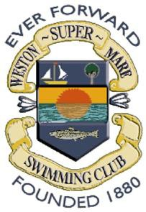
WESTON-SUPER-MARE S.C.
Saturday 11TH & Sunday 12TH OCTOBER 2020 EASTER OPEN MEET
OFFICIALS REPLY FORM
Reminder: Clubs attending this meet with 5 or more swimmers are requested that they provide at least one qualified official per session for every 10 swimmers entered. Please complete full details for each official below.

CLUB NAME:
Official’s Name
Qualification (J1, J2 etc)
Licence | Number: Expiry Date:
Email
Session availability (please circle) | 1 | 2 |  | 3 |  |  | 4
Official’s Name
Qualification (J1, J2 etc)
Licence | Number: Expiry Date:
Email
Session availability (please circle) | 1 | 2 |  |  | 3 |  |  | 4
Official’s Name
Qualification (J1, J2 etc)
Licence | Number: Expiry Date:
Email
Session availability (please circle) | 1 |  | 2 |  |  | 3 |  |  | 4

Please ensure this form is submitted with your club entry.
Closing date: Midnight Friday 20th MARCH 2020.

