Soundwell Swimming Club

Return to Training Guidelines – April 2021

Kingswood Leisure Centre

Introduction

This procedure document covers the return to training for Soundwell Swimming Club while using Kingswood Leisure Centre.

Sessions will contain age appropriate content and will be planned keeping in mind current fitness levels of participants. Swimmers will only be permitted to join in a session if they are seen to be fit and well. All content will be delivered gradually to minimise injury risk.

Alongside this guideline document you will receive a return to training health questionnaire and declaration. This is an updated document which replaces the one issued in 2020 and must be completed before your first session back. No swimmer will be permitted to train until this paperwork is complete. Please ensure the contact details held by the club, especially mobile phone numbers, are up to date and accurate as these will be used in case of emergency during the session.

1. Car Park

To keep numbers in the car park to a minimum we ask that all participants & parents arrive promptly before the start of your session.

When arriving by car, we ask that you respect any signage and directional systems in the car park, ensure you maintain adequate social distance in line with current government guidelines and remain mindful of other participants and centre users.

Please Note – A section of the small car park (accessed via Soundwell Road), is not in use, the main car park should be accessed via Church Road.

For Health and Safety reasons we respectfully request that you do not gather or meet other families in the car park before and after sessions.

2. Building Entry and Exit

Everyone should enter the building (no more than 5 minutes before the start of your session) using the main entrance. Swimmers will be asked to queue outside the main entrance and will be welcomed into the building by a member of the centre staff 5 minutes before their session starts. When waiting outside please line up along the railings keeping the steps and entrance clear. Swimmers are reminded that while they wait they should wear a mask and remain socially distanced at all times.

Upon entry to the building hand sanitiser should be used.
Swimmers and parents are reminded that masks should be worn AT ALL TIMES when not in the pool, including in the changing and spectator areas (unless exempt or under 11 years of age).

The entrance foyer has been laid out using directional arrows. Please follow the one way system to the changing areas and pool, via the balcony and stairs near the learner pool. There is to be no loitering, waiting or sitting in general areas such as the foyer, if not staying for the session, parents and guardians are asked to leave the building immediately after drop off.

After training swimmers should follow the one way system to the chaning rooms. The designated exit to the building is via the fire exit on poolside, into the small car park. Everyone is reminded of the ‘In, Train, Leave’ policy to avoid loitering and unnecessary congestion within the building.

3. Changing Rooms

Swimmers are advised to take a shower at home in advance of travelling to the pool. Lockers will be available however, swimmers should bring as minimal an amount of belongings as possible.

It is very important that everyone is clear on the ‘In, Train, Leave’ policy, this means that swimmers should arrive at the pool swim ready, wearing their swimwear under their outer clothing. After training swimmers should spend no longer than 5 minutes in the changing area to allow for other squads to arrive and avoid bubbles crossing or mixing. To ensure swimmers are able to leave the building as quickly as possible it is suggested they wear old clothing so they are able to dress while they are wet. Please ensure they are dressed appropriately for the weather.

Please Note – apart from mesh kit bags no other swim bags, will be permitted on poolside during a session.

Sanitising stations will be available in the changing rooms, swimmers and spectators are advised to sanitise their hands on arrival, before trainng and before leaving the building.

No showers will be available.

3. Registration

Before starting the session, coaches will take a register of all participants. This register will act as a current Health Declaration. When a swimmer registers for a session they are confirming that they, and their family, are well and SYMPTOM FREE. Registers will be held by the coach for a minimum of 21 days.

Spectators are permitted in the seated gallery area only, limited to 1 parent / guardian per swimmer. Parents and guardians are reminded that all swimmers aged 11 and under should always have a responsible adult present throughout the duration of training sessions. Please only use the designated seating and repsect current social distancing guidelines. While seated in the viewing gallery spectators are reminded they should be socially distanced at all times and should be wearing a mask for the duration of the session.

4. Session Arrangements

Coaches and volunteers have been fully briefed on return to pool procdures specific to Kingswood Leisure Centre.

Swimmers are advised to undertake their normal pre-pool routine at home, as close as possible to the session start, before travelling to the pool. There will be no pre or post pool taking place on poolside.

Sessions will be arranged taking into consideration Swim England recommendations for space per swimmer in the pool which currently stands at 6 swimmers per lane. Lanes will be allocated before the session and swimmers will keep to their designated lane for the duration of their swim. Swimmers are not permitted to overtake mid lane, a suitable order will be devised by the coach, if one swimmer wishes to overtake another this should be done at the end of the lane in a safe manner.

The following diagram, recommended by Swim England, will be used by coaches during sessions.

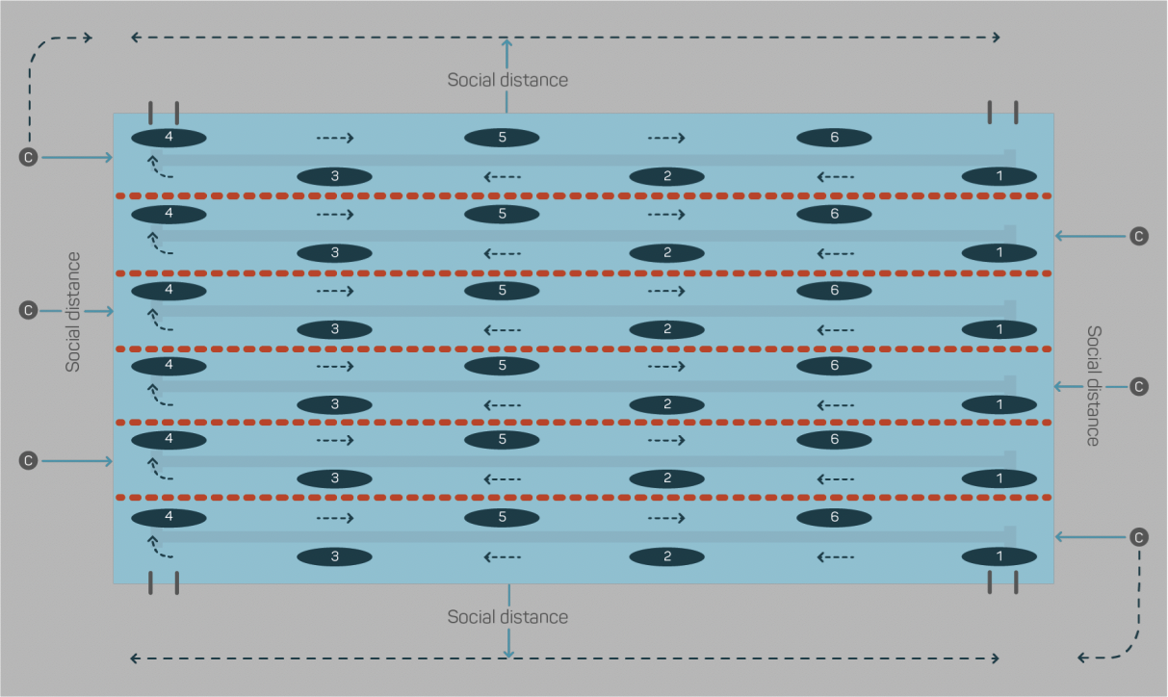

Coaches will ensure they maintain adequate distance from participants and each other while delivering the session and will adhere to the rules of the centre at all times. A Covid Liason Officer has been appointed for each session. They will be present to ensure social distancing is maintained and procedures are being followed, swimmers will be frequently reminded if they are not following the guidelines.
Coaches will avoid gathering swimmers on poolside to deliver sets, if instruction is to be given during the session coaches must be mindful at all times of social distancing and where possible coaching delivery should be conducted in a staggered approach a few swimmers at a time. The following diagram will used by coaches when delivering instruction during sessions.

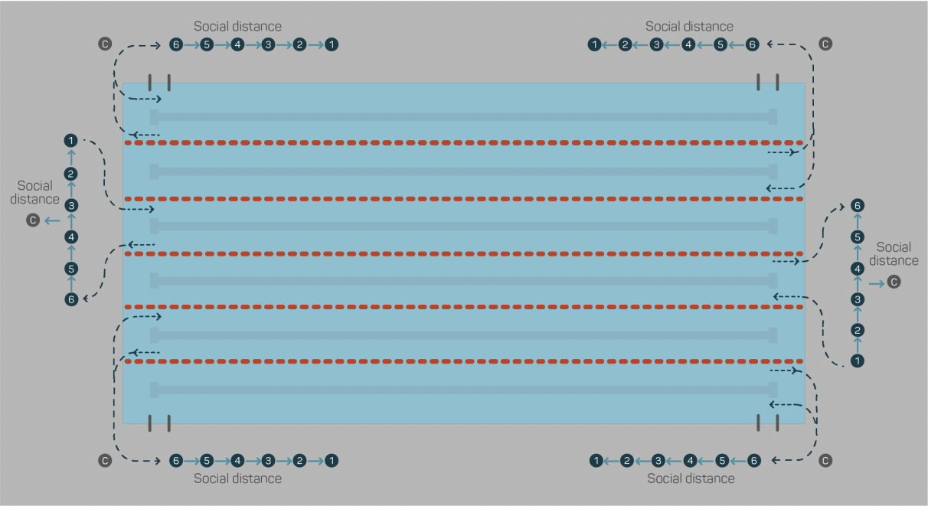

Should a participant injure themselves during the session the swimmer will be treated by a member of the leisure centre staff wearing appropriate PPE and as socially distanced as possible. The swimmers parent / guardian will be contacted, if not on site, and asked to return to collect them as soon as possible.

If a participant becomes unwell during a session, displaying Covid symptoms, they will be removed from their lane and distanced from the group (remaining under distanced supervision at all times). If not on site, the swimmers parent / guardian will be contacted using the number held by the club on Team Unify and asked to collect them and leave the venue as soon as possible. You should then follow current Government Guidelines regarding testing (including what to do in the event of a positive test result), self-isolation guidelines and we ask that you do not return to training until it is safe for you to do so. Track and Trace information of everyone involved in the session can be provided if requested.

5. Equipment

To avoid spreading the virus there must be strictly no sharing of equipment, all kit should be clearly named or identifiable. Swimmers may bring their mesh kit bags to training as normal and will be advised where to store their kit bags during the session. All equipment should be washed or wiped before and after each session.

Participants should bring enough drink, in named bottles, to last the duration of the session as there will be no opportunity to refill drinks bottles (water fountains thoughout the building are not in use) this should be placed in a visible spot. Swimmers should be careful to only drink from their bottle.

5. Sanitising and Hygiene

Swimmers are asked to shower before putting on their swim wear and leaving home for the session. Everyone is asked to bring their own hand sanitiser which should be used if required before the start of the session (hand washing with soap and water is also acceptable) and after changing at the end of the session. Participants are then asked to thoroughly wash their hands with soap and water at the earliest convenience after finishing training or arriving home.

6. Collection & Exit

Please ensure parents / guardians are familiar with the exit point for collecting swimmers after the sessions ends. To avoid conjestion we ask that parents wait outside the Fire Exit until the swimmer exits the building. If you are not staying for the session, the phone number we hold for you must be an available at all times contact number, please arrive promptly to collect swimmers.

7. Further Information and Guidance

For queries or concerns regarding Covid matters please contact Emma Dodd, who has been appointed as the clubs Covid Lead (vicechair@soundwellswim.org.uk)
For queries or concerns regarding training please contact Head Coach Jon Wills (headcoach@soundwellswim.org.uk).
For queries or concerns regarding Safeguarding please contact the Club Welfare Officers (welfare2@soundwellswim.org.uk, CWO@soundwellswim.org.uk)

Covid Liaison Officers will be present at every session to ensure guidelines are followed.

Guidelines Created – August 2020
Reviewed and Amended – March 2021
To be reviewed and adjusted as necessary

