Soundwell Swimming Club
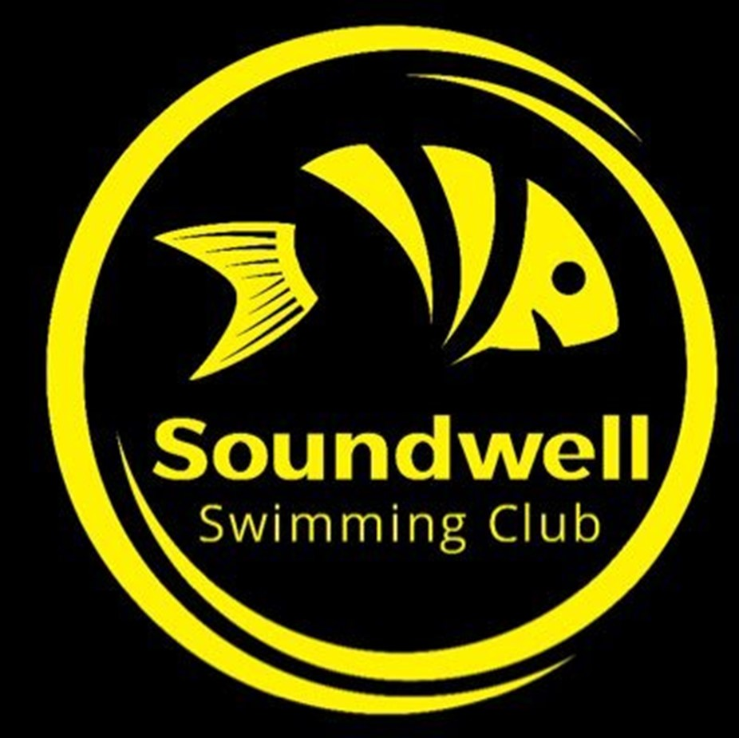

Return to Training Covid-19 and Risk Awareness Declaration (April 2021)

I ………………………………. am returning to training having completed and signed the Health Survey as requested by Soundwell Swimming Club.

By signing this declaration, I confirm I am free from any symptoms related to the Covid-19 virus, I understand the main symptoms include:

- a high temperature – this means you feel hot to touch on your chest or back

- a new, continuous cough – this means coughing a lot for more than an hour, or three or more coughing episodes in 24 hours

- a loss or change to your sense of smell or taste.

I am also confirming all in my household remain symptom free, and anyone taking me to or from training and attending my training session with me is also symptom free from the virus.

By signing this declaration, I confirm that for any future training sessions I will only attend in the full knowledge that I am free from any Covid-19 symptoms. In addition, but conversely confirm by signing this declaration that if I do display any symptoms I will not attend training for a period of at least 10 days and follow government guidance regarding testing and self-isolation.

I return to training knowing that my participation cannot be without risk, I am therefore aware of these risks associated with the Covid-19 virus, but still wish to participate in club training.

I understand the procedures and protocols Soundwell Swimming Club have put in place for all training venues in order to reduce risks and I will adhere to these in order to protect my health and the health of other members, coaches, volunteers, staff and the wider community.

Signature |  | Date
Parent/guardian signature (for members under 18) |  | Date

