Soundwell Swimming Club –
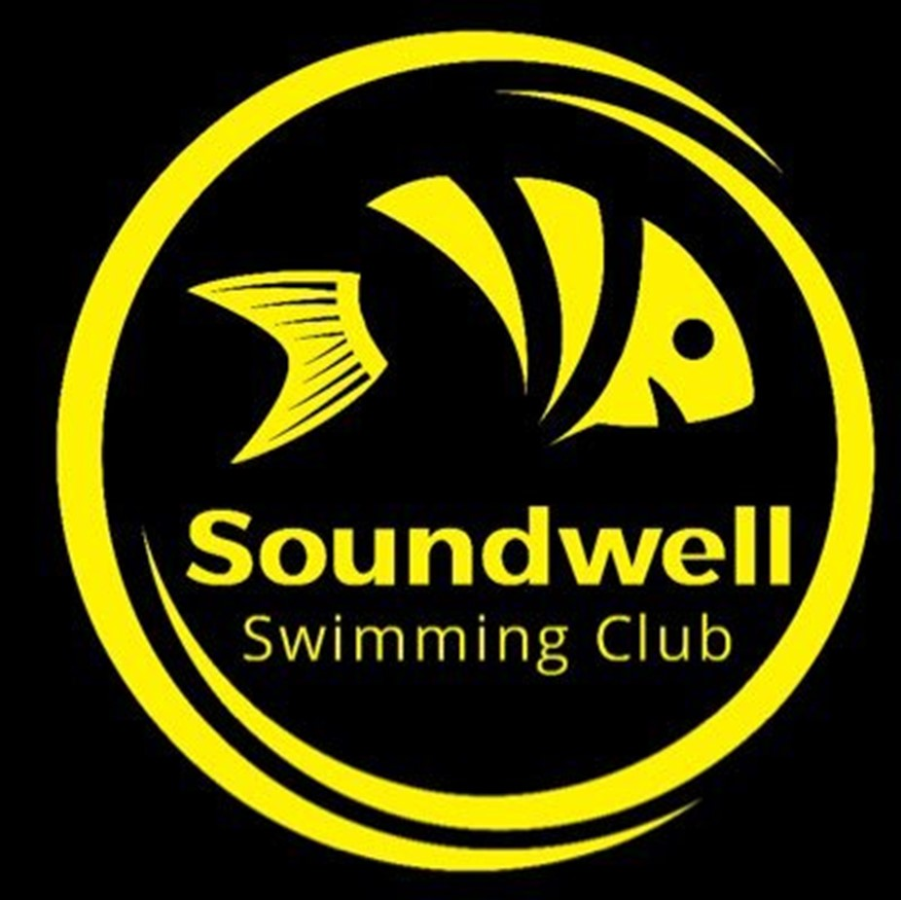
Return to Training Covid-19 Health Survey (April 2021)

Question | Yes / No | More information
1. Have you had confirmed Covid-19 infection or any symptoms (listed below) in keeping with Covid-19 in the last five months?  - Fever  - New, persistent, dry cough  - Shortness of breath  - Loss of taste or smell  - Diarrhoea or vomiting  - Muscle aches not related to sport/training | Yes / No | If ‘Yes’, please provide details: | If 7 days post recovery and no symptoms then a gradual return to exercise is permissible but should persistent symptoms of breathlessness on exertion then you should consult your usual medical practitioner.
2. Have you had a known exposure to anyone with confirmed or suspected Covid-19 in the last two weeks? (e.g. close contact, household member) | Yes / No | If ‘Yes’, please provide details: | Not allowed to train until they have self-isolated for 14 days.
3. Do you have any underlying medical conditions?  (Examples include: chronic respiratory conditions including asthma; chronic heart, kidney, liver or neurological conditions; diabetes mellitus; a spleen or immune system condition; currently taking medicines that affect your immune system such as steroid tablets) | Yes / No | If ‘Yes’, please provide details: | If you have an underlying medical condition that makes you more susceptible to poor outcomes with COVID-19 (including age >65) then you should consider the increased risk and may want to discuss this with your usual medical practitioner
4. Do you live with or will you knowingly come in close contact with someone who is currently ‘shielding’ or otherwise medically vulnerable if you return to the training environment? | Yes / No | If ‘Yes’, please provide details if you wish: | This is an individual or family decision but awareness of risks and the appropriate precautions should be taken.
5. Do you fully understand the information presented in the Covid-19 Return to Training briefing and accept the risks associated with returning to the training environment in relation to the Covid-19 pandemic? | Yes / No |  | Additional explanation required in this circumstance and if understanding is not forthcoming they should be advised not to train.

Signed: |  | Date:
If under 18 parent’s signature is required: |  | Date:
Signed by Covid-19 Lead: |  | Date:

Club Use Only

Able to train: ☐ Yes | ☐ No

Signed: |  | Date:

Sought Medical advice: ☐ Yes | ☐ No

Medical advice received (copy attached or brief summary captured below): ☐ Yes | ☐ No

